Information Management

GE Healthcare ERP Integration

MD70 Technical Design – Service PLANNING DATA SOURCE

This document describes the design for the Service PLANNING DATA SOURCE Database

Revision of the PDS\_MD70\_PLANNING\_TRANSFORMATION.doc is controlled by the MyWorkshop system. Copies can be obtained via MyWorkshop. The master document (source file) is generated and maintained by Information Management Oracle COE.

File Revision: 46.0

Issued: When released in My Workshop

Effective: When released in My Workshop

Filename: PDS\_MD70\_PLANNING\_TRANSFORMATION.doc

Document ID: DOC1912197

Status: Released

Author: Kummitha, Venkata Narayana, Digital Engineering- Oracle

Approver(s): Pyckaert, Fabrice- Sr Director - Technical Product Management, HC IT-ISCST-Global Planning Logistics & Distribution.

Note: Before using this document, make sure it is the latest revision. Access the MyWorkshop system to verify the current revision. If you do not have access to, or are unfamiliar with, MyWorkshop system, you should consult your quality representative.

Any printout of this document is considered an uncontrolled copy.

This document is proprietary to GE Healthcare.

Revision History

|  |  |  |  |  |  |
| --- | --- | --- | --- | --- | --- |
| **Revision** | **Date** | **Author** | **Change Reference** | **Reason for Change** | **Project/Control Number** |
| 1.0 | 19-AUG-2016 | Chandra Nandy | All Pages | Initial Draft | Daptiv#10635 |
| 1.0 | 25-SEP-2016 | Priyanka Bali | All Pages | Incorporated latest updates | Daptiv#10635 |
| 1.0 | 18-OCT-2016 | Subhashree Mohanty | All Pages | Incorporated latest updates | Daptiv#10635 |
| 2.0 | 02-DEC-2016 | Priyanka Bali | Section 1,1,1, Section 3.1.2.10, Section 3.1.2.11, | Changes for the addition in overview and detail for the addition of tables GE\_IFACE\_SPM\_RESTART\_MW  GEMS\_MW\_IFACE\_LOG\_IT\_TBL | CC #CHG0089303 |
| 3.0 | 12-JAN-2017 | Chandra Nandy | Section 3.1.2.10 | Changes for the addition of DESCRIPTION field of the table GE\_IFACE\_SPM\_RESTART\_MW | CC# CHG0090834 |
| 3.0 | 14-JAN-2017 | Priyanka Bali | Section 2.2.9, 6.1 , Appendix | Incorporated updated for changes done in PDS against defects or SPM BOOMI interfaces | CC# CHG0090834 |
| 4.0 | 24-JAN-2017 | Chandra Nandy | Section 6.1 (Points 5,6,7,8,9) | Functional defect fixes | CC# CHG0092076 |
| 4.0 | 24-MAY-2017 | Chandra Nandy | Section 7 (Appendix) | 10 fields added for the below tables:  GE\_INBD\_GLP\_SPM\_FEEDBACK  GE\_INBD\_GLP\_SPM\_FEEDBACK\_AR  GE\_PRSD\_GLP\_SPM\_FEEDBACK  GE\_PRSD\_GLP\_SPM\_FEEDBACK\_AR  GE\_SPM\_GLP\_FEEDBACK  GE\_SPM\_GLP\_FEEDBACK\_AR | CC # CHG0106315 |
| 5.0 | 31-AUG-2017 | Chandra Nandy | Section 2.1.5  Section 2.2  Section 7 (Appendix) | Demand Data Conversion | CC # CHG0117367 |
| 6.0 | 31-OCT-2017 | Chandra Nandy | Section 6.1.10 | Changes for consistency in segregation PM demand rollup dataset. | CC # CHG0123271 |
| 7.0 | 27-NOV-2017 | Priyanka Bali | Section 6.1.11 and 7 | Changes for Performance Improvement of Stored Procedure for Supply, Demand, Transaction and Feedback transformation during Flush and Fill activity | CC # CHG0127825 |
| 8.0 | 30-MAR-2018 | Chandra Nandy | Section 1.3.4 and 2.1.5 and 2.2.6  Section 2.1.5 and Section 7  Section 2.2.6 | Washrate Calculation Logic  Addition of backup fields to maintain previous data during Demand Data Conversion  Introduction of ServiceMax PM Order Inbound Table to consider ServiceMax PM Orders for PM Order Transformation | CC # CHG0138856 |
| 9.0 | 08-JUN-2018 | Soumyadip Ghosh | Section 2.1.5  Section 1.3.4 and 2.1.5  Section 1.3.4 and 2.1.5  Section 2.2.6 and 7  Section 2.2.6 and 7  Section 2.2.6 and 7  Section 2.2.6 and 7  Section 7 | Return Washrate Calculation  Indicated Pool Size  Priority Score, Number of Opportunity, Supply Health  SKU Transformation  Order Plan Transformation  Onhand Balances Transformation  SPM Review Reason Transformation  PDS Tables file updates for Additional fields information | CC # CHG0144375 |
| 10.0 | 08-JUN-2018 | Soumyadip Ghosh | Section 6 | Code bug in Part Changeup Transformation | CC # CHG0144889 |
| 11.0 | 30-AUG-2018 | Payal Thakur | Section 6 | Additional relevant fields added and Irrelevant fields removed from the demand history reverse flow | CC # CHG0151165 |
| 12.0 | 13-SEP-2018 | Soumyadip Ghosh | Section 2.2.6 and 7 | Allocation Restriction Matrix | CC # GECHG0288132 |
| 13.0 | 20-SEP-2018 | Soumyadip Ghosh | Section 7 | Introduced new indexes corresponding to Demand flush and fill simplification setups | CC # GECHG0294732 |
| 14.0 | 14-JAN-2018 | Soumyadip Ghosh | Section 1.3.4, Section 2.1.5, Section 2.2.1, Section 2.2.3, Section 2.2.4, Section 2.2.6 and Section 7 (Appendix)  Section 7  (Appendix, Tables) | Transaction Data Conversion  Order Plan Restructuring | CC # GECHG0380380 |
| 15.0 | 18-FEB-2019 | Soumyadip Ghosh | Section 2.1.2 (Pseudo Logic), Section 2.2.6 and Section 7 (Appendix, Tables) | Collaborative Planning Transformation | CC # GECHG0413770 |
| 16.0 | 06-MAR-2019 | Soumyadip Ghosh | Section 1.3.4  Section 2.1, Section 2.2.6, Section 7  Section 2.2 | Repair Options, Archive Logic Independence  Program Logic for SKU, NFF rate, Wash Rate  Forms for SKU Upload, SKU Edit, NFF Override, Wash Rate Override | CC # GECHG0422435 |
| 17.0 | 20-JUN-2019 | Chandra Nandy | Section 2.1.5  Section 2.1.2,  Section 2.2.6,  Section 7 | Priority Score logic change for Network Min  Change for SCS | CC # GECHG0518618 |
| 18.0 | 02-JUL-2019 | Chandra Nandy | Section 2.1.6 | Change in GE\_REIMAGING\_EXECUTION package to remove condition to check Item Status for Part Changeup Transformation | CC # GECHG0528200 |
| 19.0 | 08-JUL-2019 | Chandra Nandy | Section 2.1.5 | Modification in calculation of Repair Wash Rate | CC # GECHG0531681 |
| 20.0 | 04-SEP-2019 | Pushap Saini | Section 2.2.6, Section 7  (Appendix, Tables) | Changes in Country Restrictions Matrix corresponding to change in source of data from ITCS to GLPROD (Table structure changes) | CC # GECHG0584867 |
| 21.0 | 11-Feb-2020 | Pushap Saini | Section 2.1 | Modification in GE\_PRSD\_SPM\_STUB package for Duplicate Recommendation Identification and Repair Customization Logic Changes | CC # GECHG0724717 |
| 22.0 | 02-JUN-2020 | Chandra Nandy | Section 1.1.1  Section 1.3.2  Section 2.1.2  Section 2.2.4 | Packages  GE\_PLN\_TRANSFORMATION\_CALL Package Logic and Flow Diagram  Pseudo Logic for GE\_PLN\_TRANSFORMATION\_CALL Package  Form Description/Layout | CC # GECHG0831012 |
| 23.0 | 10-Jun-2020 | Akhilesh Jha | Section 1.3.4  Section 2.1.5 | Updated the procedure logic for GEMS\_GPO\_Priority\_Score  Updated program logic for package GE\_VALIDATION\_PROCESS | CC # GECHG0838455 |
| 24.0 | 30-Jun-2020 | Pushap Saini | Section 1.3.4, Appendix  Section 2.2.6  Appendix | Added the SEND\_MAIL procedure details in the GE\_VALIDATION\_PROCESS package.  Added the details of tables newly added for Health Check.  Tables for Health Check  Table for SMR Report Extraction  Tables for Wash Rate Analysis  SPM Master Report Mapping Document  Health Check Design | CC # GECHG0858356 |
| 25.0 | 25-Aug-2020 | Pushap Saini | Section 2.2.1, 2.2.3, 2.2.4, 2.2.6, Appendix | Supply Conversion Implementation | CC # GECHG0911924 |
| 26.0 | 04-Sep-2020 | Pushap Saini | Appendix | Added new column for Supply Max | CC # GECHG0924916 |
| 27.0 | 08-Sep-2020 | Soumyadip Ghosh | Section 2.2.6  Appendix | Added newly created table for Portion of Allocation to CEX for Low Health Parts | CC # GECHG0922111 |
| 28.0 | 14-Sep-2020 | Chandra Nandy | Section  1.1.1, 2.2.4  Appendix | Compilation Error to be showcased in Apex during Rule Setups | CC # GECHG0932152 |
| 29.0 | 05-Oct-2020 | Pushap Saini | Section 2.2.1, 2.2.3, 2.2.4  Appendix | Added new functionality details into the Module Functionality Logic Section for Listing the Executable SQL Queries with respect to a Transformation and Automation of submission of Transformation in PDS through Apex  Added indexes for BI Processing Performance Improvement | CC # GECHG0949853 |
| 30.0 | 03-Nov-2020 | Pushap Saini | Section 2.2.4 | Added the APEX Layouts with modified APEX Home Interface | CC # GECHG0977963 |
| 31.0 | 08-Feb-2021 | Chandra Nandy | Section 2.2.4,  2.2.6  Section 1.3.7  Section 2.1.7 | Added the APEX Layouts with OrderPlan Dashboard, Part Changeup  Added the list of tables which are newly introduced for OrderPlan and Part Changeup  Added Interface flow catalog for obsolete data clean-up program  Added program logic for obsolete data clean-up program. | CC # GECHG1056486 |
| 32.0 | 14-Apr-2021 | Pushap Saini | Section 7 | Added new column names and indexes for Plan Execution Matric Tables for Approval Quantity Status, Planned Flag and Procurable Flag | CC # GECHG1117311 |
| 33.0 | 13-Jul-2021 | Pushap Saini | Section 7 (Appendix) | Changes in Trigger and Sequence for Allocation Restriction Matrix | CC # GECHG1187679 |
| 34.0 | 27-Aug-2021 | Pushap Saini | Section 2.2, 2.2.1, 2.2.3, 2.2.4, 2.2.6, 7 (Appendix) | Addition of Table, Sequence and Trigger Details for PDS Data Mapping (APEX Section Added) | CC #GECHG1199450 |
| 35.0 | 01-Oct-2021 | Pushap Saini | Section 2.2.1, 2.2.4, 7 | Addition of Date Range Parameters for the (Repair/Return) Wash Rate Override Values. | CC # GECHG1249543 |
| 36.0 | 15-Nov-2021 | Pushap Saini | Section 2.2.6, 7 | Additional of Table, Indexes details for Supply Forecast Interface | CC #GECHG1287391 |
| 37.0 | 11-Jan-2022 | Chandra  Nandy | Section 7,6.1 | Addition of Indexes for INBD transaction and Source tables  Additional of Bug & Resolution details in Plan Execution Report | CC# GECHG1333670 |
| 38.0 | 15-Feb-2022 | Pushap Saini | Section 7 (Appendix), 3.1.2.12, 3.1.2.13,  Section 2.2 | Addition of Columns into SMR PDS Table  Addition of Columns into SKU Table  Modification of SKU edit functionality to provide SKU overload | CC# GECHG1366314 |
| 39.0 | 08-Mar-2022 | Pushap Saini | Section 7 (Appendix), 3.1.2.12, 3.1.2.13 | Additional of Columns into SMR PDS Table | CC #GECHG1381430 |
| 40.0 | 07-Apr-2022 | Pushap Saini | Section 7 (Appendix) | Addition of new Table of Onhand for MOVE Project  Addition of new columns into Order Plan Check Engine Table | CC #GECHG1407218 |
| 41.0 | 30-Aug-2022 | Chandra Nandy | Section 7 (Appendix) | Alter table for Part Masters ( 10 fields are added) | CC #GECHG1522304 |
| 42.0 | 18-Oct-2022 | Saurav  Pawar | Section 1.1.4,2.2.6  ,4.4, 5.1 | Added the table details for IB Project  And Boomi side IRS details | CC #GECHG1558448 |
| 43.0 | 06-Mar-2023 | Saurav  Pawar | Section 2.3 | Added the server details that is useful for reporting purpose | CC #GECHG1668910 |
| 44.0 | 22-Aug-2023 | Kummitha, Venkata Narayana | Section 7 (Appendix), 3.1.2.12, 3.1.2.13 | Addition of BACKORDER\_CHILD\_ROLLEDUP Column into SMR Report | CC  #GECHG1819671 |
| 45.0 | 5-Sep-2024 | Chandra Nandy | 3.1.2.14  3.1.2.15  3.1.2.16 | Addition of some columns into Supplier forecast integrations and as a result there is a change in INBD, PRSD and SPM table | CC# GECHG1831903 |
| 46.0 | 26-Sep-2024 | Kummitha, Venkata Narayana | 2.2.6 Table and Objects  7. Appendix | Addition of a column into Product rollout integrations and as a result there is a change in SPM table | CC# GECHG1851320 |

Table of Contents

1. Introduction 13

1.1. Approach 13

1.1.1. Technical Overview 13

1.1.2. Critical to Process Variables 15

1.1.3. Definitions 15

1.1.4. Reference Documents 15

1.1.5. Assumptions 16

1.1.5.1. Functional Assumptions: 16

1.1.5.2. Technical Assumptions: 16

1.2. Application Information 17

1.3. Interface Flow Catalog 17

1.3.1 GE\_PLN\_TRANSFORMATION Package 18

1.3.2 GE\_PLN\_TRANSFORMATION\_CALL Package 19

1.3.3 GE\_MW\_INTF\_UTIL Package 21

1.3.4 GE\_VALIDATION\_PROCESS Package 22

1.3.5 GE\_IFACE\_SPM\_DETAILS Package 23

1.3.6 GE\_REIMAGING\_EXECUTION Package 23

1.3.7 DATA\_CLEANUP\_PRG Package 24

2. Module Functionality Logic 25

2.1. Program Logic 25

2.1.1. (A) Program Description 25

Inputs / Outputs 25

2.1.1.1. Inputs 25

**2.1.1.2.** **Outputs** 26

Program Logic 26

**2.1.1.3.** **Error Conditions** 26

**2.1.1.4.** **Warning Conditions** 26

2.1.2. (A) Program Description 26

Inputs / Outputs 27

**2.1.1.1** **Inputs** 27

**2.1.1.2** **Outputs** 27

Program Logic (pseudo code) 27

**2.1.1.3** **Error Conditions** 32

**2.1.1.4** **Warning Conditions** 32

2.1.3. (C) Program Description 32

Inputs / Outputs 33

**2.1.3.1.** **Inputs** 33

**2.1.3.2.** **Outputs** 33

Program Logic 33

**2.1.3.3.** **Error Conditions** 33

**2.1.3.4.** **Warning Conditions** 33

2.1.4. (D) Program Description 33

Inputs / Outputs 34

2.1.4.1. Inputs 34

**2.1.4.2.** **Outputs** 34

Program Logic 34

**2.1.4.3.** **Error Conditions** 34

**2.1.4.4.** **Warning Conditions** 34

2.1.5. (E) Program Description 35

Inputs / Outputs 35

**2.1.5.1.** **Inputs** 35

**2.1.5.2.** **Outputs** 35

Program Logic 36

**2.1.5.3.** **Error Conditions** 41

**2.1.5.4.** **Warning Conditions** 41

2.1.6. (F) Program Description 41

Inputs / Outputs 42

**2.1.6.1.** **Inputs** 42

**2.1.6.2.** **Outputs** 42

Program Logic 42

**2.1.6.3.** **Error Conditions** 43

**2.1.6.4.** **Warning Conditions** 43

2.1.7. (G) Program Description 43

Inputs / Outputs 44

**2.1.7.1.** **Inputs** 44

**2.1.7.2.** **Outputs** 44

Program Logic 44

**2.1.7.3.** **Error Conditions** 44

**2.1.7.4.** **Warning Conditions** 44

2.2 Forms 44

2.2.1 Form Logic 44

2.2.2 Pre-requisites 48

2.2.3 Navigation 48

2.2.4 Form Description/Layout 49

2.2.5 Zones Definition 63

2.2.6 Tables and Objects 63

2.2.7 Grants 85

2.2.8 Validation Logic 85

**2.2.8.1** **Error Conditions** 85

**2.2.8.2** **Warning Conditions** 85

2.2.9 Archive logic 85

2.2.10 Purge logic 86

2.2.11 Debug logic 86

2.3 Server (SQL Server) 87

2.3.1 Server details 87

2.3.2 Associated Database and DB link: 87

3 Database Design 89

3.1 Logical Design 89

3.1.1 Entity Relationship diagram 89

3.1.2 Table details 90

**3.1.2.1** **GE\_SPM\_RULE\_HEADERS\_ALL** 90

**3.1.2.2** **GE\_SPM\_RULE\_LINES\_ALL** 90

**3.1.2.3.** **GE\_PLN\_TRANSFORMATION\_BASE\_DTL** 91

**3.1.2.4.** **GE\_PLN\_TRANSFORMATION\_EXEC\_DTL** 92

**3.1.2.5** **GE\_PLN\_TRANSFORMATION\_TABLES** 92

**3.1.2.6** **GEMS\_IFACE\_SPM\_TABLE** 93

**3.1.2.7** **GE\_PLN\_TRANSLATION\_LOOKUP** 93

**3.1.2.8** **GE\_PLN\_REFERENCE\_LOOKUP** 94

**3.1.2.9**  **GEMS\_IFACE\_SPM\_TABLE\_DETAILS** 94

**3.1.2.10** **GE\_IFACE\_SPM\_RESTART\_MW** 94

**3.1.2.11** **GEMS\_MW\_IFACE\_LOG\_IT\_TBL** 95

**3.1.2.12** **GE\_GPO\_SPM\_MASTER\_DATA** 95

**3.1.2.13** **GE\_GPO\_SPM\_MASTER\_DATA\_AR** 99

3.1.3 Desired Table Changes 103

3.2 Physical Design 103

3.2.1 Table Space Requirements 103

4 Integration Information 104

4.1 Application Interface Design 104

4.2 Interface Process Design 104

4.3 BOOMI 104

4.4 Document Type Modifications 104

4.5 Error Handling 104

4.6 Restartability 104

5 Supporting Information 105

5.1 Environment Mapping 105

5.2 Incompatibility 106

5.3 Performance Considerations 106

5.4 Other considerations 106

5.5 Archiving 106

5.6 Shared components 106

5.7 Alert conditions 106

5.8 Table Cleanup Strategy 106

6 Issues 107

6.1 Issues Identified and Resolution 107

7 Appendix 114

# Introduction

Planning Database System (PDS) is an On-premises software (sometimes abbreviated as "on-prem") installed and run on computers on the premises which serves as a platform for data storage. It holds the data which is being sent across various systems. Several logics can be applied on the raw data received from Oracle and other sources before sending it across to destination systems. It also serves the purpose to hold large historical data into PDS.

The data flow between systems via PDS is designed with below prerogatives:

1. **Forward flow :**

Data is brought in planning database from GEHC systems like GLPROD, ITCS, SBOM, IB and MWS as source and is sent over to Servigistics for planning post two layers of data massaging i.e. Business Rule and SPM Rule.

1. **Reverse flow :**

Data is brought in planning database from Servigistics and is sent over to GEHC systems like GLPROD, GLPROD FTP Locations, Informatica FTP Locations post data massaging

Briefly, data will be captured in PDS and several business logics will be applied and thereafter the transformed data will be fed to the destination system.

## Approach

### Technical Overview

Detailed PDS DB design below :

**Execution Tables:**

1. GE\_PLN\_TRANSFORMATION\_TABLES: Contains the Table Name, Table Alias and Table Code
2. GE\_SPM\_RULE\_HEADERS\_ALL: Contains all the Rules Headers Details which is mentioned in the set up document.Refer appendix for set up document.
3. GE\_SPM\_RULE\_LINES\_ALL: Contains all the Rules Lines Details which is mentioned in the set up document.Refer appendix for set up document.
4. GE\_PLN\_TRANSFORMATION\_BASE\_DTL: Contains all the base queries for each activity. The base query will be determined by activity type and logical flow.

Activity type depicts the type of data modification activity like insert or update. Logical flow determines the layer of flow of data i.e. IP (Dataflow from Inbound table to Processed table in PDS) and PS (Dataflow from Processed table to SPM table in PDS). All the base queries are mentioned in the set up document. Refer appendix for set up document.

1. GE\_PLN\_TRANSFORMATION\_EXEC\_DTL: Contains all the final validated query ready for execution.
2. GEMS\_IFACE\_SPM\_TABLE: Contains the execution details of the activity .
3. GEMS\_IFACE\_SPM\_TABLE\_DETAILS: Contains every steps of the execution details for any activity .
4. GE\_IFACE\_SPM\_RESTART\_MW: Contains all the activity names with unique process\_id and restart\_step\_id. This table is solely used by Boomi to restart an activity in case of any failure situation.

The activity restart identification denotes the mode of failure:

1. Restart id 1 signifies end to end flow needs to performed
2. Restart id 2 signifies the failure at PDS Stored Procedure
3. Restart id 3 signifies the failure at file transfer from PDS to destination system

The Restart Id is maintained from Boomi when process starts. Also Boomi controls the id after completion of each individual steps and maintains the progress of the flow depending on this id.

1. GEMS\_MW\_IFACE\_LOG\_IT\_TBL: Contains every steps of the execution details for any activity from Middle Ware end.

**Packages :**

1. **GE\_PLN\_TRANSFORMATION:**

This package is responsible to create a query as per the user created rules which will be executed at the time of data flow. It will build the executable query considering the base query from GE\_PLN\_TRANSFORMATION\_BASE\_DTL and the user provided conditions from GE\_SPM\_RULE\_LINES\_ALL for a particular activity\_name, activity\_type, data\_stream and process\_flow. After the executable is built, GE\_PLN\_TRANSFORMATION.VALIDATE\_QUERY will validate the query . After successful validation , the executable query is saved in GE\_PLN\_TRANSFORMATION\_EXEC\_DTL table. The error will be stored into the table GE\_RULE\_COMPILATION\_ERROR\_DTL in case any failure happened during validation time .

* 1. build\_query: Builds the query from the rules details and base query using the tables GE\_SPM\_RULE\_HEADERS\_ALL,GE\_SPM\_RULE\_LINES\_ALL, GE\_PLN\_TRANSFORMATION\_TABLES and GE\_PLN\_TRANSFORMATION\_BASE\_DTL.
  2. validate\_query: Validates if the query is correct or not. Essentially validates the where clause. If there is any validation error, the same error messgae will be inserted into the table - GE\_RULE\_COMPILATION\_ERROR\_DTL
  3. save\_query: Saves the query into the table GE\_PLN\_TRANSFORMATION\_EXEC\_DTL.
  4. execute\_transformation: Executes the saved query from the table GE\_PLN\_TRANSFORMATION\_EXEC\_DTL.
  5. create\_query: This procedure performs the following sequential actions:
     1. Builds the query by calling the procedure build\_query.
     2. Validate the query by calling the procedure validate\_query .
  6. Save the query by calling the procedure save\_query

1. **GE\_PLN\_TRANSFORMATION\_CALL**

GE\_PLN\_TRANSFORMATION\_CALL package has a single procedure GE\_PLN\_TRANSFORMATION\_FLOW.

This is driving implementation of 2 layers of logic i.e business logic and SPM logic.

1. This procedure allows user to enter the following parameters : Activity Name, Data Stream , Activity Type and the flow between layers.
2. The program will accept the activity name and will check the following validations for each
3. It will check if this program is already running for the given activity name within last 5 hours. If so, it will not allow rerunning this stored procedure. The stored procedure will only run if prior invoked stored procedures having the same activity name are completed with status success or error depending on the process flag.
4. This program will throw an error if the activity name is NULL.
5. After the successful validation data will flow from Inbound (INBD) to Processed (PRSD) layer i.e. IP flow and then Processed (PRSD) to Outbound (SPM) layer of tables i.e. PS flow.
6. A procedure GE\_PLN\_REQUEST\_SET is introduced which will be invoked to call child transformations within any Parent transformations at below levels

i) Before-IP -> Prior to executing IP

ii) Before PS -> After executing IP, Before executing PS

iii) After-PS -> After executing PS

iv) Before-Archive -> After executing PS, before executing Archive

The sequence and control will be defined in ‘GE\_PLN\_FUNCTIONAL\_MAPPING\_TBL’ Table where MAPPING\_TYPE is 'REQUESTSET'.

1. **GE\_INBD\_PRSD\_STUB**

This stub is for the execution of the logic needs to be executed before the records inserted into PRSD table from INBD table and also checks the mutual exclusiveness of the activity\_name through lookup value in GE\_PLN\_TRANSLATION\_LOOKUP table

1. **GE\_PRSD\_SPM\_STUB**

This stub is for the execution of the logic needs to be executed before the records inserted into SPM table from PRSD table

1. **GE\_SPM\_STUB\_LOGIC**

This stub is for the execution of the logic needs to be executed after the data inserted into the SPM table.

1. **GE\_SPM\_STUB**

This STUB is designed for implementing the archive logic.

### Critical to Process Variables

PROCESSED\_FLAG should be populated as ‘N’ means New in Inbound tables for data to be able to flow between INBD 🡪 PRSD 🡪 SPM Layer of tables.

### Definitions

|  |  |
| --- | --- |
| SPM | Service Parts Management - Global planning tool |
| PDS | Planning Data Source |

### Reference Documents

My Workshop: BOK98642

|  |  |
| --- | --- |
| Document Name | Location |
| PDS\_MD60\_PLN\_TRANSFORMATION | DOC1912194 |
| Database\_Build\_Specification\_SPM-PDS | DOC1899747 |
| GLPROD\_To\_SPM\_DataFlow\_IRS | DOC1910982 |
| BI\_TO\_SPM\_IRS | DOC1911005 |
| SPM\_TO\_GLPROD\_OR\_FTP\_DataFlow\_IRS | DOC1910985 |
| MWS-SPM\_DataFlow\_IRS | DOC1910992 |
| SPM\_To\_PDS\_Only\_DataFlow\_IRS | DOC1910984 |
| ITCS\_To\_SPM\_DataFlow\_IRS | DOC1911162 |
| BI\_To\_SPM\_DataFlow\_Field\_Mapping | DOC1911005 |
| GLPROD\_TO\_SPM\_DATAFLOW\_FIELD\_MAPPING | DOC1910982 |
| ITCS\_TO\_SPM\_DATAFLOW\_FIELD\_MAPPING | DOC1911162 |
| MWS\_TO\_SPM\_DATAFLOW\_FIELD\_MAPPING | DOC1910992 |
| SPM\_TO\_PDS\_ONLY\_DATAFLOW\_FIELD\_MAPPING | DOC1910984 |
| SPM\_TO\_GLPROD\_OR\_FTP\_DATAFLOW\_FIELD\_MAPPING | DOC1910985 |
| PDS\_SETUP\_PLN\_TRANSFORMATION | DOC1912200 |
| ODP\_To\_SPM\_Dataflow\_IRS | DOC2783287 |
| ODP\_TO\_SPM\_DATAFLOW\_FIELD\_MAPPING | DOC2783287 |

### Assumptions

#### Functional Assumptions:

1. Required data is being pulled from the source systems for planning like GLPROD, BI , ITCS, MWS
2. Manual files are being sent to SPM for initial setup like Location Master, Location Type, Location Hierarchy and Region.
3. One time setups are in-place in SPM

#### Technical Assumptions:

1. INBD layer will have fresh data pulled from source with processed\_flag = ‘N’
2. Processed data of the inbound table, processed table and outbound (SPM) table will be marked with processed\_flag as ‘Y’ post stored procedure successful run.
3. Any unprocessed record of the inbound table, processed table and outbound (SPM) table will have Processed Flag as ‘N’*.*
4. Middleware will set Processed Flag as ‘Y’ in outbound tables once the data is sent over to SPM.
5. Process flag of the tracking table : GEMS\_IFACE\_SPM\_TABLE holds the status of the procedure.

The process flag denotes:

* + - * **‘I’**: When the Store procedure is initiated the status flag will be set as ‘I’.
      * **‘C’**: When the Store procedure is completed successfully the status flag will be set as ‘C’.
      * **‘W’**: When the store procedure is completed with warning then the status flag will be set as ‘W’.
* **‘E’**: When the Store procedure is completed with error the status flag will be set as ‘E’

## Application Information

| **Information** | **Description** |
| --- | --- |
| Application/version: | Oracle |
| Hostname: | DEV1PDS/STGPDS/PRDPDS(TBC) |
| Instance Name: | PDS |
| Description of use: | Planning Database System |
| Programming language: | PL/SQL |
| Hardware platform: | PDS (Apache/2.2.15 (Unix)) |
| Hardware O/S: | NA |
| Database/version: | NA |
| Transaction monitor: | None |
| API description: | None |
| Degree of modification to base application:  (High/Medium/Low) | Medium |
| Notes and comments: | Not Applicable |
| Integration Adapters: | Not Applicable |
| System Contact: | Neel Sen |

## Interface Flow Catalog

Below is the data flow design depicting interface data flow from source via SPM PDS to target.

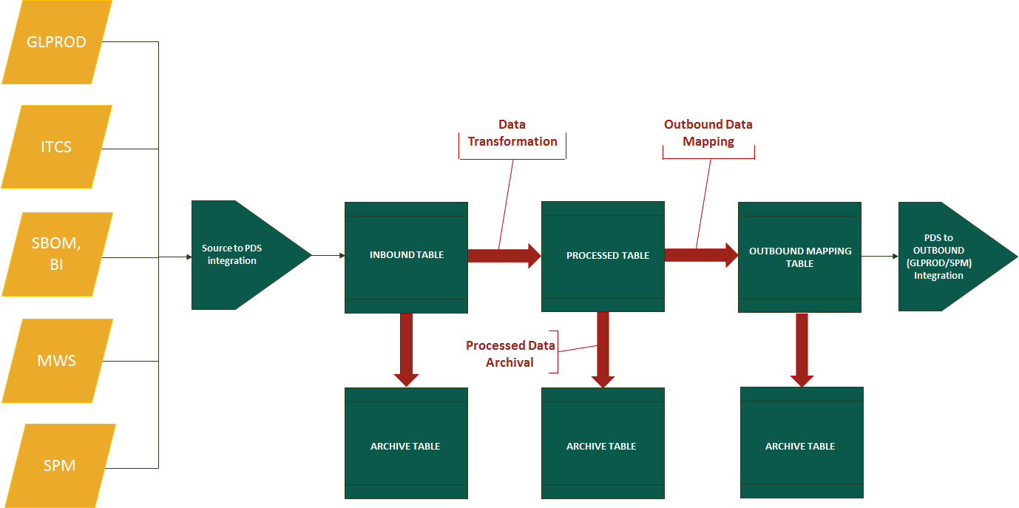

Above is achieved by following procedure/packages :

### 1.3.1 GE\_PLN\_TRANSFORMATION Package

GE\_PLN\_TRANSFORMATION package is responsible for creating an executable query. The executable query for a particular activity\_name, activity\_type, data\_stream and process\_flow is built considering the details from base query i.e. GE\_PLN\_TRANSFORMATION\_BASE\_DTL table and the user provided conditions from GE\_SPM\_RULE\_LINES\_ALL table.

This program will first check the active rule condition in GE\_SPM\_RULE\_LINES\_ALL table corresponding to the active rule in GE\_SPM\_RULE\_HEADERS\_ALL table for a particular activity name.

After the executable is built, this program validates the query.

After successful validation the executable query is saved in GE\_PLN\_TRANSFORMATION\_EXEC\_DTL for a particular activity\_name, activity\_type, data\_stream and process\_flow.

### 1.3.2 GE\_PLN\_TRANSFORMATION\_CALL Package

GE\_PLN\_TRANSFORMATION\_CALL package is responsible for data flow from INBD table of PDS to outbound (SPM) table of PDS.

It will first move the data from INBD table to PRSD table which is identified as IP logical flow. Then the data will move from PRSD table to outbound (SPM) table which is identified as PS logical flow.

This program will take Activity Name as an input and will consider all the active rules (where ENABLE\_FLAG is ‘Y’ for records in GE\_SPM\_RULE\_HEADERS\_ALL table) defined on the GE\_SPM\_RULE\_HEADERS\_ALL for the input activity name.

These active rules will be executed in order of priority defined in the DATASTREAM\_WEIGHTAGE field of GE\_SPM\_RULE\_HEADERS\_ALL table.

For every active rules in logical flow IP, the execution query for activity type ‘INSERT’ will be executed in order of the priority set in the ACTIVITY\_SEQUENCE. After this is successfully completed, the program will execute the execution query for activity type ‘UPDATE’ in order of the priority set in the ACTIVITY\_SEQUENCE of logical flow IP. In this manner execution will be performed for all active rules.

After the successful completion of IP flow, all the rules having active SPM enabled flag (SPM\_ENABLE\_FLAG is ‘Y’ of GE\_SPM\_RULE\_HEADERS\_ALL table) will be considered subsequently for the PS logical flow.

Then again the execution query for the activity type ‘INSERT’ will be executed in order of the priority set in the ACTIVITY\_SEQUENCE. After successfully completion of PS ‘INSERT’ execution query, the execution query for activity type ‘UPDATE’ will be executed in order of the priority set in the ACTIVITY\_SEQUENCE. After successful completion of PS flow, data will move to the outbound SPM table from PRSD table.

There are four stubs which are triggered by this package.

1. **GE\_INBD\_PRSD\_STUB -** This stub is executed before the commencement of IP flow. It executes the logic of all the intended ammendments on the records in the INBD table which are inserted into PRSD table after checking the mutual exclusiveness . If the process gets initiated when any corresponding mutually exclusive process is already running, then the respective process will wait untill the mutually exclusive process gets completed.
2. **GE\_PRSD\_SPM\_STUB**:- This stub is executed after the IP flow and before the PS flow. Through this stub, records in PRSD table is ammended
3. **GE\_SPM\_STUB\_LOGIC**:- This stub is executed after the PS flow. Through this stub SPM table is ammended.
4. **GE\_SPM\_STUB**:- This STUB is designed mainly for implementing the archive logic and purge logic

Archival of a particular table and Purging is at the discretion of users and can be handled through the control table i.e. GE\_PLN\_SYSTEM\_CONTROLS

A procedure **GE\_PLN\_REQUEST\_SET** is introduced which will be invoked to call child transformations within any Parent transformations at below levels

i) Before-IP -> Prior to executing IP

ii) Before PS -> After executing IP, Before executing PS

iii) After-PS -> After executing PS

iv) Before-Archive -> After executing PS, before executing Archive

The sequence and control will be defined in ‘GE\_PLN\_FUNCTIONAL\_MAPPING\_TBL’ Table where MAPPING\_TYPE is 'REQUESTSET'. Below is how the mapping will be determined :

|  |  |
| --- | --- |
| **MAPPING\_TYPE** | REQUESTSET to determine the mapping for parent-child transformation relationships |
| **INTERNAL\_USE** | Parent Transformation |
| **ACTIVITY\_NAME** | Child Transformation |
| **ACTIVITY\_TYPE** | Control for the level of run : BEFORE\_IP, BEFORE\_IP, BEFORE\_PS, AFTER\_PS |
| **MAP\_VALUE1** | Frequency of child transformation runs |
| **CHAR\_VALUE1** | Enabled/Disabled |
| **NUMERIC\_VALUE1** | Priority |
| **CREATED\_BY** | SSO of the creator of this parent-child transformation relationships |
| **CREATION\_DATE** | Date of creation |
| **MODIFIED\_BY** | SSO of the modifier of this parent-child transformation relationships |
| **MODIFICATION\_DATE** | Date of modification |

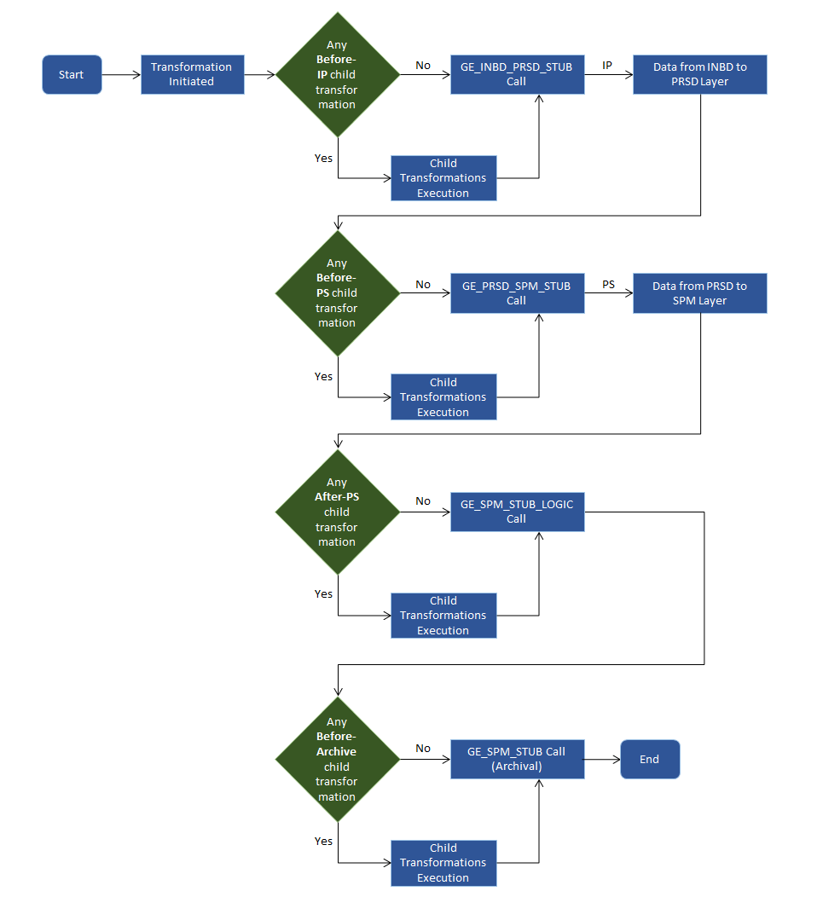

### 1.3.3 GE\_MW\_INTF\_UTIL Package

This program is designed for Middleware to be able to truncate and load inbound table in every run.

Parameters to be passed are

* ACTIVITY\_NAME
* Layer : INBOUND

### 1.3.4 GE\_VALIDATION\_PROCESS Package

This is a validation package used for Validation purposes

Has following functions or procedures

**1. DATE\_VALIDATION:** This function is used for Part Master date validation

**2. RULE\_COMPILE\_ALL :** This procedure is used to compile all rules that are created by users and create execution query from base queries.

**3. RESET\_PROCESS :** Used for making the process flag = ‘N’ in inbound table.

**4. UPDATE\_TABLE :** Used for updating process flag = ‘N’ in inbound table. This function is used in RESET\_PROCESS procedure.

**5. DELETE\_TABLE:** Used for truncating PRSD and SPM tables on basis of activity name and process id. This function is used in RESET\_PROCESS procedure.

**6. GEMS\_GPO\_DEMAND\_CALCULATION:** This procedure is responsible to calculate the demand for each single item present in item master for the three poles (AS, US and EU) for last two year. It calculates the demand from GE\_PRSD\_GLP\_PART\_DEMAND table.

**7. WASHRATE\_CALCULATION:** This procedure is utilized to calculate the wash rate of individual items present in Item Master table GE\_SPM\_GLP\_PART\_MASTER\_AR, considering the various types of transactions the item goes through in a particular date range. This calculation is done based on the record present in GE\_PRSD\_GLP\_PART\_TXN. Also the part hierarchy is honored calculate the cumulative washrate of topmost parts in the part chain as defined in GE\_SPM\_MWS\_PARTCHANGEUP.

**8. DMD\_CONV\_PROCESS :** This procedure enables the business to perform Conversion of Data for Demand for any functional changes that requires the same. Demand conversion could be required due to some change in business processes that requires some functional changes in the ERP and same needs to be transpired in PDS for further SPM planning operations. Also it can handle scenarios where demand data from the legacy system needs to be moved to PDS to appraise SPM on the historical demands.

**9.** **GEMS\_GPO\_Indicated\_Pool\_Size :** This procedure calculates the Indicated Pool Size of individual items present in GE\_SPM\_GLP\_PART\_MASTER\_AR. This is calculated through the summation of all available onhand for the part as derived from GE\_PRSD\_GLP\_PART\_ONHAND table. Also the part hierarchy is honored to calculate the cumulative Indicated Pool size of topmost parts in the part chain as defined in GE\_SPM\_MWS\_PARTCHANGEUP.

**10. GEMS\_GPO\_Priority\_Score :** This procedure calculates the Priority Score, Number of Opportunities and Supply Health of Individual Parts.

Priority Score determines the priority of individual parts considering the backorders, minimum quantity present in the network, available onhand, and average order quantity based on whether the location can either Procure, Repair or is the source pole location or replenishes from other location as fetched from GE\_INBD\_SPM\_PLN\_LVL. Also the part hierarchy is honored to calculate the cumulative Priority Score of the topmost parts in the part chain as defined in GE\_SPM\_MWS\_PARTCHANGEUP.

Number of Opportunities is calculated through the ratio of minimum quantity present in the network as defined in GE\_INBD\_SPM\_PLN\_LVL table with respect to average order quantity as seen in GE\_PRSD\_GLP\_PART\_DEMAND table.

Supply health determines the supply provisioned for individual parts calculated as the ratio of Sum of Positive Priority Score with respect to Sum of Opportunities subtracted from 1.

**11. TXN\_CONV\_PROCESS :** This procedure enables the business to perform Conversion of Data for Transactions for any functional changes that requires the same. Transaction conversion could be required due to some change in business processes that requires some functional changes in the ERP and same needs to be transpired in PDS for further SPM planning operations. Also it can handle scenarios where Transaction data from the legacy system needs to be moved to PDS to appraise SPM on the historical transaction.

**12. REPAIR\_OPTIONS :** Repair options is a break up of all probable repair combination for a particular part including with its part chain with respect to the repair orgs and associated repair vendors. The data is inserted into GE\_INBD\_REPAIR\_OPTIONS table.

The logic works as, it would consider the Repair CDC of the part itself as well as the Repair CDC of all the parts present in the part chain.

**13. SEND\_MAIL:** This procedure is introduced to add a mail functionality to the PDS environment. This is presently being called in the Health Check implemented on OAO file that is received from SPM as a reverse flow file. This could be used in other sections of PDS as well.

### 1.3.5 GE\_IFACE\_SPM\_DETAILS Package

GE\_IFACE\_SPM\_DETAILS package is responsible to modify GEMS\_IFACE\_SPM\_TABLE table and GEMS\_IFACE\_SPM\_TABLE\_DETAILS table with activity name which is running in PDS. This is to monitor the activity which is running by initiating GE\_PLN\_TRANSFORMATION\_CALL.GE\_PLN\_TRANSFORMATION\_FLOW procedure .

Below functions are used in this package.

* **GE\_IFACE\_SPM\_INSERT:** This procedure will be called to insert record into GEMS\_IFACE\_SPM\_TABLE with PROGRAM\_NAME,PROCEDURE\_NAME,START\_DATE,CREATION\_DATE,MESSAGE,STATUS\_FLAG, ACTIVITY\_NAME, PROCESS\_ID,DEBUG\_MESSAGE.
* **GE\_IFACE\_SPM\_UPDATE:** This procedure will be called to update GEMS\_IFACE\_SPM\_TABLE as per PROCESS\_ID.
* **GE\_IFACE\_SPM\_UPDATE\_END:** This procedure used to track when a program got executed.

### 1.3.6 GE\_REIMAGING\_EXECUTION Package

GE\_REIMAGING\_EXECUTION is a package which is utilized to remap the Part Changeup file coming in from MWS and transforming the hierarchy of parts and relevant flags to make it compatible with the requirement in SPM.

The function which performs this activity is:

* **MWS\_PARTCHANGEUP:** This procedure will be called to perform the re-imaging of the part hierarchies in the GE\_PRSD\_MWS\_PARTCHANGEUP table. The GE\_PRSD\_MWS\_PARTCHANGEUP\_REF table is taken as an interim table to store the re-imaged data and finally it is inserted back to GE\_PRSD\_MWS\_PARTCHANGEUP table.

### 1.3.7 DATA\_CLEANUP\_PRG Package

DATA\_CLEANUP\_PRG package is used to list down the obsolete tables and drop the tables after review. This package has 2 procedures:

1. Table listing: This procedure will list down the tables that are not used by any other code objects, transformation rule or is not in the exception list of tables.
2. Data cleanup: This procedure will drop the tables that have been identified to be dropped.

# Module Functionality Logic

## Program Logic

**Program Names:**

1. GE\_PLN\_TRANSFORMATION,
2. GE\_PLN\_TRANSFORMATION\_CALL
3. GE\_MW\_INTF\_UTIL
4. GE\_VALIDATION\_PROCESS
5. GE\_IFACE\_SPM\_DETAILS
6. GE\_REIMAGING\_EXECUTION

### (A) Program Description

**Package Name:** GE\_PLN\_TRANSFORMATION

The parameters are

* Activity Name
* Data Stream
* Activity Type
* Process Flow

This procedure will build the executable query considering the base query from GE\_PLN\_TRANSFORMATION\_BASE\_DTL and the user provided conditions from GE\_SPM\_RULE\_LINES\_ALL for a particular activity\_name, activity\_type, data\_stream and process\_flow. After the executable is built, GE\_PLN\_TRANSFORMATION.VALIDATE\_QUERY will validate the query. Once successful validation is done, the executable query is saved in GE\_PLN\_TRANSFORMATION\_EXEC\_DTL table.

### Inputs / Outputs

#### Inputs

* Base query is in-place in GE\_PLN\_TRANSFORMATION\_BASE\_DTL table with a proper activity sequence for a particular activity name and logical flow.
* Setup Rules for a specific activity name in GE\_SPM\_RULE\_HEADERS\_ALL maintaining a proper sequence and conditions will be in GE\_SPM\_RULE\_LINES\_ALL for each rule stream.

#### **Outputs**

An executable query will be built and saved into the GE\_PLN\_TRANSFORMATION\_EXEC\_DTL table.

### Program Logic

**Pseudo code for ‘**GE\_PLN\_TRANSFORMATION Package‘

1. GE\_PLN\_TRANSFORMATION. CREATE\_QUERY() is called to create the executable query.
2. Parameters will take activity name, data stream, activity type and logical flow.
3. At the time of creation of the query, it will consider all the active rule lines from GE\_SPM\_RULE\_LINES\_ALL table for the given data stream name.
4. The conditions fetched from the rule lines are appended with the base query.
5. The query is validated.
6. After successful validation the query is saved into the GE\_PLN\_TRANSFORMATION\_EXEC\_DTL table.
7. For any exception error is thrown.

#### **Error Conditions**

Error conditions as depicted in the pseudo code are captured.

#### **Warning Conditions**

There are no warning conditions.

### (A) Program Description

**Package Name:** GE\_PLN\_TRANSFORMATION\_CALL

The parameter is –

* Activity Name

The package is responsible for the data flow from INBD table of PDS to Outbound (SPM) table of PDS. It will first move the data from INBD table to PRSD table depending on the active defined rules and processed\_fag in Inbound Tables = ‘N’.

Then the data will move from PRSD table to outbound (SPM) table depending on the spm enable defined rules.

### Inputs / Outputs

#### **Inputs**

Inbound (INBD) table data needs to be populated with the process flag = ‘N’

#### **Outputs**

All data in INBD table will move to the outbound (SPM) table based on the spm enable rule stream

### Program Logic (pseudo code)

**Pseudo code for ‘**GE\_PLN\_TRANSFORMATION\_CALL Package’

1. GE\_PLN\_TRANSFORMATION\_CALL.GE\_PLN\_TRANSFORMATION\_FLOW procedure is called to initiate the procedure for a particular activity name.
2. GE\_IFACE\_SPM\_DETAILS.GE\_IFACE\_SPM\_INSERT procedure is called to insert into GEMS\_IFACE\_SPM\_TABLE for this activity name with the status flag of ‘I’
3. Check if the procedure is already running for this activity name for the commenced within last 5 hours. If yes the procedure will throw an error.
4. Else, GE\_INBD\_PRSD\_STUB.GE\_INBD\_PRSD\_FLOW procedure is called to execute the first STUB.
5. After successful completion of this stub it is checked if there exist any active rule for the activity name from GE\_SPM\_RULE\_HEADERS\_ALL. If No, It will follow from STEP:7
6. If Yes, Then for every single rule stream
   1. GE\_PLN\_TRANSFORMATION.EXECUTE\_TRANSFORMATION procedure is called to execute the INSERT query for IP flow.
   2. It will throw an error if the INSERT query is not successfully completed.
   3. GE\_PLN\_TRANSFORMATION.EXECUTE\_TRANSFORMATION procedure is called to execute the UPDATE query for IP flow.
   4. It will throw an error if the UPDATE query is not successfully completed.
7. GE\_PRSD\_SPM\_STUB.GE\_PRSD\_SPM\_FLOW procedure is called to execute the next STUB.
8. After successful completion of this stub, it is checked if there exist any SPM enabled active rule for the activity name from GE\_SPM\_RULE\_HEADERS\_ALL.

If No, It will follow from STEP: 10

1. If Yes, Then for every single rule stream
   1. GE\_PLN\_TRANSFORMATION.EXECUTE\_TRANSFORMATION procedure is called to execute the INSERT query for PS flow.
   2. It will throw an error if the INSERT query is not successfully completed.
   3. GE\_PLN\_TRANSFORMATION.EXECUTE\_TRANSFORMATION procedure is called to execute the UPDATE query for PS flow
   4. It will throw an error if the UPDATE query is not successfully completed
2. GE\_SPM\_STUB\_LOGIC.GE\_SPM\_FLOW procedure is called to execute the next STUB.
3. After successful execution of this STUB, IFACE table (GEMS\_IFACE\_SPM\_TABLE) is UPDATED with the STATUS ‘C’.
4. The procedure GE\_PLN\_TRANSFORMATION\_CALL then will check if the GE\_SPM\_STUB is called by Middleware or not from the lookup value against the activity name. If it is not called by the MW then the procedure itself will call the below STUB.
5. GE\_SPM\_STUB.GE\_SPM\_FLOW procedure is called to execute the final STUB.
6. After successful execution, IFACE table (GEMS\_IFACE\_SPM\_TABLE) is UPDATED with the STATUS ‘C’.
7. **GE\_PLN\_REQUEST\_SET** procedure is introduced which will be invoked to call child transformations within any Parent transformations at multiple levels.

The sequence and control will be defined in ‘GE\_PLN\_FUNCTIONAL\_MAPPING\_TBL’ Table where MAPPING\_TYPE is 'REQUESTSET'. Below is how the mapping will be determined:

|  |  |
| --- | --- |
| **MAPPING\_TYPE** | REQUESTSET determing the mapping for parent-child transformation relationships |
| **INTERNAL\_USE** | Parent Transformation |
| **ACTIVITY\_NAME** | Child Transformation |
| **ACTIVITY\_TYPE** | Control for the level of run :  BEFORE\_IP -> Prior to executing IP  BEFORE\_IP -> After executing IP, Before executing PS  BEFORE\_PS -> After executing PS  AFTER\_PS -> After executing PS, before executing Archive |
| **MAP\_VALUE1** | Frequency of child transformation runs |
| **CHAR\_VALUE1** | Enabled/Disabled |
| **NUMERIC\_VALUE1** | Priority |
| **CREATED\_BY** | SSO of the creator of this parent-child transformation relationships |
| **CREATION\_DATE** | Date of creation |
| **MODIFIED\_BY** | SSO of the modifier of this parent-child transformation relationships |
| **MODIFICATION\_DATE** | Date of modification |

**STUB:**

1. GE\_INBD\_PRSD\_STUB - This stub is executed before the commencement of IP flow. It executes the logic of all the intended ammendments on the records in the INBD table which are inserted into PRSD table after checking the mutual exclusiveness . If the process gets initiated when any corresponding mutually exclusive process is already running, then the respective process will wait untill the mutually exclusive process gets completed.

As a part of this stub the Inbound data for Collaborative Planning Item and SupplyDemand forecast details is loaded into the GE\_INBD\_ITEM\_CP table and GE\_INBD\_SUP\_DMD\_CP respectively :

1. Item Forecast Inbound insertion – The data is picked for distinct items in the Order Plan Processed Layer table GE\_PRSD\_PLAN\_ORDER and inserted into CP Inbound Item table based on below values, mapping and conditions :

|  |  |  |
| --- | --- | --- |
| **Column in GE\_INBD\_ITEM\_CP** | **Data** | **Comment** |
| ITEM\_NAME | Part\_Number | Distinct Part\_Number from GE\_PRSD\_PLAN\_ORDER table |
| ORGANIZATION\_CODE | 'GPO', | Hard coded value |
| MRP\_PLANNING\_CODE | '3', | Hard coded value |
| UOM\_CODE | 'EA', | Hard coded value |
| BUILT\_IN\_WIP\_FLAG | '2', | Hard coded value |
| PURCHASING\_ENABLED\_FLAG | '1', | Hard coded value |
| PLANNING\_MAKE\_BUY\_CODE | '2', | Hard coded value |
| ENGINEERING\_ITEM\_FLAG | '2', | Hard coded value |
| EFFECTIVITY\_CONTROL | '1', | Hard coded value |
| INVENTORY\_PLANNING\_CODE | '6', | Hard coded value |
| SOURCE\_INSTANCE\_CODE | 'LEG', | Hard coded value |
| DESCRIPTION | Item\_Description | Corresponding item\_description extracted from GE\_PRSD\_GLP\_PART\_MASTER table. There should be no '~' sign in the description |
| PLANNER\_CODE | planner\_code | Corresponding planner\_code derived from GE\_PRSD\_GLP\_PART\_MASTER table |
| BOM\_ITEM\_TYPE | '4', | Hard coded value |
| INVENTORY\_ITEM\_FLAG | '1', | Hard coded value |
| INVENTORY\_ASSET\_FLAG | 'Y', | Hard coded value |
| COMPANY\_NAME | 'GE Healthcare', | Hard coded value |
| PROCESSED\_FLAG | N' | Hard coded value. Initial status of Inbound layer |
| INBD\_PROCESSED\_DATE | SYSDATE | System Date |

Conditions:

1. Order\_Type in GE\_PRSD\_PLAN\_ORDER table for the item is ‘Procure’
2. Supplier\_Type in the GE\_PRSD\_PLAN\_ORDER table is ‘EXTERNAL’
3. Should not consider the return forecasts in the GE\_PRSD\_PLAN\_ORDER table
4. Should not consider the Open orders]
5. Only GPO items as defined in the GE\_PRSD\_GLP\_PART\_MASTER table should be considered
6. Supply Demand Forecast Inbound insertion – The sum of the forecast quantity is evaluated grouped on the basis of Part\_Number, Supplier\_Name, Site\_Code, Available\_Date, OP\_RUN\_DATE in the Order Plan Processed Layer table GE\_PRSD\_PLAN\_ORDER and inserted into CP Inbound Supply-Demand forecast table based on below values, mapping and conditions :

|  |  |  |
| --- | --- | --- |
| **Column in GE\_INBD\_SUP\_DMD\_CP** | **Value** | **Comment** |
| SYNC\_INDICATOR | R' | Hard coded value |
| ITEM\_NAME | Part\_Number | Part\_Number from GE\_PRSD\_PLAN\_ORDER table |
| ORDER\_TYPE | Order forecast' | Hard coded value |
| UOM | EA' | Hard coded value |
| PUBLISHER\_COMPANY | GE Healthcare' | Hard coded value |
| PUBLISHER\_SITE | GPO' | Hard coded value |
| SUPPLIER\_COMPANY | Supplier\_Name | Supplier\_Name from GE\_PRSD\_PLAN\_ORDER table |
| SUPPLIER\_SITE | Site\_Code | Site\_Code from GE\_PRSD\_PLAN\_ORDER table |
| SHIP\_FROM\_PARTY\_NAME | Supplier\_Name | Supplier\_Name from GE\_PRSD\_PLAN\_ORDER table |
| SHIP\_FROM\_PARTY\_SITE | Site\_Code | Supplier\_Code from GE\_PRSD\_PLAN\_ORDER table |
| SHIP\_TO\_PARTY\_NAME | GE Healthcare' | Hard coded value |
| SHIP\_TO\_PARTY\_SITE | GPO' | Hard coded value |
| RECEIPT\_DATE | Receipt Date | In 'DD-MON-YY' format |
| BUCKET\_END\_DATE | Bucket End Date | In 'DD-MON-YY' format |
| BUCKET\_TYPE | Day' | Hard coded value |
| COMMENTS | TESTLOADv1' | Some identifiable comments in Hard coded value |
| DESIGNATOR | SVC-SPM' | Hard coded value |
| VERSION | OP\_RUN\_DATE | In 'YYYYMMDD' format |
| PROCESSED\_FLAG | N' | Hard coded value. Initial status of Inbound |
| INBD\_PROCESSED\_DATE | SYSDATE | System Date |
| QUANTITY | SUM of quantity within PLAN\_QUANTITY or REC\_QUANTITY | Grouped on the basis of Part\_Number, Supplier\_Name, Site\_Code, Available\_Date, OP\_RUN\_DATE in GE\_PRSD\_PLAN\_ORDER. Also based on this grouping condition if there is a record on the previous week and not on the current week, a ‘0’ Quantity record should be inserted |

Conditions :

1. Order\_Type in GE\_PRSD\_PLAN\_ORDER table for the item is ‘Procure’
2. Supplier\_Type in the GE\_PRSD\_PLAN\_ORDER table is ‘EXTERNAL’
3. Should not consider the return forecasts in the GE\_PRSD\_PLAN\_ORDER table
4. Should not consider the Open orders
5. Only GPO items as defined in the GE\_PRSD\_GLP\_PART\_MASTER table should be considered
6. GE\_PRSD\_SPM\_STUB:- This stub is executed after the IP flow and before the PS flow. Through this stub, records in PRSD table is ammended before sending to SPM layer. The records which do not abide by any of the rule setups are segregated as Problem records and stopped from being sent to SPM layer. In this STUB the SPM layer is also archived before the fresh data gets inserted into it.

As a part of this stub in the Procedure ‘GE\_SCS\_ORDER\_LOGIC’, the Processed layer data for Approved Orders details (i.e. activity name = ‘APPROVED\_ORDERS\_TRANSFORMATION’) goes through below logic before reaching the Outbound layer :

For Modification recommendation all the recommendations which arrive as SCS flag (i.e. additional\_info\_12 ) ‘Y’/’y’/’yes’/’Yes’/’YES’ needs to be restricted from being sent as part of normal flow. These records needs to be seperately stored in reference table ‘GE\_SCS\_OAO\_REFERENCE’. These records will further be honored during the forward flow runs at the time of sending Open supply, where these orders will be marked not to be further considered for SCS in SPM.

For the next new set of OAO records, if the records with additional\_info\_12 as Y already exists in the reference table ‘GE\_SCS\_OAO\_REFERENCE’, the new records will update the old records in merge functionality. For no existing record the fresh record will get inserted.

There is purging logic as well to delete the records from the reference table ‘GE\_SCS\_OAO\_REFERENCE’ based on the condition : if greater of need\_by\_date and plan\_order\_date (Additional\_info\_5 in reference table ‘GE\_SCS\_OAO\_REFERENCE’ ) is less than sysdate

As a part of this stub in the Procedure ‘GE\_APP\_ORDER\_LOGIC’, the Processed layer data for Approved Orders details (i.e. activity name = ‘APPROVED\_ORDERS\_TRANSFORMATION’) goes through below logic before reaching the Outbound layer :

All the recommendations which are processed under DEFAULT rule\_stream are checked for duplicate transaction id and are updated with a modified transaction id.

**‘TRXN\_APPEND\_ID\_S’** Sequence is created to make the TRANSACTION IDs unique. The duplicate TRANSACTION IDs are appended with a number from the **‘TRXN\_APPEND\_ID\_S’** Sequence and all the duplicate TRANSACTION IDs are made unique.

The Transaction id of both the records having duplicate transaction id are modified.

Moreover, the repair orders having more than 1 quantity are split into multiple records having only 1 quantity for each repair recommendation. This change is done to remove the Repair Customization from the SPM end and make this customization from the PDS end.

Further, for the repair orders Sub Inventory information is also populated based on the defective Sub Inventory priority and onhand present at the respective location for that part.

1. Item Forecast Inbound insertion – The data is picked for distinct items in
2. GE\_SPM\_STUB\_LOGIC:- This stub is executed after the PS flow. Through this stub SPM table is ammended.
3. GE\_SPM\_STUB:- This STUB is designed mainly for implementing the archive logic and purge logic. It is called by the MW separately. It is executed as the part of the SP excution if the last stub is not called by MW. When this process is executed, there will be no dependency for other activities on this step

#### **Error Conditions**

Error conditions as depicted in the pseudo code are captured.

#### **Warning Conditions**

There are no warning conditions.

### (C) Program Description

**Package Name:** GE\_MW\_INTF\_UTIL

The parameters are

* ACTIVITY\_NAME
* Layer : INBOUND

This procedure is designed for Middleware to be able to truncate and load inbound table in every run.

### Inputs / Outputs

#### **Inputs**

Activity Name and Inbound layer will be the input

#### **Outputs**

Specified table in GE\_PLN\_TRANSLATION\_LOOKUP will be truncated based on the inputs.

### Program Logic

**Pseudo code for ‘**GE\_MW\_INTF\_UTIL Package‘

1. GE\_MW\_INTF\_UTIL. truncate\_table () is called to truncate and load inbound table in every run for each interface.
2. Parameters will take activity name.
3. For any exception error is thrown.

#### **Error Conditions**

Error conditions as depicted in the pseudo code are captured.

#### **Warning Conditions**

There are no warning conditions.

### (D) Program Description

**Package Name:** GE\_IFACE\_SPM\_DETAILS

The parameters are

* PROGRAM\_NAME
* PROCEDURE\_NAME
* START\_DATE
* CREATION\_DATE
* MESSAGE
* STATUS\_FLAG
* ACTIVITY\_NAME
* PROCESS\_ID
* DEBUG\_MESSAGE

### Inputs / Outputs

#### Inputs

Details to update columns of table : GEMS\_IFACE\_SPM\_TABLE.

#### **Outputs**

GEMS\_IFACE\_SPM\_TABLE is updated with latest information.

### Program Logic

**Pseudo code for ‘**GE\_IFACE\_SPM\_DETAILS ‘

1.GE\_IFACE\_SPM\_DETAILS. GE\_IFACE\_SPM\_INSERT() is called to insert into GEMS\_IFACE\_SPM\_TABLE.

2. Parameters will take PROGRAM\_NAME,PROCEDURE\_NAME,START\_DATE, CREATION\_DATE,MESSAGE,STATUS\_FLAG, ACTIVITY\_NAME, PROCESS\_ID,DEBUG\_MESSAGE..

3.GE\_IFACE\_SPM\_UPDATE procedure will be called to update GEMS\_IFACE\_SPM\_TABLE for a PROCESS\_ID.

4.GE\_IFACE\_SPM\_UPDATE\_END procedure used to track when a program got executed .

5. For any exception error is thrown.

#### **Error Conditions**

Error conditions as depicted in the pseudo code are captured.

#### **Warning Conditions**

There are no warning conditions.

### (E) Program Description

**Package Name:** GE\_VALIDATION\_PROCESS

The parameters are:

|  |  |
| --- | --- |
| **Procedure** | **Parameters** |
| DATE\_VALIDATION | Date |
| RULE\_COMPILE\_ALL | process\_id |
| UPDATE\_TABLE | table name , process\_id |
| DELETE\_TABLE | table name , process\_id |

### Inputs / Outputs

#### **Inputs**

Production date and creation date for a particular part for Date\_validation procedure

Activity name and the rulestream for Rule\_compile\_all procedure

Process\_id for a particular activity\_name is the input for the Reset\_process Procedure.

Process\_id and Table\_name are the inputs for the Update\_table procedure.

Process\_id and Table\_name are the inputs for the Delete\_table procedure.

#### **Outputs**

Date\_validation returns a value out of production\_date or the value of creation\_date if production\_date is incorrect

Rule\_compile\_all validates the combination of the base query and the rules and saves it in the execution table after successful validation

Reset\_process helps to clear the data from the INBD table, PRSD table and SPM (Outbound) table for the records having the corresponding process id. It also updates the process\_flag to N for the INBD table and the process\_id is set to NULL.

Update\_table is called by the Reset\_process to update the process\_flag to N for the INBD table and the process\_id is set to NULL for the records having the corresponding process id

Delete\_table is called by the Reset\_process to clear the data from the INBD table, PRSD table and SPM (Outbound) table which is taken as Input for the records having the corresponding process id.

### Program Logic

**Pseudo code for ‘**GE\_VALIDATION\_PROCESS‘ with its respective procedures :

1. Date\_validation returns a value out of production\_date or the value of the creation\_date if production\_date is incorrect

2. Rule\_compile\_all validates the combination of the base query and the rules and saves it in the execution table after successful validation

3.Reset\_process helps to clear the data from the INBD table, PRSD table and SPM (Outbound) table for the records having the corresponding process id. It also updates the process\_flag to N for the INBD table and the process\_id is set to NULL.

4. Update\_table is called by the Reset\_process to update the process\_flag to N for the INBD table and the process\_id is set to NULL for the records having the corresponding process id

5. Delete\_table is called by the Reset\_process to clear the data from the INBD table, PRSD table and SPM (Outbound) table which is taken as Input for the records having the corresponding process id.

1. The GEMS\_GPO\_DEMAND\_CALCULATION will calculate the demand from GE\_PRSD\_GLP\_PART\_DEMAND table for each individual item present in item master for the three poles (Asia, US and EU ) for last two years in set of one year each and will keep it stored.
2. Demand Conversion Process is done to load Oracle/Legacy system demands to Oracle as per the business needs

* Initially technically correct records is inserted into the staging table GE\_DEMAND\_CONV\_STAGING\_TABLE in a proposed format (Attached in Appendix)
* For these records as per the check from front end for Oracle or Legacy system demand data order\_line\_id is populated or auto generated respectively
* The records are then inserted into the interface table GE\_DEMAND\_CONV\_INTERFACE\_TABLE with status ‘V’ validated or status ‘E’ error.
* A snapshot of the current records in the GE\_DEMAND\_CONV\_INTERFACE\_TABLE table are inserted into a snapshot table GE\_DMD\_CONV\_SNAPSHOT to provide users visibility to their inserted records
* Also the entire set of records with errored data for a conversion\_id is srored into GE\_DMD\_CONV\_INTRFC\_ERR\_TABLE table to help users to make necessary rectification
* If the number of inserted records in GE\_DEMAND\_CONV\_INTERFACE\_TABLE is equal to the number of validated records i.e. all records are validated, the status of the records is changed to ‘A’ i.e. authenticated
* If the number of inserted records is not equal to the number of validated records in GE\_DEMAND\_CONV\_INTERFACE\_TABLE, all data from staging (GE\_DEMAND\_CONV\_STAGING\_TABLE) as well as interface table (GE\_DEMAND\_CONV\_INTERFACE\_TABLE) are deleted to keep the tables fresh for next data load and so that no partial records are available in the planning system
* Once the conversion process is initiated, all the loaded data in the GE\_DEMAND\_CONV\_INTERFACE\_TABLE with current status ‘A’ gets inserted into the DEMAND\_CONV\_INBD\_TABLE which is Inbound Conversion Table.
* From DEMAND\_CONV\_INBD\_TABLE the data gets loaded to the Processed Conversion Table i.e. DEMAND\_CONV\_PRSD\_TABLE
* From DEMAND\_CONV\_PRSD\_TABLE the data gets loaded to Demand Processed Table GE\_PRSD\_GLP\_PART\_DEMAND which holds all the pristine records
* The GE\_PRSD\_GLP\_PART\_DEMAND retains backup of the data prior to the conversion in the columns by updating the records during the Demand Conversion Process. The records which come as a part of the conversion is inserted into the GE\_PRSD\_GLP\_PART\_DEMAND table. If the records which are arriving through conversion is over an existing demand record, then the below fields are updated from the corresponding fields of the existing old records into the converted fresh records :

PRE\_CNV\_CUSTOMER\_CATEGORY

PRE\_CNV\_FE\_SSO

PRE\_CNV\_ORDERED\_QUANTITY

PRE\_CNV\_SHIPPED\_QUANTITY

PRE\_CNV\_RESERVED\_QUANTITY

PRE\_CNV\_SHIP\_FROM

PRE\_CNV\_HISTORY\_DATE

PRE\_CNV\_SCHEDULED\_SHIP\_DATE

PRE\_CNV\_LINE\_UPDATION\_DATE

PRE\_CNV\_SOURCED\_FROM

PRE\_CNV\_LCT

PRE\_CNV\_FE\_COUNTRY

PRE\_CNV\_FE\_WAREHOUSE

PRE\_CNV\_REQUEST\_DATE

PRE\_CNV\_ORDER\_LINE\_STATUS

PRE\_CNV\_HEADER\_ORDER\_STATUS

Later to this the existing old records which is being replaced by converted records are deleted. This helps maintain the reference of the details of the old records and keeps the Demand PRSD pristine.

* The full process is described with a Standard Operating Procedure in the Appendix section
* The description of the navigations are provided in the section 2.2.1
* The archival for the GE\_INBD\_GLP\_PART\_DEMAND\_CONV and GE\_PRSD\_GLP\_PART\_DEMAND\_CONV tables are done as per the existing process defined in section 2.2.9 into GE\_INBD\_GLP\_PART\_DMND\_CONV\_AR table and GE\_PRSD\_GLP\_PART\_DMD\_CONV\_AR table respectively

1. PRIORITY\_SCORE, No\_Of\_Opportunities, Supply\_health is calculated by considering the below categories of data

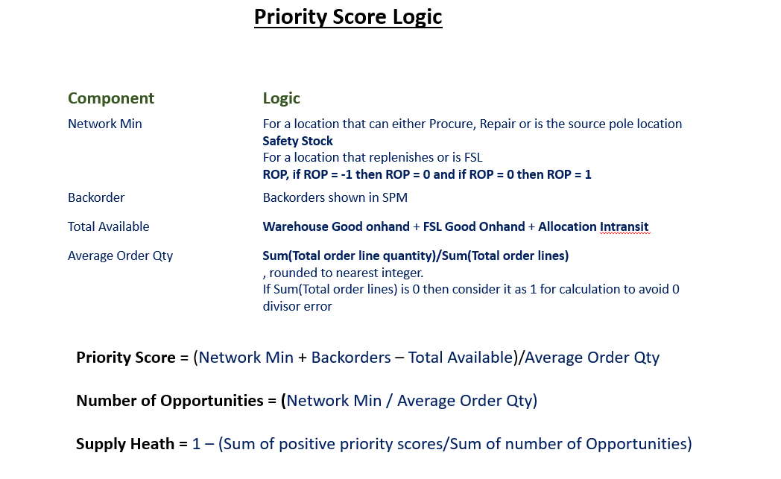

1. Indicated Pool Size is calculated by considering the below categories of data

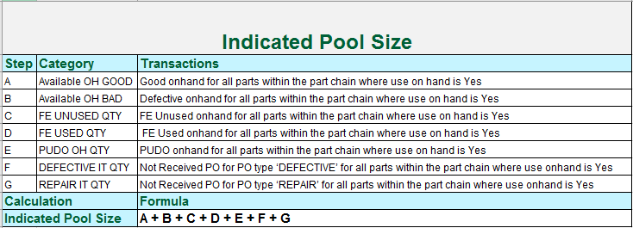

1. Priority Score is calculated by considering the below categories of data

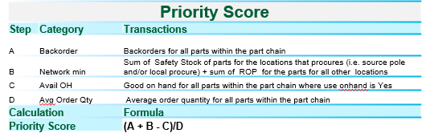

1. Transaction Conversion Process is done to load Oracle/Legacy system demands to Oracle as per the business needs

* Initially technically correct records is inserted into the staging table GE\_TXN\_CONV\_STAGING\_TABLE in a proposed format (Attached in Appendix)
* For these records as per the check from front end for Oracle or Legacy system transaction data transaction\_id is populated or auto generated respectively
* The records are then inserted into the interface table GE\_TXN\_CONV\_INTERFACE\_TABLE with status ‘V’ validated or status ‘E’ error.
* A snapshot of the current records in the GE\_TXN\_CONV\_INTERFACE\_TABLE table are inserted into a snapshot table GE\_TXN\_CONV\_SNAPSHOT to provide users visibility to their inserted records
* Also the entire set of records with errored data for a conversion\_id is srored into GE\_TXN\_CONV\_INTRFC\_ERR\_TABLE table to help users to make necessary rectification
* If the number of inserted records in GE\_TXN\_CONV\_INTERFACE\_TABLE is equal to the number of validated records i.e. all records are validated, the status of the records is changed to ‘A’ i.e. authenticated
* If the number of inserted records is not equal to the number of validated records in GE\_TXN\_CONV\_INTERFACE\_TABLE, all data from staging (GE\_TXN\_CONV\_STAGING\_TABLE) as well as interface table (GE\_TXN\_CONV\_INTERFACE\_TABLE) are deleted to keep the tables fresh for next data load and so that no partial records are available in the planning system
* Once the conversion process is initiated, all the loaded data in the GE\_TXN\_CONV\_INTERFACE\_TABLE with current status ‘A’ gets inserted into the GE\_INBD\_GLP\_PART\_TXN\_CONV which is Inbound Conversion Table.
* From GE\_INBD\_GLP\_PART\_TXN\_CONV the data gets loaded to the Processed Conversion Table i.e. GE\_PRSD\_GLP\_PART\_TXN\_CONV
* From GE\_PRSD\_GLP\_PART\_TXN\_CONV the data gets loaded to Transaction Processed Table GE\_PRSD\_GLP\_PART\_TXN which holds all the pristine records
* The full process is described with a Standard Operating Procedure in the Appendix section
* The description of the navigations are provided in the section 2.2.1
* The archival for the GE\_INBD\_GLP\_PART\_TXN\_CONV and GE\_PRSD\_GLP\_PART\_TXN\_CONV tables are done as per the existing process defined in section 2.2.9 into GE\_PRSD\_GLP\_PART\_TXN\_CONV\_AR table and GE\_PRSD\_GLP\_PART\_TXN\_CONV\_AR table respectively

1. NFF Rate is calculated based on the below logic :



User can override NFF rate from which would have precedence over the calculated data. Process of entering the NFF rate override is mentioned in Section 2.2

1. SKU Transformation value for a Part-Org combination can be entered by the user. Process to enter this value is mentioned in Section 2.2

#### **Error Conditions**

Error conditions as depicted in the pseudo code are captured.

#### **Warning Conditions**

There are no warning conditions.

### (F) Program Description

**Package Name:** GE\_REIMAGING\_EXECUTION

### Inputs / Outputs

#### **Inputs**

Input will be the data from GE\_PRSD\_MWS\_PARTCHANGEUP table

#### **Outputs**

Output will be the data for parts with remapped hierarchy in GE\_PRSD\_MWS\_PARTCHANGEUP table

### Program Logic

**Pseudo code for ‘**GE\_REIMAGING\_EXECUTION ‘

1. Elimination of items are done in the input file whose status are not defined in GPO. There will be no check on the item\_status. The Input file hierarchy structure of the parts are rebuilt so that all functionally correct parts are used to form the hierarchy

2. Also the Ultimate Primes which are not defined in GPO irrespective of the item\_status are eliminated from the chain hierarchy and its subsequent parts are allowed to replace its position

3. We are considering all the Ultimate Primes from the GE\_PRSD\_MWS\_PARTCHANGEUP table and undergoing the following steps :

1. The ultimate\_prime part is designated as the Level 1 Part, for which data is inserted first. The relationship\_type for these parts is 0
2. Under the Level 1 part, the topmost repairable part is looked for in the GE\_PRSD\_MWS\_PARTCHANGEUP table and will be treated as alternate part with relationship\_type as 1. All the other parts in the chain under the same ultimate prime are considered as replace part with relationship\_type as 0. This part will be considered as Level 2.
3. If repairable part is not found then Harvest part is looked for and it is the designated as the alternate with relationship\_type as 1. All the other parts in the chain under the same ultimate prime are considered as replace part with relationship\_type as 0. This part will be considered as Level 2.
4. Else it will consider the Used part as the alternative part with relationship\_type as 1. All the other parts in the chain under the same ultimate prime are considered as replace part with relationship\_type as 0. This part will be considered as Level 2.
5. All the Repairable parts under the same Ultimate Prime Part will follow suite of the Level 2 part if it is a Repairable part. These will be designated as Level 3 parts. Only the topmost harvest part will follow suite of the Level 2 part and will be designated as level 3 part. The other Harvest or Used parts will be considered as Level 4 and will follow the Level 3 harvest part
6. If no Repairable part are present in the Level 2 but Harvest part is present, all other Harvest and Used parts follow the Level 2 Harvest Part
7. If Used part present in Level 2, all the other used parts will follow the Used part in Level 2 and will be considered as Level 3
8. Finally all the other parts which are neither Repairable, Harvest nor Used are inserted as part of the Level 2.
9. Procurable Flag
   * Y for Ultimate Prime
   * N for Alternate
   * N for Replace
10. Repairable Flag
    * Y for Ultimate Prime if Item type is GP\_Repairable
    * N for Ultimate Prime if Item type is not GP\_Repairable
    * Y for Alternate
    * N for Replace
11. RollUpGood
    * Y, for ultimate prime
    * N, for alternate part
    * Y, for replace part when include inventory = Y
    * N, for replace part when include inventory = N
12. RollUpBad
    * N (Always)
13. RollUpGoodAsBad
    * N (Always)
14. RollUpDemand
    * N, for Alternate
    * Y, for Replace
    * Y, ultimate prime

4. All the remapped data is initially stored in the GE\_PRSD\_MWS\_PARTCHANGEUP\_REF table with Processed\_flag N.

5. After remapping is done all the records in the GE\_PRSD\_MWS\_PARTCHANGEUP table with processed\_flag N is updated to Processed\_flag C.

6. The data in the GE\_PRSD\_MWS\_PARTCHANGEUP\_REF is finally moved back to GE\_PRSD\_MWS\_PARTCHANGEUP table with Process\_Flag N.

#### **Error Conditions**

Error conditions as depicted in the pseudo code are captured.

#### **Warning Conditions**

There are no warning conditions.

### (G) Program Description

**Package Name:** DATA\_CLEANUP\_PRG

### Inputs / Outputs

#### **Inputs**

This program has no input

#### **Outputs**

List of tables that are not used by any code objects or transformation rules

### Program Logic

**Pseudo code for ‘**DATA\_CLEANUP\_PRG ‘

1. Table listing:

A list of tables will be extracted from PDS schema of PDS database where the tables have no dependency on any other objects and the table is not listed in the table GE\_PDS\_DATA\_CLN\_UP\_EXC. This list will then be validated against the list of tables used in transformations rules. All such tables that are not used in the transformation rules will be populated in table GE\_PDS\_OBSOLETE\_TABLES along with its size.

1. Data Clean up:

Table GE\_PDS\_OBSOLETE\_TABLES will have a column marked for deletion. This column will be updated to ‘Y’ when the table is reviewed and marked to be dropped. All such tables for which the value in column marked for deletion of table GE\_PDS\_OBSOLETE\_TABLES is set to ‘Y’ will be dropped from the database.

#### **Error Conditions**

N/A

#### **Warning Conditions**

N/A

## Forms

APEX is used as Front End User Interface to PRDPDS for enhanced accessibility and usability.

### Form Logic

Planning Rules Management –

Allows the user to change and create the different rules for various transformation logics depending on the business scenarios through which one can control the data streams for a particular transformation. The existing transformation rules are as defined in Setup Doc

Transformation Management –

Allows the user to change and create the different base queries through which one can control the data as mentioned in the underlying rule stream depending on the business scenarios. The existing transformation rules are as defined in Setup Doc

Archive Management –

Provides accessibility to users to control Archival of individual tables through a Flag to control if it requires to be archived or not through Y/N. The archive management control in PDS is as defined in Section 2.2.9

Debug Details Management –

Provides control to switch on Debug Mode or not for individual Activities types as defined in Setup Document. The Debug functionality is as defined in Section 2.2.11

Purge Details Management –

Provides control to purge records for specified amount of days for specific tables. The logic for Purge in PDS is as defined in Section 2.2.10

Reports –

Used to Display reports on the progress of different functionalities in PDS by extracting appropriate records from GEMS\_IFACE\_SPM\_TABLE

Wash Rate –

This provides a visibility to users on Washrates of Individual Items which gets submitted on the 1st day of every month. The logic is as defined in Washrate calculation in program logic section and Section 1.3.4.7

Demand Calculation –

Provides visibility to users to view the demands for different items which gets submitted on the 1st day of every month. The logic is as defined in Section 1.3.4.6

Wash Rate Override –

Allows the user to enter the Wash Rate override for Part-Location combinations which would get precedence over the calculated Wash Rate if entered from here.

As per the latest additions, Wash Rate Override would have the functionality to add the Date Range separately for Repair/Return Wash Rate Override Values. This functionality would help to control the override values which replaces the calculated values for Repair/Return Wash Rate in the Part Master Extract sent to SPM.

Demand Conversion Process –

Enables users to perform demand conversion

1. Check for Oracle/Non-Oracle Demand Conversion – Allows users to select if Demand Conversion is to be done for Oracle System or some other Legacy System
2. Demand Conversion Data Load – Allows users to load the data for Demand Conversion
3. Demand Conversion Summary – Allows user to check the status of the Demand Data File Uploaded for the assigned Conversion\_Id and also extract the data which got error
4. Demand Conversion Transformation – This allows user to start off with the Demand Conversion Process

Supply Conversion Process –

Enables users to perform supply conversion

1. Check for Oracle/Non-Oracle Supply Conversion – Allows users to select if Supply Conversion is to be done for Oracle System or some other Legacy System
2. Supply Conversion Data Load – Allows users to load the data for Supply Conversion
3. Supply Conversion Summary – Allows user to check the status of the Supply Data File Uploaded for the assigned Conversion\_Id and also extract the data which got error out
4. Supply Conversion Transformation – This allows user to start off with the Supply Conversion Process

Repair and Allocation Block –

Allows users to block Repair and Allocation for a particular organization for desired time period

Planning Lookups Setup –

To provide visibility to access the lookup table of PDS GE\_PLN\_TRANSLATION\_LOOKUP where user can see any lookup value which is being used for various data references and transformation

Process Control Setup –

To provide visibility to access the different system controls on different tables and business functionalities as defined in GE\_PLN\_SYSTEM\_CONTROLS table

Transformation Alias Setup –

Provides visibility to view the different aliases used for different tables in the base query as defined in setup doc

Transaction Conversion Process –

Enables users to perform Transaction conversion

1. Check for Oracle/Non-Oracle Transaction Conversion – Allows users to select if Transaction Conversion is to be done for Oracle System or some other Legacy System
2. Transaction Conversion Data Load – Allows users to load the data for Transaction Conversion
3. Transaction Conversion Summary – Allows user to check the status of the Transaction Data File Uploaded for the assigned Conversion\_Id and also extract the data which got error
4. Transaction Conversion Transformation – This allows user to start off with the Transaction Conversion Process

SKU Data Upload –

Allows user to upload bulk SKU information

SKU Edit Infomation –

Allows user to edit SKU information for individual records.

NFF Rate Override –

Allows users to override NFF Rate which will get precedence over the calculated NFF Rate if entered from here.

Detailed Transformation Sequencing –

Allows users to list down all the SQL queries executed as part of a Transformation run. This section also includes the Child Transformations triggered as part of the Transformation run.

Automation of submission of Transformation in PDS through Apex –

Allows users to reset a previously ran Transformation and helps to submit the PDS Transformation from APEX

PDS Data Mapping –

Allows the users to check on the data flow of the PDS Transformations, i.e. details of how the data moves from Inbound Layer to Processed Layer and to final SPM Layer. Along with this data flow/mapping of the PDS transformation, the functional meaning of each Field is also explained/showcased in this Section.

### Pre-requisites

PDS Database must be up and functional

### Navigation

Home -> Planning Rules Management

Home -> Transformation Management

Home -> Archive Management

Home -> Debug Details Management

Home -> Purge Details Management

Home -> Reports

Home -> Wash Rate

Home -> Demand Calculation

Home -> Demand Conversion Process

* Check for Oracle/Non-Oracle Demand Conversion
* Demand Conversion Data Load
* Demand Conversion Summary – Allows user to check the status of the Demand Data File Uploaded for the assigned Conversion\_Id and also extract the data which got error
* Demand Conversion Transformation – This allows user to start off with the Demand Conversion Process

Home -> Supply Conversion Process

* Check for Oracle/Non-Oracle Supply Conversion
* Supply Conversion Data Load
* Supply Conversion Summary – Allows user to check the status of the Supply Data File Uploaded for the assigned Conversion\_Id and also extract the data which got error
* Supply Conversion Transformation – This allows user to start off with the Supply Conversion Process

Home -> Repair and Allocation Block

Home -> Planning Lookups Setup

Home -> Process Control Setup

Home -> Transformation Alias Setup

Home -> Transaction Conversion Process

* Check for Oracle/Non-Oracle Transaction Conversion
* Transaction Conversion Data Load
* Transaction Conversion Summary – Allows user to check the status of the Transaction Data File Uploaded for the assigned Conversion\_Id and also extract the data which got error
* Transaction Conversion Transformation – This allows user to start off with the Transaction Conversion Process

Home -> Wash Rate Override

Home -> Detailed Transformation Sequencing

Home -> Submit PDS Transformation

LOG IN -> Sign Up

LOG IN -> Forgot Password

Home -> PDS Data Mapping

### Form Description/Layout

Page Layout

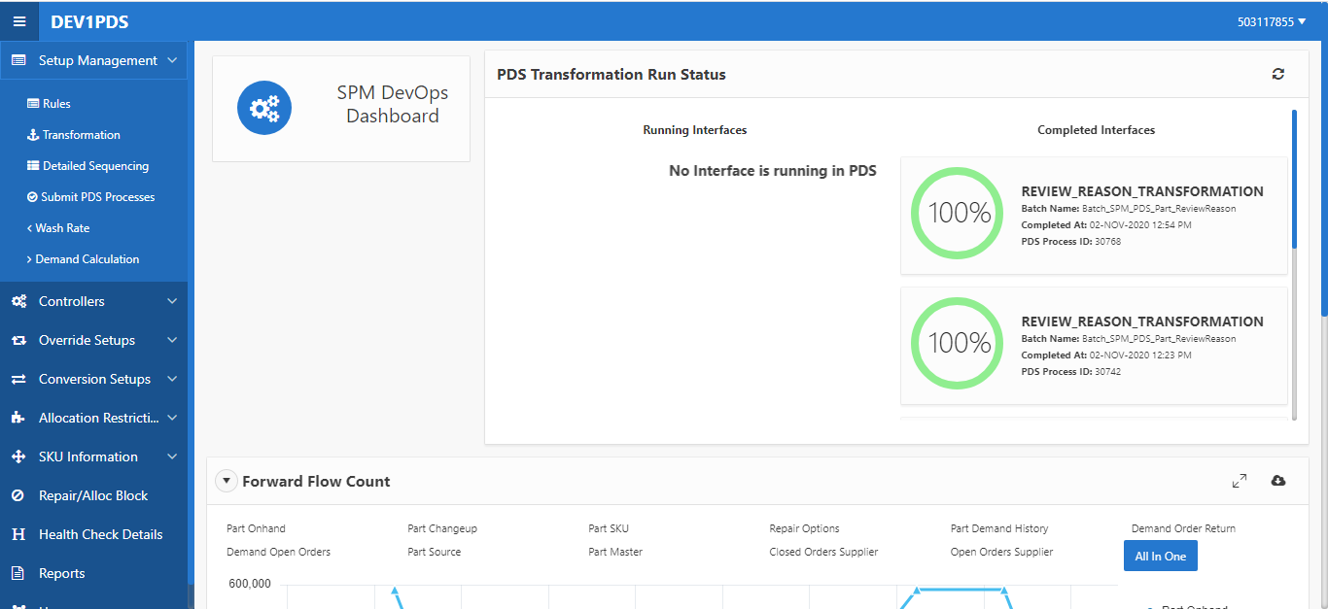

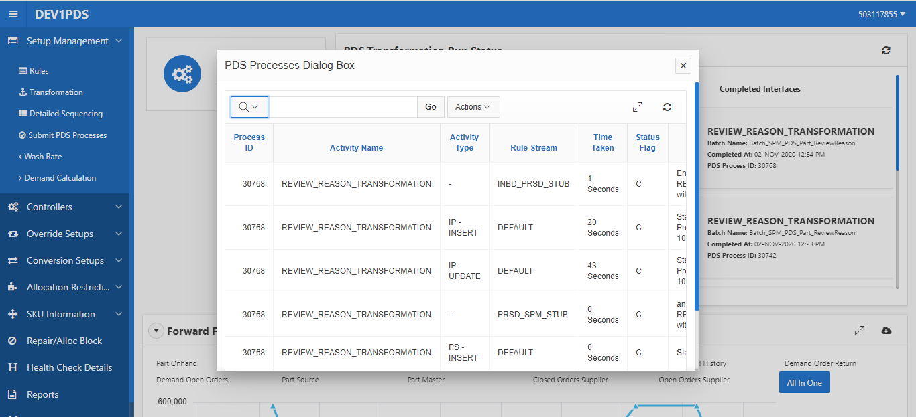

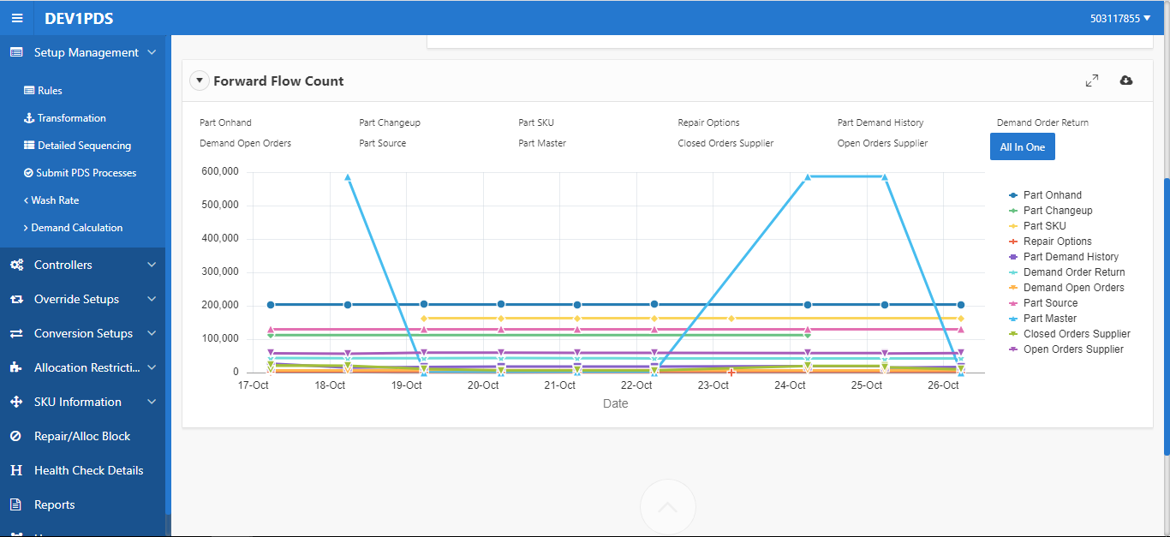

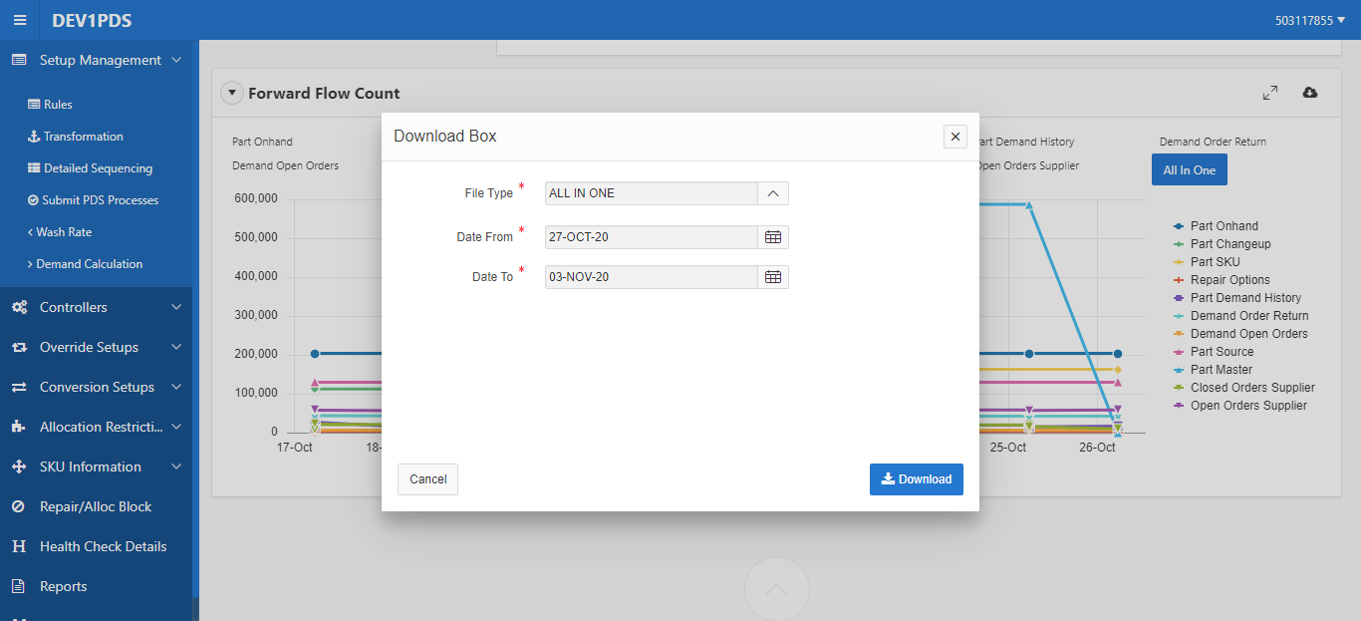

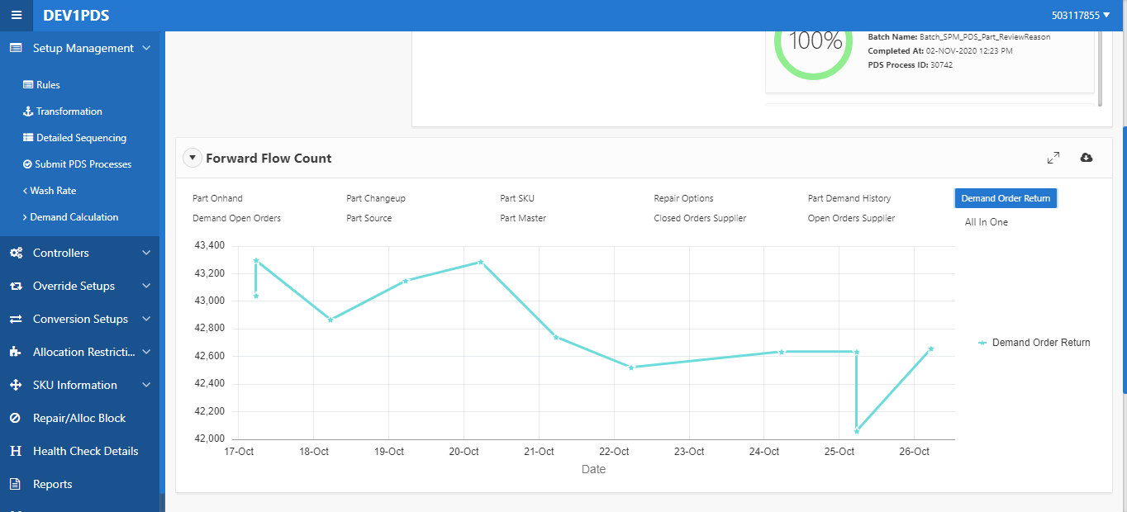

Planning Rules Management –

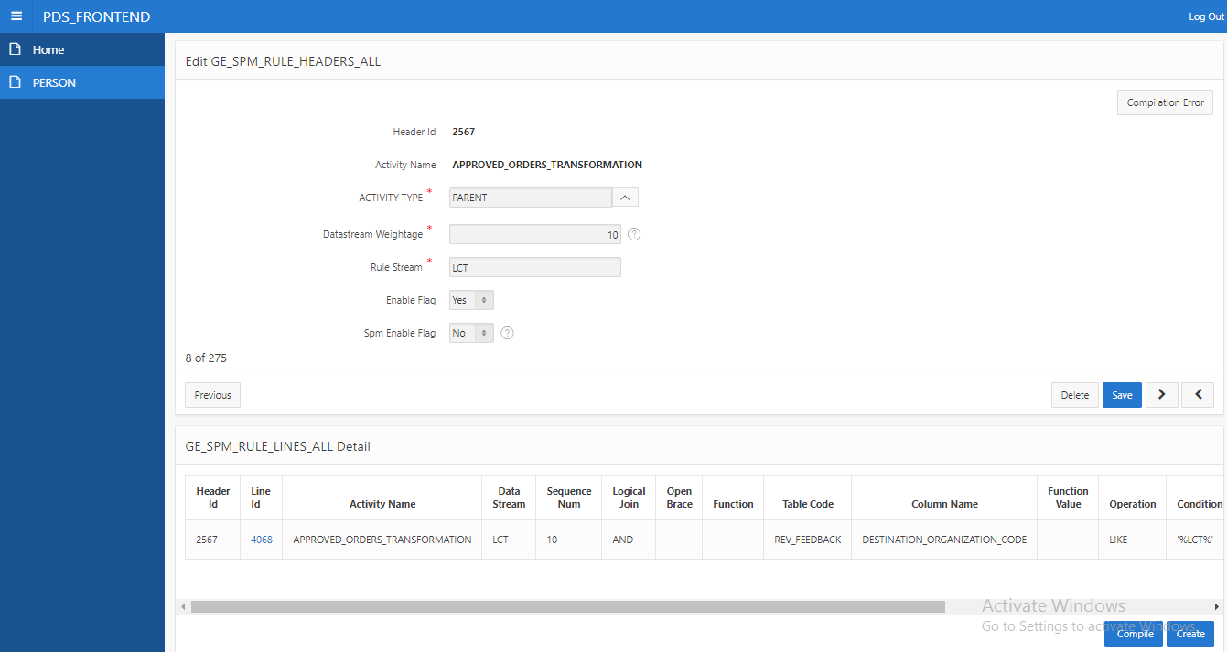

Transformation Management –

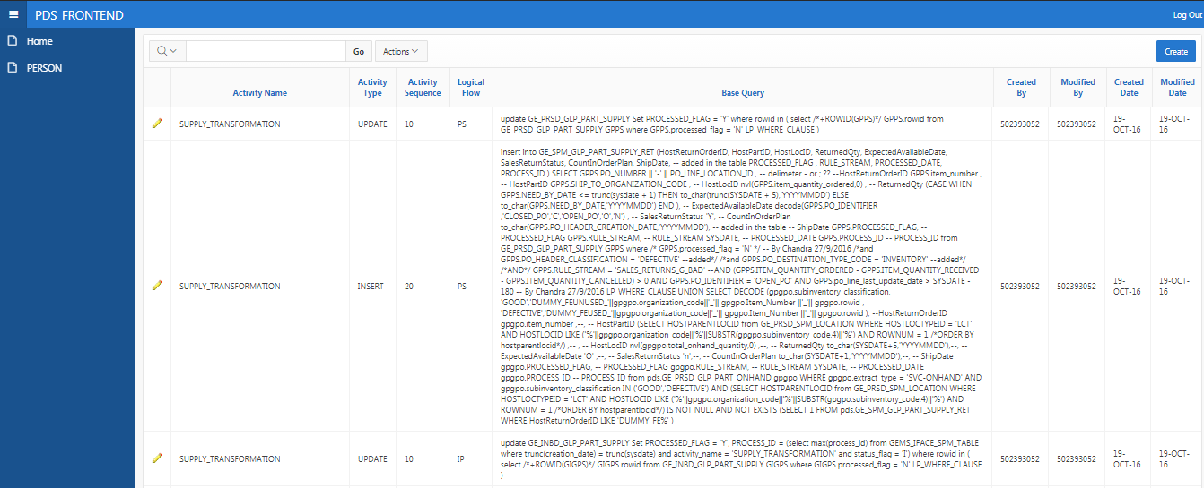

Archive Management –

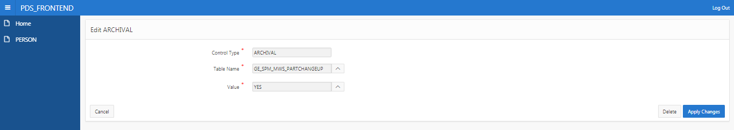

Debug Details Management –

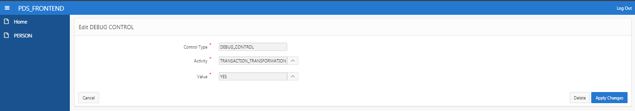

Purge Details Management –

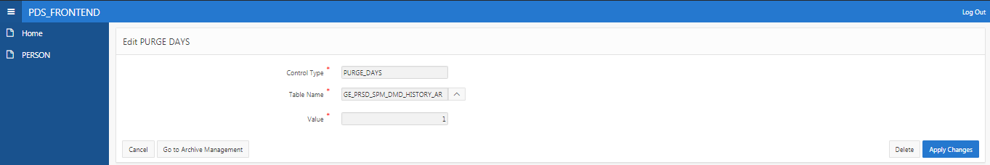

Reports –

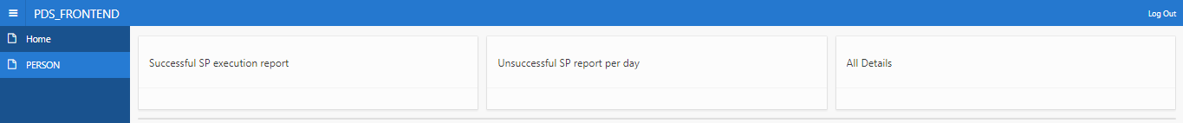

Wash Rate –



Demand Calculation –

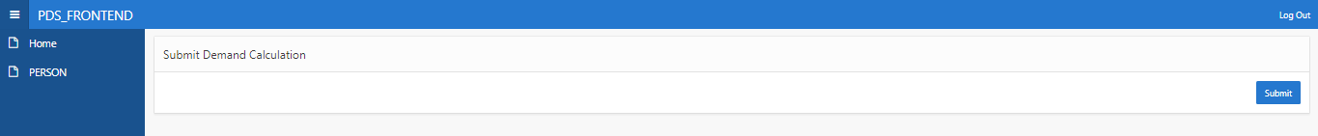

Demand Conversion Process Layout –

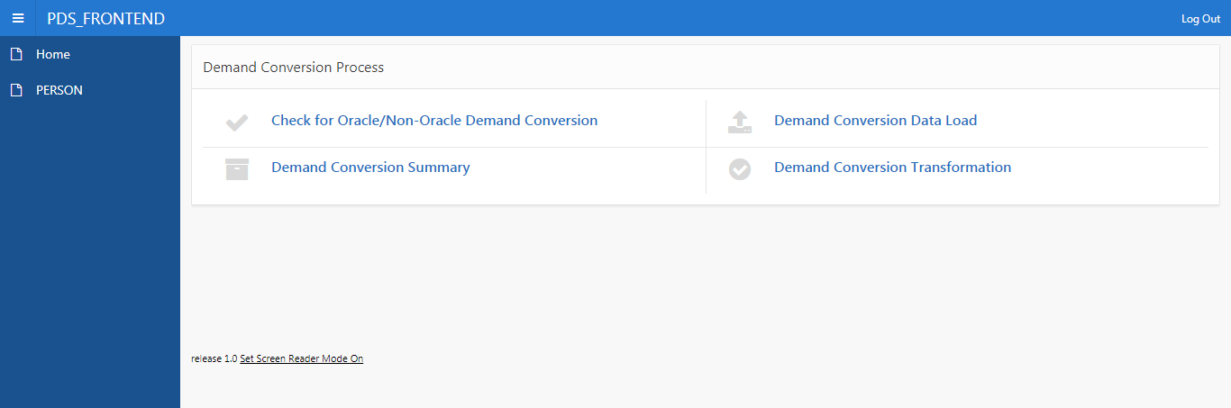

Supply Conversion Process Layout –

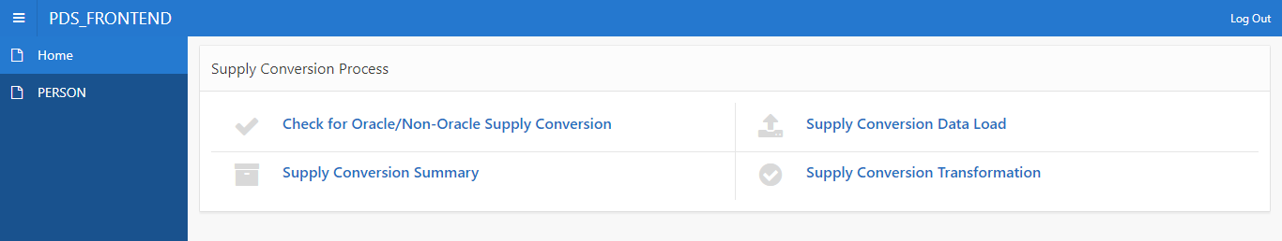

Repair and Allocation Block –

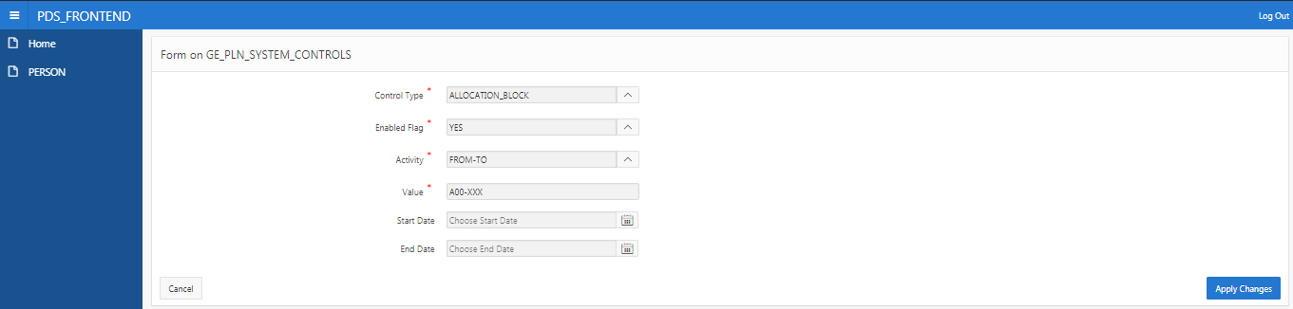

Planning Lookups Setup –

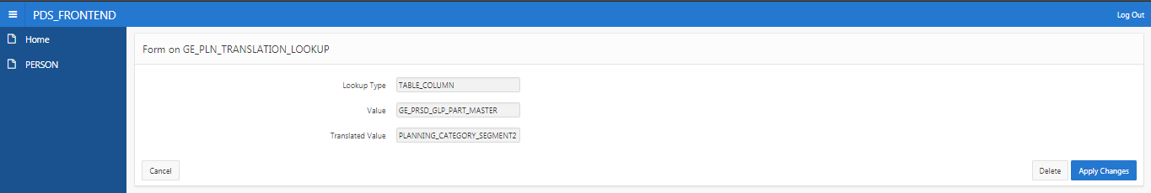

Process Control Setup –

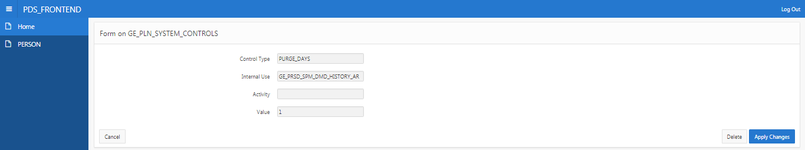

Transformation Alias Setup –

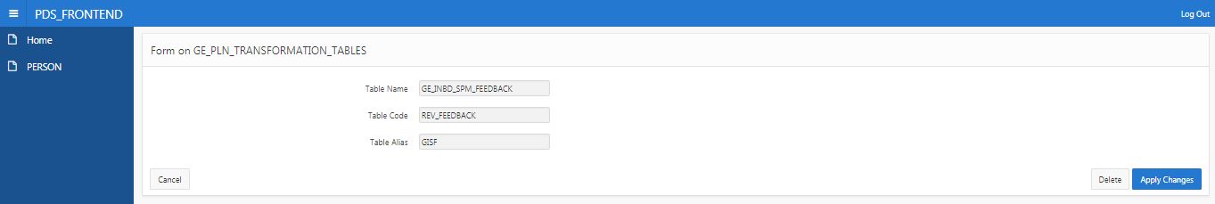

Transaction Conversion Process Layout –

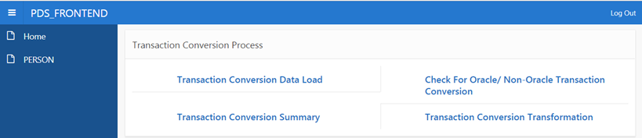

Wash Rate Override –

* + Go to Washrate Override

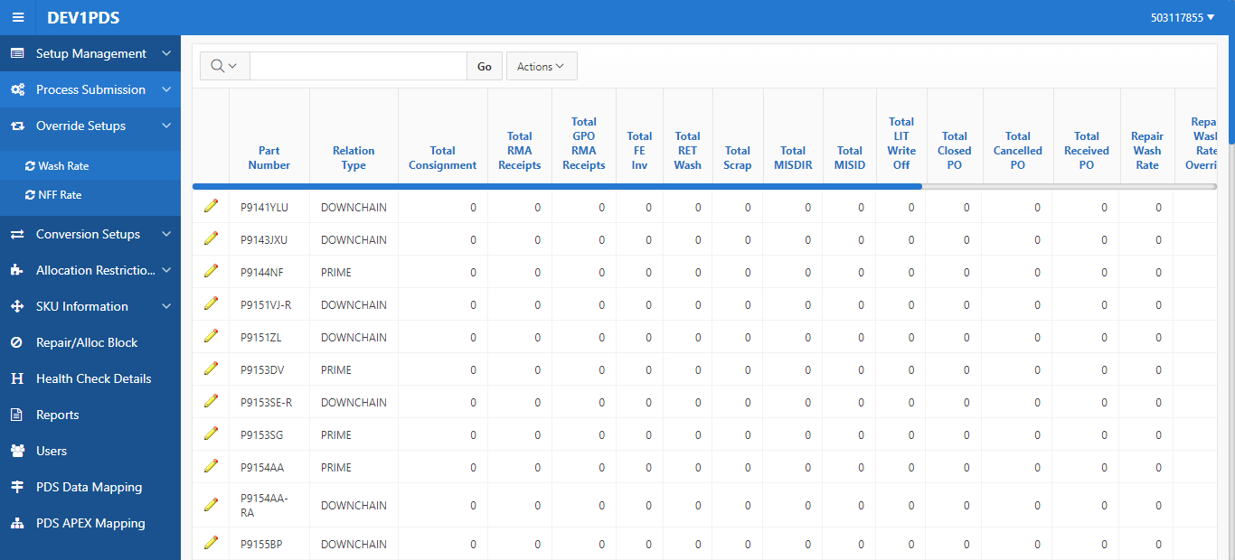

* + Select the Part-Location combination for which Override can be set, set the override value along with the date range and click on Apply changes :

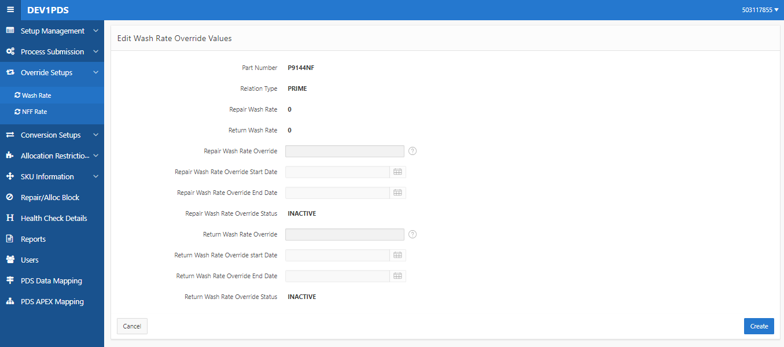

SKU Upload, Edit and NFF Rate

Detailed Transformation Sequencing

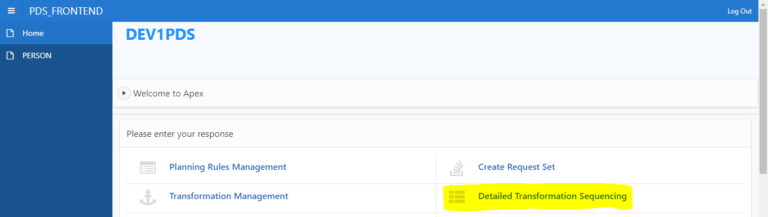

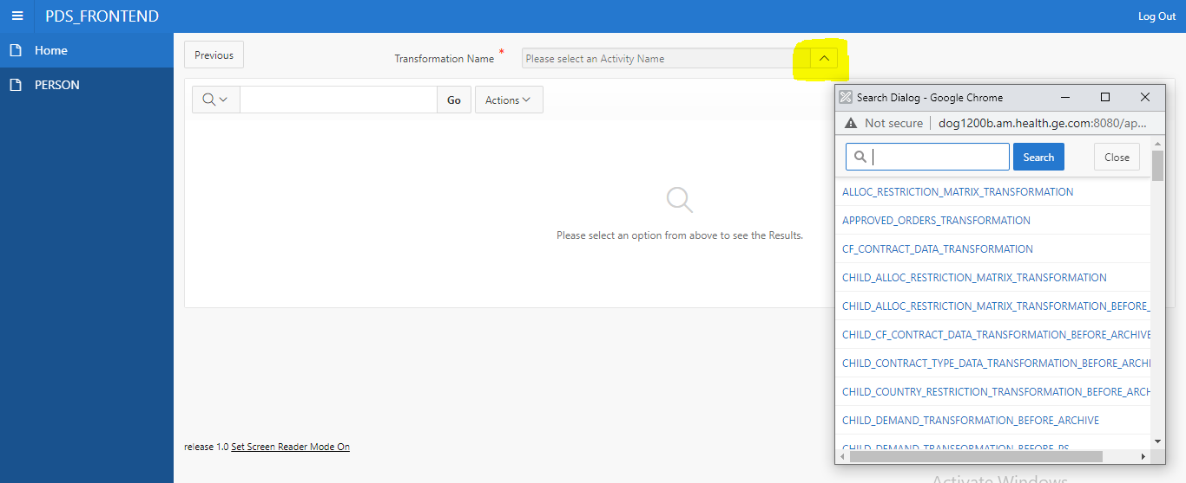

Reforming Apex Login

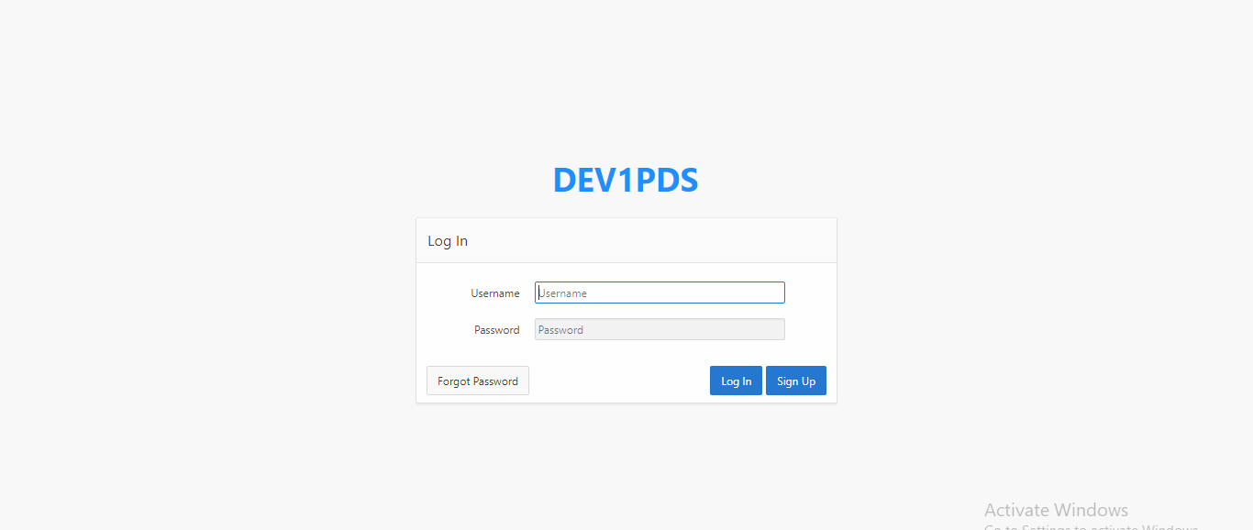

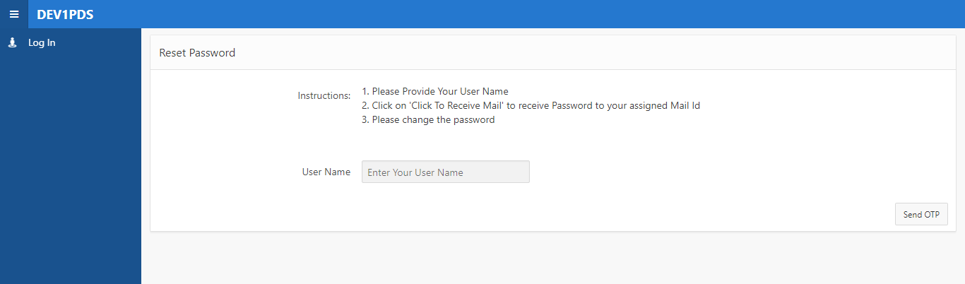

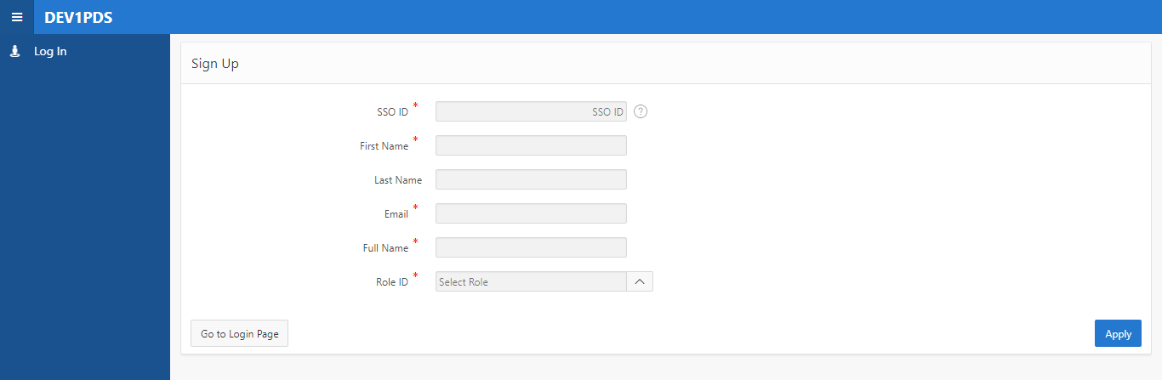

Automation of submission of Transformation in PDS through Apex

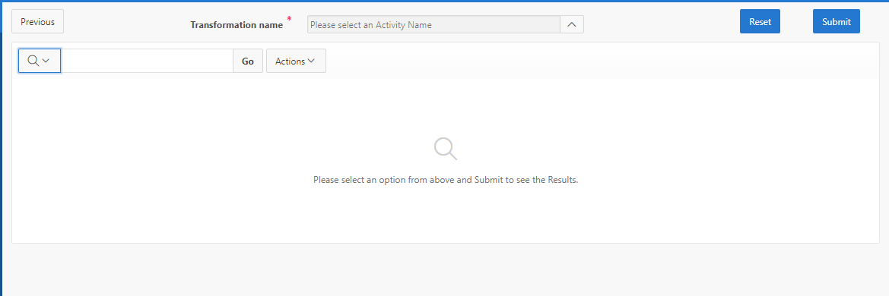

Order Plan DashBoard

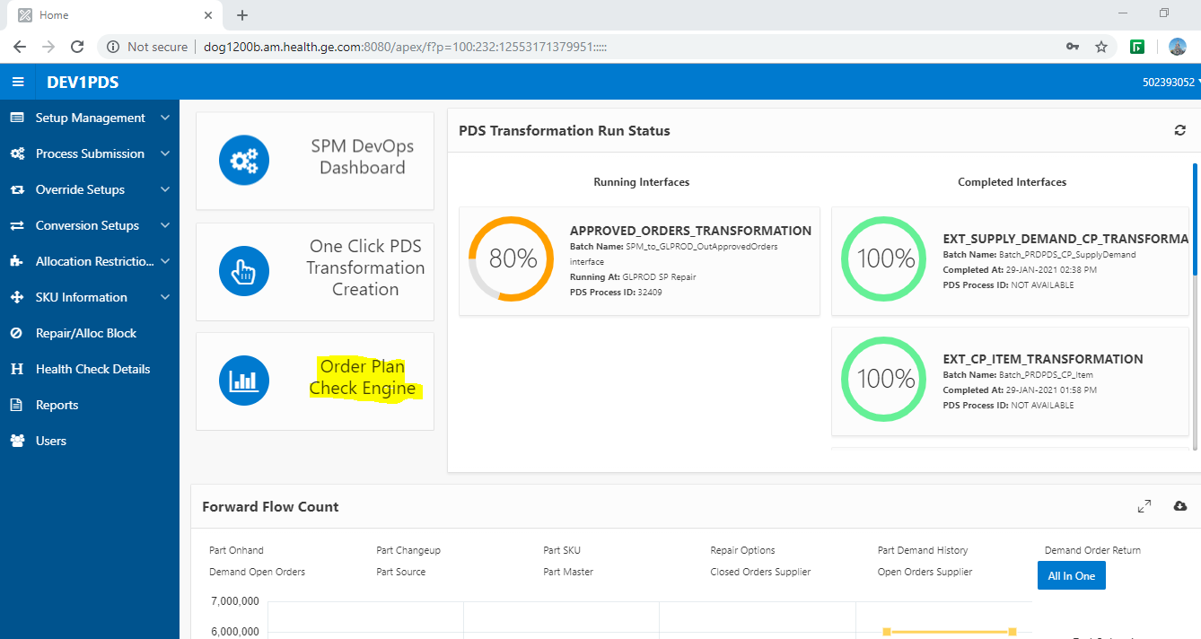

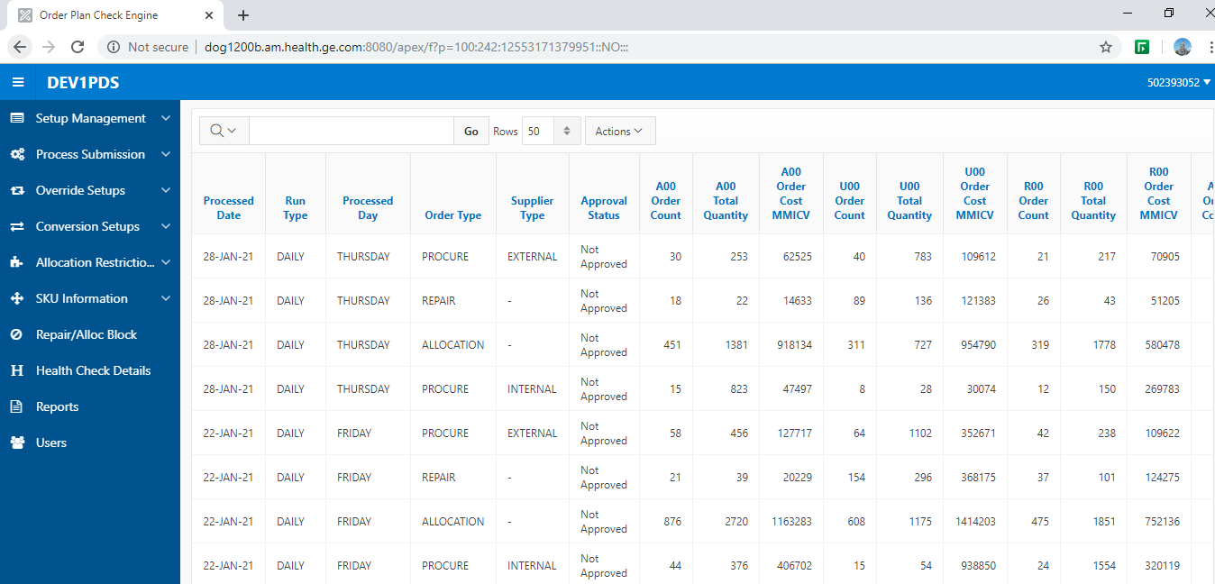

Part ChangeUp Data

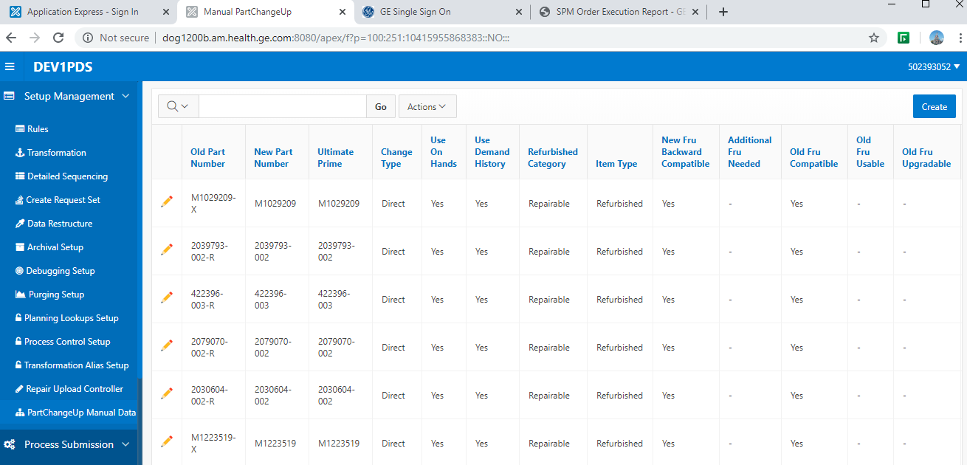

PDS Data Mapping –

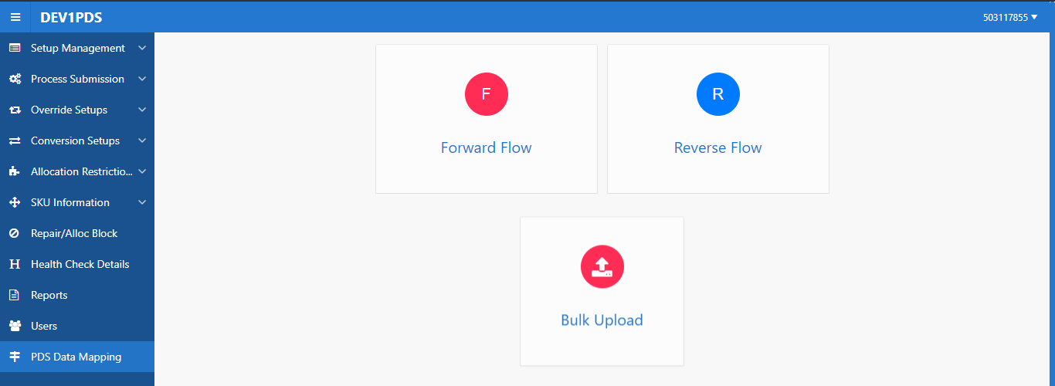

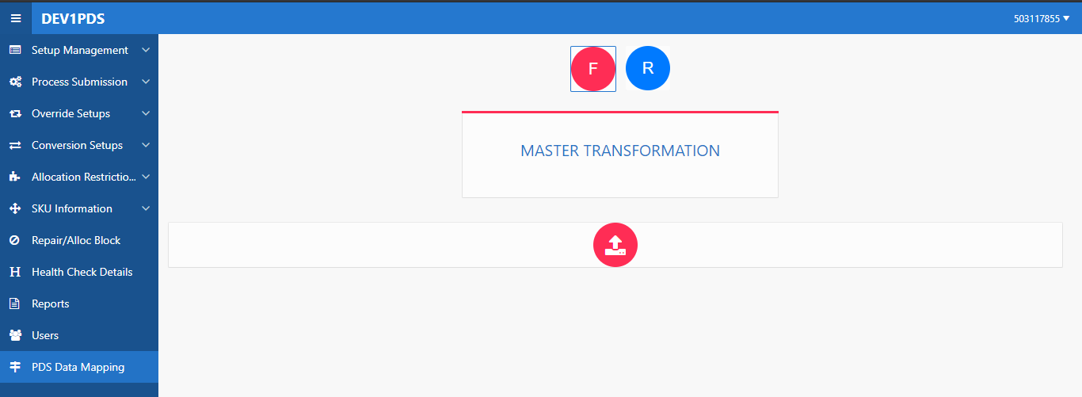

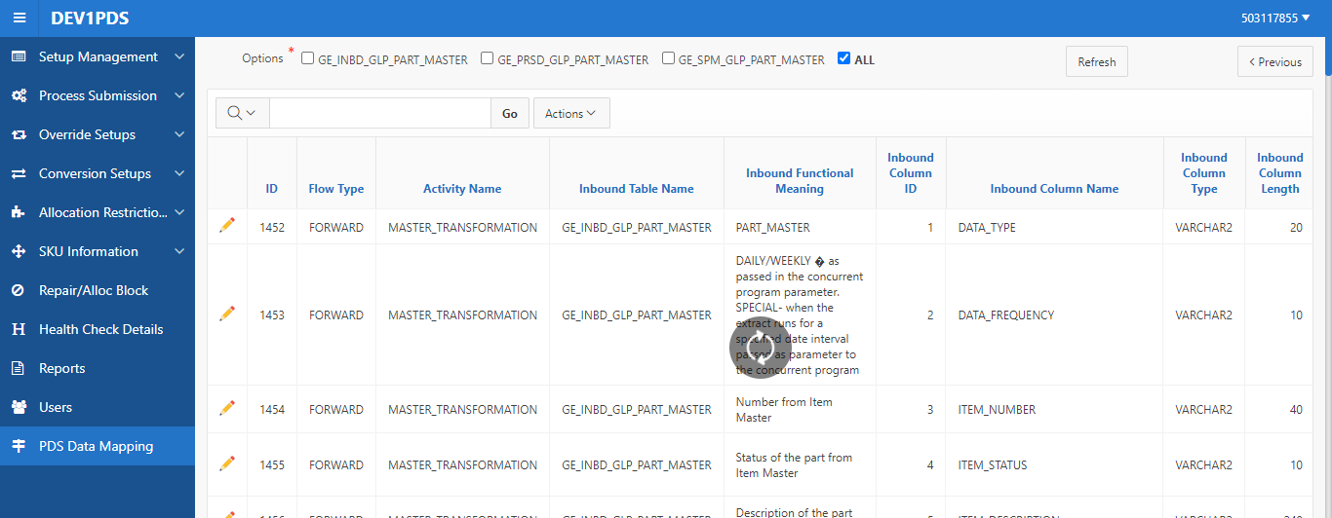

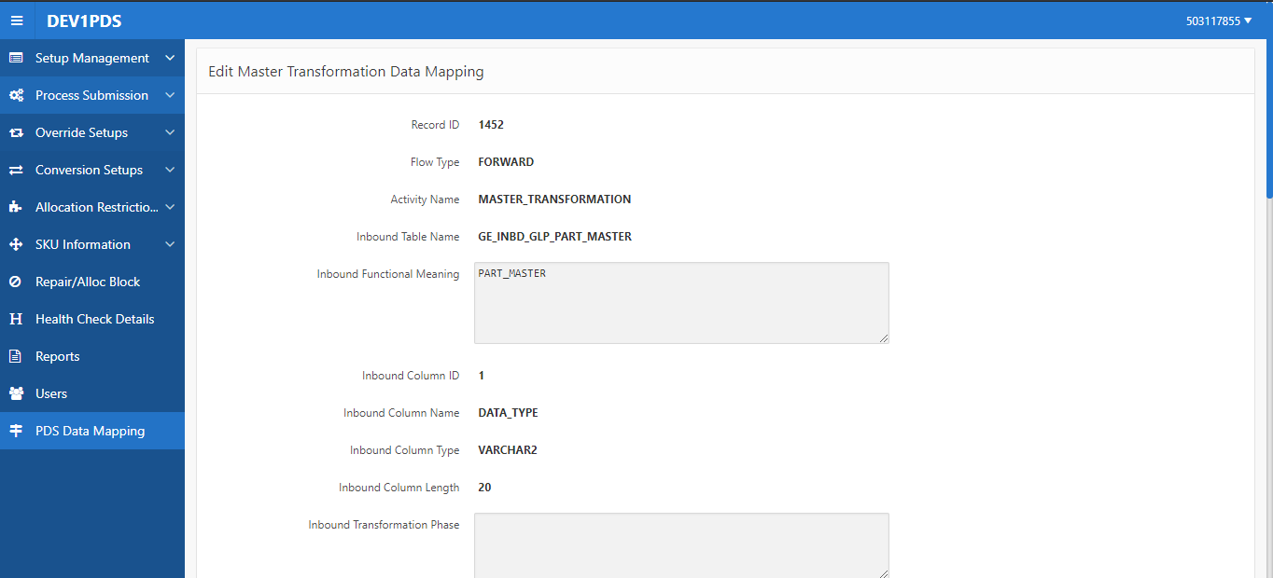

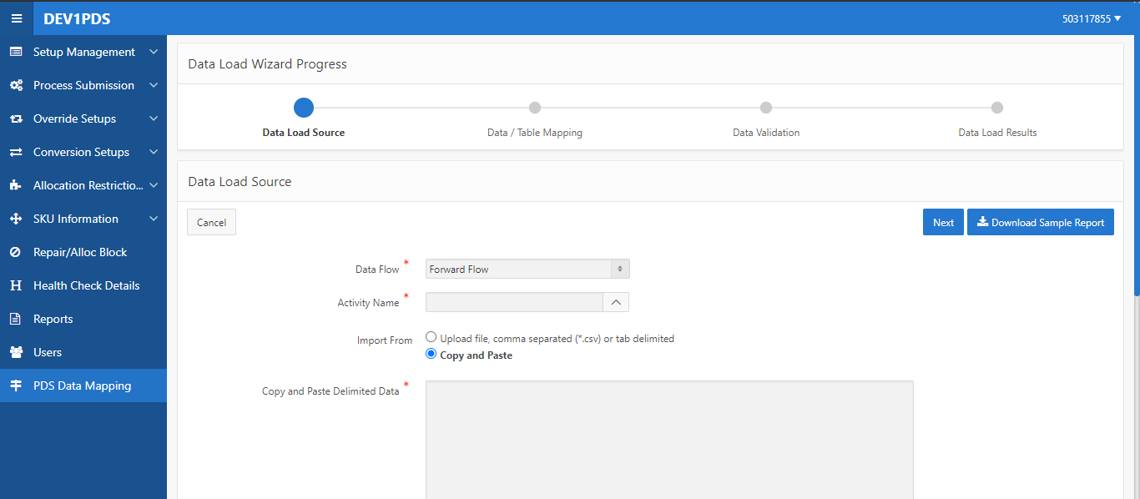

### Zones Definition

NA

### Tables and Objects

|  |  |  |  |
| --- | --- | --- | --- |
| **Source** | **Object Detail** | **Object Name** | **Object Name - Archive** |
| GLPROD Forward Flow | INBD\_TABLE | GE\_INBD\_GLP\_PART\_MASTER | GE\_INBD\_GLP\_PART\_MASTER\_AR |
| GLPROD Forward Flow | INBD\_TABLE | GE\_INBD\_GLP\_PART\_ONHAND | GE\_INBD\_GLP\_PART\_ONHAND\_AR |
| GLPROD Forward Flow | INBD\_TABLE | GE\_INBD\_GLP\_PART\_SOURCE | GE\_INBD\_GLP\_PART\_SOURCE \_AR |
| GLPROD Forward Flow | INBD\_TABLE | GE\_INBD\_GLP\_PART\_DEMAND | GE\_INBD\_GLP\_PART\_DEMAND\_AR |
| GLPROD Forward Flow | INBD\_TABLE | GE\_INBD\_GLP\_PART\_TXN | GE\_INBD\_GLP\_PART\_TXN\_AR |
| GLPROD Forward Flow | INBD\_TABLE | GE\_INBD\_GLP\_PART\_SUPPLY | GE\_INBD\_GLP\_PART\_SUPPLY\_AR |
| GLPROD Forward Flow | INBD\_TABLE | GE\_INBD\_GLP\_SPM\_FEEDBACK | GE\_INBD\_GLP\_SPM\_FEEDBACK\_AR |
| BI | INBD\_TABLE | GE\_INBD\_BI\_PRODUCT | GE\_INBD\_BI\_PRODUCT\_AR |
| BI | INBD\_TABLE | GE\_INBD\_BI\_PRODUCT\_BOM | GE\_INBD\_BI\_PRODUCT\_BOM\_AR |
| BI | INBD\_TABLE | GE\_INBD\_BI\_PRODUCT\_FR | GE\_INBD\_BI\_PRODUCT\_FR\_AR |
| BI | INBD\_TABLE | GE\_INBD\_BI\_PRODUCT\_ROLLOUT | GE\_INBD\_BI\_PRODUCT\_ROLLOUT\_AR |
| BI | INBD\_TABLE | GE\_INBD\_BI\_CONTRACT | GE\_INBD\_BI\_CONTRACT\_AR |
| BI | INBD\_TABLE | GE\_INBD\_BI\_CONTRACT\_TYPE | GE\_INBD\_BI\_CONTRACT\_TYPE\_AR |
| BI | INBD\_TABLE | GE\_INBD\_BI\_INSTALL\_SITE | GE\_INBD\_BI\_INSTALL\_SITE\_AR |
| BI | INBD\_TABLE | GE\_INBD\_BI\_PRODUCT\_CUSTOMER | GE\_INBD\_BI\_PRODUCT\_CUSTOMER\_AR |
| BI | INBD\_TABLE | GE\_INBD\_BI\_DEMAND\_LINK | GE\_INBD\_BI\_DEMAND\_LINK\_AR |
| BI | INBD\_TABLE | GE\_INBD\_BI\_PM\_ORDERS | GE\_INBD\_BI\_PM\_ORDERS\_AR |
| MWS | INBD\_TABLE | GE\_INBD\_MWS\_PARTCHANGEUP | GE\_INBD\_MWS\_PARTCHANGEUP\_AR |
| SPM Reverse Flow | INBD\_TABLE | GE\_INBD\_SPM\_FEEDBACK | GE\_INBD\_SPM\_FEEDBACK\_AR |
| SPM Reverse Flow | INBD\_TABLE | GE\_INBD\_SPM\_INTERNAL\_SUPPLIER | GE\_INBD\_SPM\_INT\_SUPPLIER\_AR |
| SPM Reverse Flow | INBD\_TABLE | GE\_INBD\_SPM\_EXT\_SUPPLIER\_ITEM | GE\_INBD\_SPM\_EXT\_SUP\_ITEM\_AR |
| SPM Reverse Flow | INBD\_TABLE | GE\_INBD\_SPM\_EXT\_SUPPLIER\_DMD | GE\_INBD\_SPM\_EXT\_SUP\_DMD\_AR |
| SPM Reverse Flow | INBD\_TABLE | GE\_INBD\_SPM\_DMD\_FORECAST | GE\_INBD\_SPM\_DMD\_FORECAST\_AR |
| SPM Reverse Flow | INBD\_TABLE | GE\_INBD\_SPM\_DMD\_HISTORY | GE\_INBD\_SPM\_DMD\_HISTORY\_AR |
| SPM Reverse Flow | INBD\_TABLE | GE\_INBD\_SPM\_HIERARCHY | GE\_INBD\_SPM\_HIERARCHY\_AR |
| SPM Reverse Flow | INBD\_TABLE | GE\_INBD\_SPM\_PLN\_LVL | GE\_INBD\_SPM\_PLN\_LVL\_AR |
| SPM Reverse Flow | INBD\_TABLE | GE\_INBD\_SPM\_LOCATION | GE\_INBD\_SPM\_LOCATION\_AR |
| GLPROD Forward Flow | PRSD\_TABLE | GE\_PRSD\_GLP\_PART\_MASTER | GE\_PRSD\_GLP\_PART\_MASTER\_AR |
| GLPROD Forward Flow | PRSD\_TABLE | GE\_PRSD\_GLP\_PART\_ONHAND | GE\_PRSD\_GLP\_PART\_ONHAND\_AR |
| GLPROD Forward Flow | PRSD\_TABLE | GE\_PRSD\_GLP\_PART\_SOURCE | GE\_PRSD\_GLP\_PART\_SOURCE\_AR |
| GLPROD Forward Flow | PRSD\_TABLE | GE\_PRSD\_GLP\_PART\_DEMAND | GE\_PRSD\_GLP\_PART\_DEMAND\_AR |
| GLPROD Forward Flow | PRSD\_TABLE | GE\_PRSD\_GLP\_PART\_TXN | GE\_PRSD\_GLP\_PART\_TXN\_AR |
| GLPROD Forward Flow | PRSD\_TABLE | GE\_PRSD\_GLP\_PART\_SUPPLY | GE\_PRSD\_GLP\_PART\_SUPPLY\_AR |
| GLPROD Forward Flow | PRSD\_TABLE | GE\_PRSD\_GLP\_SPM\_FEEDBACK | GE\_PRSD\_GLP\_SPM\_FEEDBACK\_AR |
| BI | PRSD\_TABLE | GE\_PRSD\_BI\_PRODUCT | GE\_PRSD\_BI\_PRODUCT\_AR |
| BI | PRSD\_TABLE | GE\_PRSD\_BI\_PRODUCT\_BOM | GE\_PRSD\_BI\_PRODUCT\_BOM\_AR |
| BI | PRSD\_TABLE | GE\_PRSD\_BI\_PRODUCT\_FR | GE\_PRSD\_BI\_PRODUCT\_FR\_AR |
| BI | PRSD\_TABLE | GE\_PRSD\_BI\_PRODUCT\_ROLLOUT | GE\_PRSD\_BI\_PRODUCT\_ROLLOUT\_AR |
| BI | PRSD\_TABLE | GE\_PRSD\_BI\_CONTRACT | GE\_PRSD\_BI\_CONTRACT\_AR |
| BI | PRSD\_TABLE | GE\_PRSD\_BI\_CONTRACT\_TYPE | GE\_PRSD\_BI\_CONTRACT\_TYPE\_AR |
| BI | PRSD\_TABLE | GE\_PRSD\_BI\_INSTALL\_SITE | GE\_PRSD\_BI\_INSTALL\_SITE\_AR |
| BI | PRSD\_TABLE | GE\_PRSD\_BI\_PRODUCT\_CUSTOMER | GE\_PRSD\_BI\_PRODUCT\_CUSTOMER\_AR |
| BI | PRSD\_TABLE | GE\_PRSD\_BI\_DEMAND\_LINK | GE\_PRSD\_BI\_DEMAND\_LINK\_AR |
| BI | PRSD\_TABLE | GE\_PRSD\_BI\_PM\_ORDERS | GE\_PRSD\_BI\_PM\_ORDERS\_AR |
| MWS | PRSD\_TABLE | GE\_PRSD\_MWS\_PARTCHANGEUP | GE\_PRSD\_MWS\_PARTCHANGEUP\_AR |
| SPM Reverse Flow | PRSD\_TABLE | GE\_PRSD\_SPM\_FEEDBACK | GE\_PRSD\_SPM\_FEEDBACK\_AR |
| SPM Reverse Flow | PRSD\_TABLE | GE\_PRSD\_SPM\_INTERNAL\_SUPPLIER | GE\_INBD\_SPM\_INT\_SUPPLIER\_AR |
| SPM Reverse Flow | PRSD\_TABLE | GE\_PRSD\_SPM\_EXT\_SUPPLIER\_ITEM | GE\_PRSD\_SPM\_EXT\_SUP\_ITEM\_AR |
| SPM Reverse Flow | PRSD\_TABLE | GE\_PRSD\_SPM\_EXT\_SUPPLIER\_DMD | GE\_PRSD\_SPM\_EXT\_SUP\_DMD\_AR |
| SPM Reverse Flow | PRSD\_TABLE | GE\_PRSD\_SPM\_DMD\_FORECAST | GE\_PRSD\_SPM\_DMD\_FORECAST\_AR |
| SPM Reverse Flow | PRSD\_TABLE | GE\_PRSD\_SPM\_DMD\_HISTORY | GE\_PRSD\_SPM\_DMD\_HISTORY\_AR |
| SPM Reverse Flow | PRSD\_TABLE | GE\_PRSD\_SPM\_HIERARCHY | GE\_PRSD\_SPM\_HIERARCHY\_AR |
| SPM Reverse Flow | PRSD\_TABLE | GE\_PRSD\_SPM\_PLN\_LVL | GE\_PRSD\_SPM\_PLN\_LVL\_AR |
| SPM Reverse Flow | PRSD\_TABLE | GE\_PRSD\_SPM\_LOCATION | GE\_PRSD\_SPM\_LOCATION\_AR |
| GLPROD Forward Flow | SPM\_TABLE | GE\_SPM\_GLP\_PART\_MASTER | GE\_SPM\_GLP\_PART\_MASTER\_AR |
| GLPROD Forward Flow | SPM\_TABLE | GE\_SPM\_GLP\_PART\_ONHAND | GE\_SPM\_GLP\_PART\_ONHAND\_AR |
| GLPROD Forward Flow | SPM\_TABLE | GE\_SPM\_GLP\_PART\_SOURCE | GE\_SPM\_GLP\_PART\_SOURCE\_AR |
| GLPROD Forward Flow | SPM\_TABLE | GE\_SPM\_GLP\_PART\_DEMAND\_HST | GE\_SPM\_GLP\_PART\_DEMAND\_HST\_AR |
| GLPROD Forward Flow | SPM\_TABLE | GE\_SPM\_GLP\_PART\_DEMAND\_OPEN | GE\_SPM\_GLP\_PART\_DEMAND\_OPEN\_AR |
| GLPROD Forward Flow | SPM\_TABLE | GE\_SPM\_GLP\_PART\_SUPPLY\_RET | GE\_SPM\_GLP\_PART\_SUPPLY\_RET\_AR |
| GLPROD Forward Flow | SPM\_TABLE | GE\_SPM\_GLP\_OPEN\_PO | GE\_SPM\_GLP\_OPEN\_PO\_AR |
| GLPROD Forward Flow | SPM\_TABLE | GE\_SPM\_GLP\_CLOSED\_PO | GE\_SPM\_GLP\_CLOSED\_PO\_AR |
| BI | SPM\_TABLE | GE\_SPM\_BI\_PRODUCT | GE\_SPM\_BI\_PRODUCT\_AR |
| BI | SPM\_TABLE | GE\_SPM\_BI\_PRODUCT\_BOM | GE\_SPM\_BI\_PRODUCT\_BOM\_AR |
| BI | SPM\_TABLE | GE\_SPM\_BI\_PRODUCT\_ROLLOUT | GE\_SPM\_BI\_PRODUCT\_ROLLOUT\_AR |
| BI | SPM\_TABLE | GE\_SPM\_BI\_CONTRACT | GE\_SPM\_BI\_CONTRACT\_AR |
| BI | SPM\_TABLE | GE\_SPM\_BI\_CONTRACT\_TYPE | GE\_SPM\_BI\_CONTRACT\_TYPE\_AR |
| BI | SPM\_TABLE | GE\_SPM\_BI\_INSTALL\_SITE | GE\_SPM\_BI\_INSTALL\_SITE\_AR |
| MWS | SPM\_TABLE | GE\_SPM\_MWS\_PARTCHANGEUP | GE\_SPM\_MWS\_PARTCHANGEUP\_AR |
| SPM Reverse Flow | SPM\_TABLE | GE\_SPM\_GLP\_FEEDBACK | GE\_SPM\_GLP\_FEEDBACK\_AR |
| SPM Reverse Flow | SPM\_TABLE | GE\_SPM\_GLP\_INTERNAL\_SUPPLIER | GE\_SPM\_GLP\_INT\_SUPPLIER\_AR |
| SPM Reverse Flow | SPM\_TABLE | GE\_SPM\_GLP\_EXT\_SUPPLIER\_ITEM | GE\_SPM\_GLP\_EXT\_SUP\_ITEM\_AR |
| SPM Reverse Flow | SPM\_TABLE | GE\_SPM\_GLP\_EXT\_SUPPLIER\_DMD | GE\_SPM\_GLP\_EXT\_SUP\_DMD\_AR |
| PDS | PACKAGE | GE\_IFACE\_SPM\_DETAILS | NA |
| PDS | PACKAGE | GE\_INBD\_PRSD\_STUB | NA |
| PDS | PACKAGE | GE\_MW\_INTF\_UTIL | NA |
| PDS | PACKAGE | GE\_PLN\_TRANSFORMATION | NA |
| PDS | PACKAGE | GE\_PLN\_TRANSFORMATION\_CALL | NA |
| PDS | PACKAGE | GE\_PLN\_TRANSFORMATION\_MAIN | NA |
| PDS | PACKAGE | GE\_PLN\_TRANSFORMATIONS | NA |
| PDS | PACKAGE | GE\_PRSD\_SPM\_STUB | NA |
| PDS | PACKAGE | GE\_REIMAGING\_EXECUTION | NA |
| PDS | PACKAGE | GE\_SPM\_STUB | NA |
| PDS | PACKAGE | GE\_SPM\_STUB\_LOGIC | NA |
| PDS | PACKAGE | GE\_VALIDATION\_PROCESS | NA |
| PDS | PLN\_Table | GE\_PLN\_TRANSFORMATION\_TABLES | NA |
| PDS | PLN\_Table | GE\_PLN\_TRANSFORMATION\_BASE\_DTL | NA |
| PDS | PLN\_Table | GE\_PLN\_TRANSFORMATION\_EXEC\_DTL | NA |
| PDS | PLN\_Table | GEMS\_IFACE\_SPM\_TABLE | NA |
| PDS | PLN\_Table | GE\_SPM\_RULE\_HEADERS\_ALL | NA |
| PDS | PLN\_Table | GE\_SPM\_RULE\_LINES\_ALL | NA |
| PDS | PLN\_Table | GE\_PLN\_TRANSLATION\_LOOKUP | NA |
| PDS | PLN\_Table | demand\_lastyear | NA |
| PDS | PLN\_Table | demand\_secondlastyear | NA |
| PDS | PLN\_Table | GE\_ITEM\_DEMAND\_HISTORY | NA |
| PDS | PLN\_Table | GE\_ITEM\_DEMAND\_HISTORY\_LCT | NA |
| PDS | PLN\_Table | GE\_ITEM\_DEMAND\_HISTORY\_DMD | NA |
| PDS | PLN\_Table | GE\_ITEM\_DEMAND\_HISTORY\_SHIP | NA |
| PDS | PLN\_Table | GE\_PRSD\_MWS\_PARTCHANGEUP\_REF | NA |
| PDS | PLN\_Table | GE\_CUMULATIVE\_WASH\_RATES | NA |
| PDS | PLN\_Table | GE\_PRSD\_BI\_PRODUCT\_ROLLOUT\_REF | NA |
| PDS | PLN\_Table | GE\_PRSD\_BI\_PRODUCT\_BOM\_REF | NA |
| PDS | PLN\_Table | GE\_IFACE\_SPM\_RESTART\_MW | NA |
| PDS | PLN\_Table | GEMS\_MW\_IFACE\_LOG\_IT\_TBL | NA |
| PDS | PLN\_Table | GEMS\_IFACE\_SPM\_TABLE\_DETAILS | NA |
| PDS | PLN\_Table | GE\_PRSD\_BI\_PRODUCT\_BOM\_REF | NA |
| Demand Data Conversion | Staging Table | GE\_DEMAND\_CONV\_STAGING\_TABLE | NA |
| Demand Data Conversion | Interface Table | GE\_DEMAND\_CONV\_INTERFACE\_TABLE | NA |
| Demand Data Conversion | Error Table | GE\_DMD\_CONV\_INTRFC\_ERR\_TABLE | NA |
| Demand Data Conversion | Snapshot Table | GE\_DMD\_CONV\_SNAPSHOT | NA |
| Demand Data Conversion | INBD Table | DEMAND\_CONV\_INBD\_TABLE | DEMAND\_CONV\_INBD\_TABLE\_AR |
| Demand Data Conversion | PRSD Table | DEMAND\_CONV\_PRSD\_TABLE | DEMAND\_CONV\_PRSD\_TABLE\_AR |
| PM Order Transformation Table | INBD Table created to accommodate the ServiceMax PM Order Data. (Since ServiceMax Data does not interface into BI, data from this table along with GE\_INBD\_BI\_PM\_ORDERS must be considered for PM Order Transformation) | GE\_INBD\_SERVICE\_MAX\_PM\_ORDERS | NA |
| SKU Transformation | INBD Table | GE\_INBD\_SKU\_TRANSFORMATION | GE\_INBD\_SKU\_TRANSFORMATION\_AR |
| SKU Transformation | PRSD Table | GE\_PRSD\_SKU\_TRANSFORMATION | GE\_PRSD\_SKU\_TRANSFORMATION\_AR |
| SKU Transformation | SPM table | GE\_SPM\_SKU\_TRANSFORMATION | GE\_SPM\_SKU\_TRANSFORMATION\_AR |
| Order Plan Transformation | INBD Table | GE\_INBD\_PLAN\_ORDER | GE\_INBD\_PLAN\_ORDER\_AR |
| Order Plan Transformation | PRSD Table | GE\_PRSD\_PLAN\_ORDER | GE\_PRSD\_PLAN\_ORDER\_AR |
| Onhand Balances Transformation | INBD Table | GE\_INBD\_SPM\_ONHAND\_BALANCE | GE\_INBD\_SPM\_ONHAND\_BALANCE\_AR |
| Onhand Balances Transformation | PRSD Table | GE\_PRSD\_SPM\_ONHAND\_BALANCE | GE\_PRSD\_SPM\_ONHAND\_BALANCE\_AR |
| SPM Review Reason Transformation | INBD Table | GE\_INBD\_SPM\_REVIEW\_REASON | GE\_INBD\_SPM\_REVIEW\_REASON\_AR |
| SPM Review Reason Transformation | PRSD Table | GE\_PRSD\_SPM\_REVIEW\_REASON | GE\_PRSD\_SPM\_REVIEW\_REASON\_AR |
| Allocation Restriction Matrix Transformation | INBD Table | GE\_INBD\_ALLOC\_RESTRICT\_MATRIX | GE\_INBD\_ALLC\_RESTRCT\_MATRIX\_AR |
| Allocation Restriction Matrix Transformation | PRSD Table | GE\_PRSD\_ALLOC\_RESTRICT\_MATRIX | GE\_PRSD\_ALLC\_RESTRCT\_MATRIX\_AR |
| Allocation Restriction Matrix Transformation | SPM Table | GE\_SPM\_ALLOC\_RESTRICT\_MATRIX | GE\_SPM\_ALLC\_RESTRCT\_MATRIX\_AR |
| Transaction Data Conversion | Staging Table | GE\_TXN\_CONV\_STAGING\_TABLE | NA |
| Transaction Data Conversion | Interface Table | GE\_TXN\_CONV\_INTERFACE\_TABLE | NA |
| Transaction Data Conversion | Error Table | GE\_DMD\_CONV\_INTRFC\_ERR\_TABLE | NA |
| Transaction Data Conversion | Snapshot Table | GE\_TXN\_CONV\_SNAPSHOT | NA |
| Transaction Data Conversion | INBD Table | GE\_INBD\_GLP\_PART\_TXN\_CONV | GE\_INBD\_GLP\_PART\_TXN\_CONV\_AR |
| Transaction Data Conversion | PRSD Table | GE\_PRSD\_GLP\_PART\_TXN\_CONV | GE\_PRSD\_GLP\_PART\_TXN\_CONV\_AR |
| Collaborative Planning Item Transformation | INBD Table | GE\_INBD\_ITEM\_CP | GE\_INBD\_ITEM\_CP\_AR |
| Collaborative Planning Item Transformation | PRSD Table | GE\_PRSD\_ITEM\_CP | GE\_PRSD\_ITEM\_CP\_AR |
| Collaborative Planning Item Transformation | Outbound Table | GE\_SPM\_ITEM\_CP | GE\_SPM\_ITEM\_CP\_AR |
| Collaborative Planning Supply Transformation | INBD Table | GE\_INBD\_SUP\_DMD\_CP | GE\_INBD\_SUP\_DMD\_CP\_AR |
| Collaborative Planning Supply Transformation | PRSD Table | GE\_PRSD\_SUP\_DMD\_CP | GE\_PRSD\_SUP\_DMD\_CP\_AR |
| Collaborative Planning Supply Transformation | Outbound Table | GE\_SPM\_SUP\_DMD\_CP | GE\_SPM\_SUP\_DMD\_CP\_AR |
| NFF Rate Calculation | NFF Interface Table | GE\_NFF\_RATE\_INTERFACE | NA |
| NFF Rate Override | NFF Override Table | GE\_NFF\_RATE\_OVERRIDE | NA |
| NFF Rate Details | NFF Rate Table | GE\_NFF\_RATES\_DETAILS | NA |
| SKU Information | SKU Information Table | GE\_PART\_SKU\_INFORMATION | NA |
| SKU Interface | SKU Interface Table | GE\_PART\_SKU\_INTERFACE | NA |
| Wash Rate Override | Wash Rate Override Table | GE\_WASH\_RATE\_OVERRIDE | NA |
| Block Exclude SCS | Block Exclude SCS Table | GE\_SCS\_OAO\_REFERENCE | NA |
| GLPROD Country Restriction Matrix | Inbound Table | GE\_INBD\_ITCS\_CNTRY\_REST\_MATRIX | GE\_INBD\_ITCS\_CNTRY\_MATRIX\_AR |
| GLPROD Country Restriction Matrix | PRSD Table | GE\_PRSD\_ITCS\_CNTRY\_REST\_MATRIX | GE\_PRSD\_ITCS\_CNTRY\_MATRIX\_AR |
| GLPROD Country Restriction Matrix | Outbound Table | GE\_SPM\_ITCS\_CNTRY\_REST\_MATRIX | GE\_SPM\_ITCS\_CNTRY\_MATRIX\_AR |
| SMR Table | SMR Table | GE\_GPO\_SPM\_MASTER\_DATA | GE\_GPO\_SPM\_MASTER\_DATA\_AR |
| Wash Rate Analysis Table | Wash Rate Analysis Table | GE\_PLN\_WASH\_RATE\_TXN | NA |
| Wash Rate Analysis Table | Wash Rate Analysis Table | GE\_PLN\_WASH\_RATE\_SUPPLY | NA |
| HealthCheck | HealthCheck | GE\_HEALTHCHECK\_EXTRACTS\_APEX | NA |
| HealthCheck | HealthCheck | GE\_HEALTHCHECK\_SNAPSHOT | NA |
| HealthCheck | HealthCheck | GE\_HEALTHCHECK\_EXTRACTS | NA |
| HealthCheck | HealthCheck | GE\_THRESHOLD\_TABLE | NA |
| HealthCheck | HealthCheck | GE\_PDS\_MAIL\_SETTINGS | NA |
| HealthCheck | HealthCheck | GE\_HC\_LIMIT\_TABLE | NA |
| HealthCheck | HealthCheck | GE\_HEALTHCHECK\_HEADERS\_ALL | NA |
| HealthCheck | HealthCheck | GE\_HEALTHCHECK\_LINES\_ALL | NA |
| HealthCheck | HealthCheck | GE\_HEALTHCHECK\_EXEC\_DTL | NA |
| Supply Data Conversion | Staging Table | GE\_APEX\_STG\_SUPPLY\_CONV | NA |
| Supply Data Conversion | Interface Table | GE\_IFACE\_SUPPLY\_CONV | NA |
| Supply Data Conversion | Error Table | GE\_IFACE\_ERR\_SUPPLY\_CONV | NA |
| Supply Data Conversion | Snapshot Table | GE\_SNAPSHOT\_SUPPLY\_CONV | NA |
| Supply Data Conversion | INBD Table | GE\_INBD\_GLP\_PART\_SUPPLY\_CONV | NA |
| Supply Data Conversion | PRSD Table | GE\_PRSD\_GLP\_PART\_SUPPLY\_CONV | NA |
| Supply Data Conversion | Temp Table | GE\_TEMP\_SUPPLY\_CONV | NA |
| Allocation CEX Transformation | Temp Table | GE\_ALLOC\_CEX\_TEMP | NA |
| Forecast Variance Table | Variance Monitoring Table | GE\_PLN\_FRCST\_PARTS\_APEX | NA |
| Forecast Variance Table | Variance Monitoring Table | GE\_PLN\_FRCST\_DFCT\_PARTS\_APEX | NA |
| Order Plan Variance Table | Variance Monitoring Table | GE\_ORDER\_PLAN\_PERCENT\_APEX | NA |
| Order Plan Variance Table | Variance Monitoring Table | GE\_ORDER\_PLAN\_EXTRACT\_APEX | NA |
| Manual Part ChangeUp Table | Table to store changeup relationship which is not maintained in MWS | GE\_MANUAL\_PARTCHANGEUP | NA |
| Manual Part ChangeUp Table | Table to store the deleted record from GE\_MANUAL\_PARTCHANGEUP | GE\_MANUAL\_PARTCHANGEUP\_AR | NA |
| OrderPlan Dashboard Data | Table to store OrderPlan dashboard | GE\_ORDER\_PLAN\_DATA\_STAT | NA |
| PDS Data Mapping | Table to store Functional Meaning and Transformation details for PDS Transformations displayed in APEX | APEX\_DATA\_MAPPING\_TBL | NA |
| BI | Inbound table to get the data from BI (ODP) database with help of Middleware Interface | GE\_INBD\_SUPP\_FRCST\_PO\_DETAILS | GE\_INBD\_SUPP\_FRCST\_PO\_DTLS\_AR |
| BI | Processed Layer of Supply Forecast Data | GE\_PRSD\_SUPP\_FRCST\_PO\_DETAILS | GE\_PRSD\_SUPP\_FRCST\_PO\_DTLS\_AR |
| BI | Final Layer of Supply Forecast Data | GE\_SPM\_SUPP\_FRCST\_PO\_DETAILS | GE\_SPM\_SUPP\_FRCST\_PO\_DTLS\_AR |
| IB Product Data | INBD table | GE\_INBD\_ODP\_PRODUCT | GE\_INBD\_ODP\_PRODUCT\_AR |
| IB Product Data | PRSD table | GE\_PRSD\_ODP\_PRODUCT | GE\_PRSD\_ODP\_PRODUCT\_AR |
| IB Product Data | SPM table | GE\_SMP\_ODP\_PRODUCT | GE\_SPM\_ODP\_PRODUCT\_AR |
| IB – Product Rollout data | INBD table | GE\_INBD\_ODP\_PRODUCT\_ROLLOUT | GE\_INBD\_ODP\_PRODUCT\_ROLLOUT \_AR |
| IB – Product Rollout data | PRSD table | GE\_PRSD\_ODP\_PRODUCT\_ROLLOUT | GE\_PRSD\_ODP\_PRODUCT\_ROLLOUT \_AR |
| IB – Product Rollout data | SPM table | GE\_SMP\_ODP\_PRODUCT\_ROLLOUT | GE\_SPM\_ODP\_PRODUCT\_ROLLOUT \_AR |
| IB – Early Life Failure | INBD table | GE\_INBD\_ODP\_EARLY\_LIFE\_FAILURE | GE\_INBD\_ODP\_ELF\_AR |
| IB – Early Life Failure | PRSD table | GE\_PRSD\_ODP\_ EARLY\_LIFE\_FAILURE | GE\_PRSD\_ODP\_ELF\_AR |
| IB – Early Life Failure | SPM table | GE\_SMP\_ODP\_ EARLY\_LIFE\_FAILURE | GE\_SPM\_ODP\_ELF\_AR |
| IB- SBOM | INBD table | GE\_INBD\_ODP\_PRODUCT\_SBOM | GE\_INBD\_ODP\_PRODUCT\_SBOM\_AR |
| IB- SBOM | PRSD table | GE\_PRSD\_ODP\_PRODUCT\_SBOM | GE\_PRSD\_ODP\_PRODUCT\_\_SBOM\_AR |
| IB- SBOM | SPM table | GE\_SMP\_ODP\_PRODUCT\_SBOM | GE\_SPM\_ODP\_PRODUCT\_\_SBOM\_AR |
| IB- SCAN DATA | INBD table | GE\_INBD\_ODP\_SCAN | GE\_INBD\_ODP\_SCAN\_AR |
| IB- SCAN DATA | PRSD table | GE\_PRSD\_ODP\_SCAN | GE\_PRSD\_ODP\_SCAN\_AR |
| IB- SCAN DATA | SPM table | GE\_SPM\_ODP\_SCAN | GE\_SPM\_ODP\_SCAN\_AR |
| IB -DBOM | PRSD table | GE\_PRSD\_DEMAND\_BOM\_FR | GE\_PRSD\_DEMAND\_BOM\_FR\_AR |
| IB-MONTHLY ROLLUP | PRSD table | MONTHLY\_IB\_ROLLUP\_DATA | MONTHLY\_IB\_ROLLUP\_DATA\_AR |

### Grants

Refer attached final Grant Script below.

Samples below

GRANT SELECT, INSERT, UPDATE ON PDS.GE\_INBD\_% TO INTF\_ACCESS\_USER;

GRANT SELECT, UPDATE ON PDS.GE\_SPM\_% TO INTF\_ACCESS\_USER;

GRANT SELECT ON PDS.GE\_% TO PDS\_RO;



### Validation Logic

GE\_PLN\_TRANSFORMATION.VALIDATE\_QUERY will validate the Rules

#### **Error Conditions**

For future use

#### **Warning Conditions**

For future use

### Archive logic

Archive logic is utilized to Archive the data from INBD, PRSD and SPM table. It is at the discretion of the user to control the archival of the tables as per need.

If ‘ARCHIVAL’ Value of **Control\_Type** column for particular table is set to 'YES' in GE\_PLN\_SYSTEM\_CONTROLS, archive would be performed; else it would not be performed.

For BOOMI Interfaces to be able to call last stub explicitly, GE\_PLN\_TRANSLATION\_LOOKUP table’s value: ‘MW\_LAST\_STUB\_CALL’ drives the call of PDS.GE\_SPM\_STUB procedure call from main PDS SP PDS. GE\_PLN\_TRANSFORMATION\_CALL.

Translated Value ‘Y’ means main PDS SP will not initiate last stub and Translated Value ‘N’ means main call procedure will initiate last stub.

### Purge logic

In this logic the user can control the deletion of the old data prior to the number of days provided.

‘PURGE\_DAYS’ Value of **Control\_Type** column of GE\_PLN\_SYSTEM\_CONTROLS will drive the purging.

### Debug logic

In this logic the user can control the enabling of debug through a flag. The debug message is visible for a particular process\_id in PDS Tracking table GEMS\_IFACE\_SPM\_TABLE

## Server (SQL Server)

SQL Server is hosted in Azure cloud platform which is connected to PDS database and used for reporting activity. There are some reports like SMR which are generated in PDS from SPM and PDS data, but it is also used by other teams. SQL server makes it visible for other teams so that they can use the report based on their requirement.

SQL Server is owned and supported by @GE HEALTHCARE AZURE MSSQL Team and maintained by SPM DevOps (spm\_devops@ge.com)

### Server details

Two SQL Servers are currently being used, below are the details.

**Dev server**

svc-spm-db-b8u.mgmt.cloud.ds.ge.com,2433 [10.210.27.100 (IP)]

**Prod server**

svc-spm-db-eoe.mgmt.cloud.ds.ge.com,3433 [10.155.88.236 (IP)]

### Associated Database and DB link:

Three PDS databases are associated with SQL Server through DB links. Below are the details.

DB Link Name: PRD2PDS

DB Name: **PRD2PDS**

HOST = ora-mke1-scanp.am.health.ge.com

IP:

SCAN 1 IPv4 VIP: 3.231.202.103

SCAN 2 IPv4 VIP: 3.231.202.102

SCAN 3 IPv4 VIP: 3.231.202.101

PORT = 1521

DB Link Name: STG2PDS

DB Name: **STG2PDS**

HOST = ora-mke1-scans.am.health.ge.com

IP:

SCAN 1 IPv4 VIP: 3.231.202.39

SCAN 2 IPv4 VIP: 3.231.202.38

SCAN 3 IPv4 VIP: 3.231.202.37

PORT = 1521

DB Link Name: DEV2PDS

DB Name: **DEV2PDS**

HOST = oramke1d-scan.am.health.ge.com

IP:

SCAN 1 IPv4 VIP: 3.231.203.198

SCAN 2 IPv4 VIP: 3.231.203.199

SCAN 3 IPv4 VIP: 3.231.203.197

PORT = 1521

# Database Design

## Logical Design

### Entity Relationship diagram PDS_Data_Model

Refer attached ER\_diagram\_detailed.xls for details of indexes and joining details.



### Table details

#### **GE\_SPM\_RULE\_HEADERS\_ALL**

|  |  |  |  |  |
| --- | --- | --- | --- | --- |
| **COLUMN\_NAME** | **DATA\_TYPE** | **DATA\_LENGTH** | **NULLABLE** | **EXPLANATION** |
| HEADER\_ID | NUMBER | 22 | N | Unique number to identify  row data in table |
| ACTIVITY\_NAME | VARCHAR2 | 100 | Y | Name of the transformation |
| DATASTREAM\_WEIGHTAGE | NUMBER | 22 | Y | Sequence priority based on  which the data\_stream is executed |
| DATA\_STREAM | VARCHAR2 | 100 | Y | The standpoints on which data  is segregated |
| ENABLE\_FLAG | VARCHAR2 | 1 | Y | Flag to determine whether a  rule is enabled or not |
| SPM\_ENABLE\_FLAG | VARCHAR2 | 1 | Y | Flag to determine if data will  flow to Outbound (SPM) Table or not |
| DESCRIPTION | VARCHAR2 | 2000 | Y | Description of data\_stream |
| CREATED\_BY | VARCHAR2 | 20 | Y | Identification of user creating the rule |
| CREATED\_DTTM | VARCHAR2 | 20 | Y | Stores date and time of creation of rule |
| MODIFIED\_BY | VARCHAR2 | 20 | Y | Identification of user modifying the rule |
| MODIFIED\_DTTM | VARCHAR2 | 20 | Y | Stores date and time of modification of rule |

#### **3.1.2.2 GE\_SPM\_RULE\_LINES\_ALL**

|  |  |  |  |  |
| --- | --- | --- | --- | --- |
| **COLUMN\_NAME** | **DATA\_TYPE** | **DATA\_LENGTH** | **NULLABLE** | **EXPLANATION** |
| LINE\_ID | NUMBER | 22 | N | Unique number to identify  row data in table |
| HEADER\_ID | NUMBER | 22 | Y | Foreign key connecting to header table |
| ACTIVITY\_NAME | VARCHAR2 | 100 | Y | Name of the transformation |
| DATA\_STREAM | VARCHAR2 | 100 | Y | The standpoints on which data  is segregated |
| SEQUENCE\_NUM | NUMBER | 22 | Y | Sequence priority based on  which the condition is added to the base query |
| LOGICAL\_JOIN | VARCHAR2 | 3 | Y | Identification of the level of flow of the data across various table layers |
| OPEN\_BRACE | VARCHAR2 | 2 | Y | ( - to include conditional operations |
| FUNCTION | VARCHAR2 | 100 | Y | Inclusion of functional operations |
| TABLE\_CODE | VARCHAR2 | 20 | Y | Alias name of the main table name |
| COLUMN\_NAME | VARCHAR2 | 30 | Y | Column names included in the queried tables |
| FUNCTION\_VALUE | VARCHAR2 | 2000 | Y | Value of the functional operations that is used |
| OPERATION | VARCHAR2 | 20 | Y | The logical operators being used |
| CONDITION | VARCHAR2 | 2000 | Y | The condition required to be met |
| CLOSE\_BRACE | VARCHAR2 | 2 | Y | ) - to include conditional operations |
| ENABLE\_FLAG | VARCHAR2 | 1 | Y | Determines whether a row of particular condition is enabled or not |
| CREATED\_BY | VARCHAR2 | 20 | Y | Identification of user creating the rule |
| CREATED\_DTTM | VARCHAR2 | 20 | Y | Stores date and time of creation of rule |
| MODIFIED\_BY | VARCHAR2 | 20 | Y | Identification of user modifying the rule |
| MODIFIED\_DTTM | VARCHAR2 | 20 | Y | Stores date and time of modification of rule |

#### **GE\_PLN\_TRANSFORMATION\_BASE\_DTL**

|  |  |  |  |  |
| --- | --- | --- | --- | --- |
| **COLUMN\_NAME** | **DATA\_TYPE** | **DATA\_LENGTH** | **NULLABLE** | **EXPLANATION** |
| ACTIVITY\_NAME | VARCHAR2 | 100 | Y | Name of the transformation |
| ACTIVITY\_TYPE | VARCHAR2 | 100 | Y | Activity\_type determines the type of data modification query(Insert, Update) |
| ACTIVITY\_SEQUENCE | NUMBER | 22 | Y | Sequence priority based on  which the executable\_query is executed |
| LOGICAL\_FLOW | VARCHAR2 | 100 | Y | Determines the data flow of the different layer. Mainly two types of data flows are there. IP: Data Flow from INBD to PRSD table. PS: Data Flow from PRSD to Outbound (SPM) table |
| BASE\_QUERY | CLOB | 4000 | Y | Base Query |
| CREATED\_BY | VARCHAR2 | 100 | Y | Identification of user creating the rule |
| CREATED\_DTTM | DATE | 7 | Y | Stores date and time of creation of rule |
| MODIFIED\_BY | VARCHAR2 | 100 | Y | Identification of user modifying the rule |
|  |  |  |  |  |
| MODIFIED\_DTTM | DATE | 7 | Y | Stores date and time of modification of rule |
|  |  |  |  |  |
|  |  |  |  |  |

#### **GE\_PLN\_TRANSFORMATION\_EXEC\_DTL**

|  |  |  |  |  |
| --- | --- | --- | --- | --- |
| **COLUMN\_NAME** | **DATA\_TYPE** | **DATA\_LENGTH** | **NULLABLE** | **EXPLANATION** |
| ACTIVITY\_NAME | VARCHAR2 | 100 | Y | Name of the transformation |
| DATA\_STREAM | VARCHAR2 | 100 | Y | The standpoints on which data  is segregated |
| WEIGHTAGE | NUMBER | 22 | Y | Sequence priority based on  which the rule needs to be executed |
| ACTIVITY\_TYPE | VARCHAR2 | 100 | Y | Activity\_type detemines the type of data modification query (Insert, Update) |
| ACTIVITY\_SEQUENCE | NUMBER | 22 | Y | Sequence priority based on  which the executable\_query for a particular rule is executed |
| LOGICAL\_FLOW | VARCHAR2 | 100 | Y | Determines the data flow of the different layer. Mainly two types of data flows are there. IP: Data Flow from INBD to PRSD table. PS: Data Flow from PRSD to Outbound (SPM) table |
| FINAL\_QUERY | CLOB | 4000 | Y | Resultant of the base query and the rules which forms the ultimate query |

#### **GE\_PLN\_TRANSFORMATION\_TABLES**

|  |  |  |  |  |
| --- | --- | --- | --- | --- |
| **COLUMN\_NAME** | **DATA\_TYPE** | **DATA\_LENGTH** | **NULLABLE** | **EXPLANATION** |
| TABLE\_NAME | VARCHAR2 | 30 | Y | Name of the table |
| TABLE\_CODE | VARCHAR2 | 30 | Y | The code which identifies the table |
| TABLE\_ALIAS | VARCHAR2 | 20 | Y | Alias of the table |

#### **GEMS\_IFACE\_SPM\_TABLE**

|  |  |  |  |  |
| --- | --- | --- | --- | --- |
| **COLUMN\_NAME** | **DATA\_TYPE** | **DATA\_LENGTH** | **NULLABLE** | **EXPLANATION** |
| PROCESS\_ID | VARCHAR2 | 100 | Y | Unique id which identifies individual processes |
| ACTIVITY\_NAME | VARCHAR2 | 1000 | Y | Name of the activity |
| CREATION\_DATE | DATE | 7 | Y | The date when the activity is created |
| END\_DATE | DATE | 7 | Y | The date when the activity gets completed |
| MESSAGE | CLOB | 4000 | Y | The status is written on the progress with the completion time |
| STATUS\_FLAG | VARCHAR2 | 2 | Y | The status flag denotes the completion status of the process |
| START\_DATE | DATE | 7 | Y | Start date of individual activities |
| PROCEDURE\_NAME | VARCHAR2 | 100 | Y | Denotes which procedure is getting executed |
| PROGRAM\_NAME | VARCHAR2 | 100 | Y | Denotes which program for a particular procedure is getting executed |
| ACTIVITY\_TYPE | VARCHAR2 | 1000 | Y | Denotes the type of DML statement in base query |
| DATA\_FLOW | VARCHAR2 | 1000 | Y | It denotes if the data flow is for IP (Inbound to Process layer) or PS (Process to SPM layer) |
| DATA\_STREAM | VARCHAR2 | 1000 | Y | The name of the rule stream which is getting executed |
| DEBUG\_MESSAGE | CLOB | 4000 | Y | If the debug mode is on, the debug message gets populated |

#### **3.1.2.7 GE\_PLN\_TRANSLATION\_LOOKUP**

|  |  |  |  |  |
| --- | --- | --- | --- | --- |
| **COLUMN\_NAME** | **DATA\_TYPE** | **DATA\_LENGTH** | **NULLABLE** | **EXPLANATION** |
| LOOKUP\_TYPE | VARCHAR2 | 250 | Y | It denotes the purpose of look up |
| VALUE | VARCHAR2 | 250 | Y | The value for which lookup is needed |
| TRANSLATED\_VALUE | VARCHAR2 | 250 | Y | The resulting value after translation depending on Lookup |

#### **GE\_PLN\_REFERENCE\_LOOKUP**

|  |  |  |  |  |
| --- | --- | --- | --- | --- |
| **COLUMN\_NAME** | **DATA\_TYPE** | **DATA\_LENGTH** | **NULLABLE** | **EXPLANATION** |
| ITEM\_NUMBER | VARCHAR2 | 40 | Y | Stores the Item information |
| ADDITIONAL\_INFO\_10 | VARCHAR2 | 500 | Y | Stores the Organization Type where it is defined |
| OLD\_MODALITY | VARCHAR2 | 240 | Y | Stores the old modality for each item |

#### **3.1.2.9 GEMS\_IFACE\_SPM\_TABLE\_DETAILS**

|  |  |  |  |  |
| --- | --- | --- | --- | --- |
| **COLUMN\_NAME** | **DATA\_TYPE** | **DATA\_LENGTH** | **NULLABLE** | **EXPLANATION** |
| PROCESS\_ID | NUMBER | 22 | Y | Unique id which identifies individual processes |
| ACTIVITY\_NAME | VARCHAR2 | 100 | Y | Name of the activity |
| FLOW | VARCHAR2 | 100 | Y | It denotes if the data flow is for IP (Inbound to Process layer) or PS (Process to SPM layer) |
| DML\_ACTIVITY | VARCHAR2 | 100 | Y | Denotes the type of DML statement in base query |
| RULE\_STREAM | VARCHAR2 | 100 | Y | The name of the rule stream which is getting executed |
| EXEX\_START\_DATE | DATE | 7 | Y | Start date of individual activities |
| EXEC\_END\_DATE | DATE | 7 | Y | The date when the individual activity gets completed |
| STATUS\_FLAG | VARCHAR2 | 10 | Y | The status flag denotes the completion status of the process |
| STATUS\_MESSAGE | CLOB | 4000 | Y | The status is written on the progress with the completion time |
| ROWS\_PROCESSED | VARCHAR2 | 100 | Y | Number of rows affected |
| ENTRY\_LIST | NUMBER | 22 | Y | The sequence of the entry of records |

#### **3.1.2.10 GE\_IFACE\_SPM\_RESTART\_MW**

|  |  |  |  |  |
| --- | --- | --- | --- | --- |
| **COLUMN\_NAME** | **DATA\_TYPE** | **DATA\_LENGTH** | **NULLABLE** | **EXPLANATION** |
| PROCESS\_ID | VARCHAR2 | 100 | Y | Unique id which identifies individual processes |
| ACTIVITY\_NAME | VARCHAR2 | 1000 | Y | Name of the activity |
| MW\_PROCESS\_NAME | VARCHAR2 | 1000 | Y | The batch name of the activity |
| RESTART\_STEP\_ID | NUMBER | 22 | Y | Restart id 1 signifies end to end flow needs to performed Restart id 2 signifies the failure at PDS Stored Procedure Restart id 3 signifies the failure at file transfer from PDS to destination system |
| CREATION\_DATE | DATE | 7 | Y | The date of creation |
| CREATED\_BY | VARCHAR2 | 1000 | Y | The user who created the record |
| LAST\_UPDATE\_DATE | DATE | 7 | Y | The date of last updation |
| LAST\_UPDATED\_BY | VARCHAR2 | 1000 | Y | The user who last updated the record |
| DESCRIPTION | VARCHAR2 | 500 | Y | Description of RESTART\_STEP\_ID |

#### **3.1.2.11 GEMS\_MW\_IFACE\_LOG\_IT\_TBL**

|  |  |  |  |  |
| --- | --- | --- | --- | --- |
| **COLUMN\_NAME** | **DATA\_TYPE** | **DATA\_LENGTH** | **NULLABLE** | **EXPLANATION** |
| PROCESS\_ID | VARCHAR2 | 100 | Y | Unique id which identifies individual processes |
| ACTIVITY\_NAME | VARCHAR2 | 1000 | Y | Name of the activity |
| EXECUTION\_SEQUENCE | NUMBER | 22 | Y | The sequence of execution of the activities |
| ACTIVITY\_TYPE | VARCHAR2 | 1000 | Y | Type of the activity |
| MESSAGE | VARCHAR2 | 4000 | Y | Details of the execution of the activity |
| STATUS\_FLAG | VARCHAR2 | 1 | Y | Denotes status of the activity |
| START\_DATE | DATE | 7 | Y | Start date of the activity execution |
| END\_DATE | DATE | 7 | Y | End date of the activity execution |
| MW\_PROCESS\_NAME | VARCHAR2 | 1000 | Y | Batch name of the middleware process |

#### **3.1.2.12 GE\_GPO\_SPM\_MASTER\_DATA**

|  |  |  |  |  |
| --- | --- | --- | --- | --- |
| **COLUMN\_NAME** | **DATA\_TYPE** | **DATA\_LENGTH** | **NULLABLE** | **EXPLANATION** |
| YEARFW | VARCHAR2 | 6 | Y |  |
| PART | VARCHAR2 | 80 | Y |  |
| PART\_DESCRIPTION | VARCHAR2 | 255 | Y |  |
| LOC\_HIERARCHY | VARCHAR2 | 80 | Y |  |
| SRC\_POLE | VARCHAR2 | 8 | Y |  |
| PRIMARY\_DEMAND\_POLE | VARCHAR2 | 8 | Y |  |
| ANNUAL\_AM\_DMD | NUMBER | 22 | Y |  |
| ANNUAL\_AS\_DMD | NUMBER | 22 | Y |  |
| ANNUAL\_EU\_DMD | NUMBER | 22 | Y |  |
| ANNUAL\_AT\_DMD | NUMBER | 22 | Y |  |
| HAZARDOUS | VARCHAR2 | 1 | Y |  |
| PROPRIETARY\_CODE | VARCHAR2 | 80 | Y |  |
| PART\_PROCURABLE | VARCHAR2 | 1 | Y |  |
| PART\_REPAIRABLE | VARCHAR2 | 1 | Y |  |
| MANUAL\_NEW\_BUY\_OFF | VARCHAR2 | 1 | Y |  |
| PLANNED\_FLAG | VARCHAR2 | 80 | Y |  |
| PLANNER\_CODE | VARCHAR2 | 80 | Y |  |
| PLANNER\_NAME | VARCHAR2 | 80 | Y |  |
| PLANNER | VARCHAR2 | 80 | Y |  |
| PART\_STATUS | VARCHAR2 | 80 | Y |  |
| TCP | VARCHAR2 | 1 | Y |  |
| CREATION\_DATE | VARCHAR2 | 20 | Y |  |
| BUSINESS | VARCHAR2 | 80 | Y |  |
| MODALITY\_FAMILY | VARCHAR2 | 80 | Y |  |
| MODALITY | VARCHAR2 | 80 | Y |  |
| PART\_CRITICAL | VARCHAR2 | 255 | Y |  |
| ABC\_DMD\_QTY | VARCHAR2 | 30 | Y |  |
| ABC\_DMD\_VALUE\_GLOBAL | VARCHAR2 | 30 | Y |  |
| PRIMARY\_VENDOR | VARCHAR2 | 80 | Y |  |
| PRIMARY\_VENDOR\_NAME | VARCHAR2 | 240 | Y |  |
| PRIMARY\_REPAIR\_VENDOR | VARCHAR2 | 80 | Y |  |
| REPAIR\_VENDOR\_NAME | VARCHAR2 | 240 | Y |  |
| PROCUREMENT\_LENGTH | NUMBER | 22 | Y |  |
| REPAIR\_LENGTH | NUMBER | 22 | Y |  |
| MINOQ | NUMBER | 22 | Y |  |
| LOTSIZE | NUMBER | 22 | Y |  |
| EOQ | NUMBER | 22 | Y |  |
| PART\_COST | NUMBER | 22 | Y |  |
| REPAIR\_COST | NUMBER | 22 | Y |  |
| ITEM\_TYPE | VARCHAR2 | 80 | Y |  |
| LOCAL\_PROCUREMENT | VARCHAR2 | 971 | Y |  |
| REPAIR\_LOCATIONS | VARCHAR2 | 647 | Y |  |
| INDICATED\_POOL | NUMBER | 22 | Y |  |
| REPAIR\_WASH\_RATE | NUMBER | 22 | Y |  |
| RETURN\_WASH\_RATE | NUMBER | 22 | Y |  |
| FROZEN\_MIN | NUMBER | 22 | Y |  |
| SAFETY\_STOCK | NUMBER | 22 | Y |  |
| ROP | NUMBER | 22 | Y |  |
| STOCK\_MAXIMUM | NUMBER | 22 | Y |  |
| SRC\_POLE\_SL | NUMBER | 22 | Y |  |
| SRC\_POLE\_SMAX | NUMBER | 22 | Y |  |
| ONHANDGOODROLLEDUP | NUMBER | 22 | Y |  |
| ONHANDCHILDONLY | NUMBER | 22 | Y |  |
| ALLOCATIONINTRANSIT | NUMBER | 22 | Y |  |
| INTRANSIT\_WITHIN\_POLE | NUMBER | 22 | Y |  |
| RESERVEDQTY | NUMBER | 22 | Y |  |
| AVAILABLEONHANDGOOD | NUMBER | 22 | Y |  |
| BACKORDER | NUMBER | 22 | Y |  |
| BACKORDER\_CHILD\_ROLLEDUP | NUMBER | 22 | Y |  |
| REC\_PROCURE\_ORDERS | NUMBER | 22 | Y |  |
| ON\_ORDER | NUMBER | 22 | Y |  |
| INREPAIR | NUMBER | 22 | Y |  |
| ONHANDBAD | NUMBER | 22 | Y |  |
| OHBADSALESRETURN | NUMBER | 22 | Y |  |
| DEF\_OH | NUMBER | 22 | Y |  |
| FEUNUSEDQTY | NUMBER | 22 | Y |  |
| FEUSEDQTY | NUMBER | 22 | Y |  |
| PUDOUNUSEDQTY | NUMBER | 22 | Y |  |
| PUDOUSEDQTY | NUMBER | 22 | Y |  |
| DEFECTIVEINTRANSIT | NUMBER | 22 | Y |  |
| REPAIRINTRANSIT | NUMBER | 22 | Y |  |
| GDRTNSFCSTATLT | NUMBER | 22 | Y |  |
| DMD\_FREQUENCY | NUMBER | 22 | Y |  |
| DMD\_25\_36 | NUMBER | 22 | Y |  |
| DMD\_13\_24 | NUMBER | 22 | Y |  |
| DMD\_PAST\_12 | NUMBER | 22 | Y |  |
| DEMAND\_TREND | NUMBER | 22 | Y |  |
| ANNUAL\_FE\_GD\_RETURN | NUMBER | 22 | Y |  |
| FE\_RETURN\_RATE | NUMBER | 22 | Y |  |
| DMD\_WITH\_ADJUST\_PAST\_12 | NUMBER | 22 | Y |  |
| CURRENT\_MONTH\_ADJ\_DMD | NUMBER | 22 | Y |  |
| MONTH1\_ADJ\_DMD | NUMBER | 22 | Y |  |
| MONTH2\_ADJ\_DMD | NUMBER | 22 | Y |  |
| MONTH3\_ADJ\_DMD | NUMBER | 22 | Y |  |
| MONTH4\_ADJ\_DMD | NUMBER | 22 | Y |  |
| MONTH5\_ADJ\_DMD | NUMBER | 22 | Y |  |
| MONTH6\_ADJ\_DMD | NUMBER | 22 | Y |  |
| MONTH7\_ADJ\_DMD | NUMBER | 22 | Y |  |
| MONTH8\_ADJ\_DMD | NUMBER | 22 | Y |  |
| MONTH9\_ADJ\_DMD | NUMBER | 22 | Y |  |
| MONTH10\_ADJ\_DMD | NUMBER | 22 | Y |  |
| MONTH11\_ADJ\_DMD | NUMBER | 22 | Y |  |
| MONTH12\_ADJ\_DMD | NUMBER | 22 | Y |  |
| CURRENT\_MONTH\_FCST | NUMBER | 22 | Y |  |
| MONTH2\_FCST | NUMBER | 22 | Y |  |
| MONTH3\_FCST | NUMBER | 22 | Y |  |
| MONTH4\_FCST | NUMBER | 22 | Y |  |
| MONTH5\_FCST | NUMBER | 22 | Y |  |
| MONTH6\_FCST | NUMBER | 22 | Y |  |
| MONTH7\_FCST | NUMBER | 22 | Y |  |
| MONTH8\_FCST | NUMBER | 22 | Y |  |
| MONTH9\_FCST | NUMBER | 22 | Y |  |
| MONTH10\_FCST | NUMBER | 22 | Y |  |
| MONTH11\_FCST | NUMBER | 22 | Y |  |
| MONTH12\_FCST | NUMBER | 22 | Y |  |
| ANNUAL\_FCST | NUMBER | 22 | Y |  |
| NEXT\_MTH\_SWAP\_FCST | NUMBER | 22 | Y |  |
| ANNUAL\_FE\_GD\_RETURN\_FCST | NUMBER | 22 | Y |  |
| ANNUAL\_HARVEST\_FCST | NUMBER | 22 | Y |  |
| TOTAL\_FE\_ORDERS | NUMBER | 22 | Y |  |
| TOTAL\_FE\_ORDERED\_QTY | NUMBER | 22 | Y |  |
| AVG\_ORDER\_QTY | NUMBER | 22 | Y |  |
| PASTDUEPROCUREMENTQTY | NUMBER | 22 | Y |  |
| NONPASTDUEPROCUREMENTQTY | NUMBER | 22 | Y |  |
| YEARPROCQTY | NUMBER | 22 | Y |  |
| DAY1PROCQTY | NUMBER | 22 | Y |  |
| CURRENT\_MONTH\_NET\_CHANGE | NUMBER | 22 | Y |  |
| MONTH1\_NET\_CHANGE | NUMBER | 22 | Y |  |
| MONTH2\_NET\_CHANGE | NUMBER | 22 | Y |  |
| MONTH3\_NET\_CHANGE | NUMBER | 22 | Y |  |
| MONTH4\_NET\_CHANGE | NUMBER | 22 | Y |  |
| MONTH5\_NET\_CHANGE | NUMBER | 22 | Y |  |
| MONTH6\_NET\_CHANGE | NUMBER | 22 | Y |  |
| MONTH\_GREATER\_THAN\_6 | NUMBER | 22 | Y |  |
| PART\_HOLD | VARCHAR2 | 80 | Y |  |
| NO\_SOURCE | VARCHAR2 | 1 | Y |  |
| TECH\_OBSO | VARCHAR2 | 1 | Y |  |
| FINANCIAL\_OBSO | VARCHAR2 | 1 | Y |  |
| SOFTWARE | VARCHAR2 | 1 | Y |  |
| SHELF\_LIFE | VARCHAR2 | 1 | Y |  |
| LTB | VARCHAR2 | 1 | Y |  |
| EARLY\_REPAIR | VARCHAR2 | 1 | Y |  |
| SWAP | VARCHAR2 | 1 | Y |  |
| HARVEST | VARCHAR2 | 80 | Y |  |
| GPO\_CAT\_SET\_CATEGORY | VARCHAR2 | 80 | Y |  |
| NPI | VARCHAR2 | 1 | Y |  |
| NPI\_PROGRAM\_NAME | VARCHAR2 | 255 | Y |  |
| TITAN\_U07 | CHAR | 1 | Y |  |
| TITAN\_U08 | CHAR | 1 | Y |  |
| TITAN\_U09 | CHAR | 1 | Y |  |
| PART\_YEARS\_OLD | NUMBER | 22 | Y |  |
| MILESTONE | VARCHAR2 | 80 | Y |  |
| BLOCKPROCURE | VARCHAR2 | 255 | Y |  |
| PRIORITYSCORE | NUMBER | 22 | Y |  |
| SUPPLYHEALTHSCORE | NUMBER | 22 | Y |  |
| NOOFOPPORTUNITIES | NUMBER | 22 | Y |  |
| MAX | NUMBER | 22 | Y |  |
| SUPPLY\_MIN | NUMBER | 22 | Y |  |
| REPAIR\_ALL | VARCHAR2 | 1 | Y |  |
| SUPPLY\_MAX | NUMBER | 22 | Y |  |
| HEAVY\_WEIGHT\_CAT | CHAR | 1 | Y |  |
| EOSL\_DATE | VARCHAR2 | 20 | Y |  |
| M8B\_DATE | VARCHAR2 | 20 | Y |  |
| UNHEALTHY\_ACTION | NUMBER | 22 | Y |  |
| UNHEALTHY\_ACTION\_NONOVERDUE | NUMBER | 22 | Y |  |

#### **3.1.2.13 GE\_GPO\_SPM\_MASTER\_DATA\_AR**

|  |  |  |  |  |
| --- | --- | --- | --- | --- |
| **COLUMN\_NAME** | **DATA\_TYPE** | **DATA\_LENGTH** | **NULLABLE** | **EXPLANATION** |
| YEARFW | VARCHAR2 | 6 | Y |  |
| PART | VARCHAR2 | 80 | Y |  |
| PART\_DESCRIPTION | VARCHAR2 | 255 | Y |  |
| LOC\_HIERARCHY | VARCHAR2 | 80 | Y |  |
| SRC\_POLE | VARCHAR2 | 8 | Y |  |
| PRIMARY\_DEMAND\_POLE | VARCHAR2 | 8 | Y |  |
| ANNUAL\_AM\_DMD | NUMBER | 22 | Y |  |
| ANNUAL\_AS\_DMD | NUMBER | 22 | Y |  |
| ANNUAL\_EU\_DMD | NUMBER | 22 | Y |  |
| ANNUAL\_AT\_DMD | NUMBER | 22 | Y |  |
| HAZARDOUS | VARCHAR2 | 1 | Y |  |
| PROPRIETARY\_CODE | VARCHAR2 | 80 | Y |  |
| PART\_PROCURABLE | VARCHAR2 | 1 | Y |  |
| PART\_REPAIRABLE | VARCHAR2 | 1 | Y |  |
| MANUAL\_NEW\_BUY\_OFF | VARCHAR2 | 1 | Y |  |
| PLANNED\_FLAG | VARCHAR2 | 80 | Y |  |
| PLANNER\_CODE | VARCHAR2 | 80 | Y |  |
| PLANNER\_NAME | VARCHAR2 | 80 | Y |  |
| PLANNER | VARCHAR2 | 80 | Y |  |
| PART\_STATUS | VARCHAR2 | 80 | Y |  |
| TCP | VARCHAR2 | 1 | Y |  |
| CREATION\_DATE | VARCHAR2 | 20 | Y |  |
| BUSINESS | VARCHAR2 | 80 | Y |  |
| MODALITY\_FAMILY | VARCHAR2 | 80 | Y |  |
| MODALITY | VARCHAR2 | 80 | Y |  |
| PART\_CRITICAL | VARCHAR2 | 255 | Y |  |
| ABC\_DMD\_QTY | VARCHAR2 | 30 | Y |  |
| ABC\_DMD\_VALUE\_GLOBAL | VARCHAR2 | 30 | Y |  |
| PRIMARY\_VENDOR | VARCHAR2 | 80 | Y |  |
| PRIMARY\_VENDOR\_NAME | VARCHAR2 | 240 | Y |  |
| PRIMARY\_REPAIR\_VENDOR | VARCHAR2 | 80 | Y |  |
| REPAIR\_VENDOR\_NAME | VARCHAR2 | 240 | Y |  |
| PROCUREMENT\_LENGTH | NUMBER | 22 | Y |  |
| REPAIR\_LENGTH | NUMBER | 22 | Y |  |
| MINOQ | NUMBER | 22 | Y |  |
| LOTSIZE | NUMBER | 22 | Y |  |
| EOQ | NUMBER | 22 | Y |  |
| PART\_COST | NUMBER | 22 | Y |  |
| REPAIR\_COST | NUMBER | 22 | Y |  |
| ITEM\_TYPE | VARCHAR2 | 80 | Y |  |
| LOCAL\_PROCUREMENT | VARCHAR2 | 971 | Y |  |
| REPAIR\_LOCATIONS | VARCHAR2 | 647 | Y |  |
| INDICATED\_POOL | NUMBER | 22 | Y |  |
| REPAIR\_WASH\_RATE | NUMBER | 22 | Y |  |
| RETURN\_WASH\_RATE | NUMBER | 22 | Y |  |
| FROZEN\_MIN | NUMBER | 22 | Y |  |
| SAFETY\_STOCK | NUMBER | 22 | Y |  |
| ROP | NUMBER | 22 | Y |  |
| STOCK\_MAXIMUM | NUMBER | 22 | Y |  |
| SRC\_POLE\_SL | NUMBER | 22 | Y |  |
| SRC\_POLE\_SMAX | NUMBER | 22 | Y |  |
| ONHANDGOODROLLEDUP | NUMBER | 22 | Y |  |
| ONHANDCHILDONLY | NUMBER | 22 | Y |  |
| ALLOCATIONINTRANSIT | NUMBER | 22 | Y |  |
| INTRANSIT\_WITHIN\_POLE | NUMBER | 22 | Y |  |
| RESERVEDQTY | NUMBER | 22 | Y |  |
| AVAILABLEONHANDGOOD | NUMBER | 22 | Y |  |
| BACKORDER | NUMBER | 22 | Y |  |
| BACKORDER\_CHILD\_ROLLEDUP | NUMBER | 22 | Y |  |
| REC\_PROCURE\_ORDERS | NUMBER | 22 | Y |  |
| ON\_ORDER | NUMBER | 22 | Y |  |
| INREPAIR | NUMBER | 22 | Y |  |
| ONHANDBAD | NUMBER | 22 | Y |  |
| OHBADSALESRETURN | NUMBER | 22 | Y |  |
| DEF\_OH | NUMBER | 22 | Y |  |
| FEUNUSEDQTY | NUMBER | 22 | Y |  |
| FEUSEDQTY | NUMBER | 22 | Y |  |
| PUDOUNUSEDQTY | NUMBER | 22 | Y |  |
| PUDOUSEDQTY | NUMBER | 22 | Y |  |
| DEFECTIVEINTRANSIT | NUMBER | 22 | Y |  |
| REPAIRINTRANSIT | NUMBER | 22 | Y |  |
| GDRTNSFCSTATLT | NUMBER | 22 | Y |  |
| DMD\_FREQUENCY | NUMBER | 22 | Y |  |
| DMD\_25\_36 | NUMBER | 22 | Y |  |
| DMD\_13\_24 | NUMBER | 22 | Y |  |
| DMD\_PAST\_12 | NUMBER | 22 | Y |  |
| DEMAND\_TREND | NUMBER | 22 | Y |  |
| ANNUAL\_FE\_GD\_RETURN | NUMBER | 22 | Y |  |
| FE\_RETURN\_RATE | NUMBER | 22 | Y |  |
| DMD\_WITH\_ADJUST\_PAST\_12 | NUMBER | 22 | Y |  |
| CURRENT\_MONTH\_ADJ\_DMD | NUMBER | 22 | Y |  |
| MONTH1\_ADJ\_DMD | NUMBER | 22 | Y |  |
| MONTH2\_ADJ\_DMD | NUMBER | 22 | Y |  |
| MONTH3\_ADJ\_DMD | NUMBER | 22 | Y |  |
| MONTH4\_ADJ\_DMD | NUMBER | 22 | Y |  |
| MONTH5\_ADJ\_DMD | NUMBER | 22 | Y |  |
| MONTH6\_ADJ\_DMD | NUMBER | 22 | Y |  |
| MONTH7\_ADJ\_DMD | NUMBER | 22 | Y |  |
| MONTH8\_ADJ\_DMD | NUMBER | 22 | Y |  |
| MONTH9\_ADJ\_DMD | NUMBER | 22 | Y |  |
| MONTH10\_ADJ\_DMD | NUMBER | 22 | Y |  |
| MONTH11\_ADJ\_DMD | NUMBER | 22 | Y |  |
| MONTH12\_ADJ\_DMD | NUMBER | 22 | Y |  |
| CURRENT\_MONTH\_FCST | NUMBER | 22 | Y |  |
| MONTH2\_FCST | NUMBER | 22 | Y |  |
| MONTH3\_FCST | NUMBER | 22 | Y |  |
| MONTH4\_FCST | NUMBER | 22 | Y |  |
| MONTH5\_FCST | NUMBER | 22 | Y |  |
| MONTH6\_FCST | NUMBER | 22 | Y |  |
| MONTH7\_FCST | NUMBER | 22 | Y |  |
| MONTH8\_FCST | NUMBER | 22 | Y |  |
| MONTH9\_FCST | NUMBER | 22 | Y |  |
| MONTH10\_FCST | NUMBER | 22 | Y |  |
| MONTH11\_FCST | NUMBER | 22 | Y |  |
| MONTH12\_FCST | NUMBER | 22 | Y |  |
| ANNUAL\_FCST | NUMBER | 22 | Y |  |
| NEXT\_MTH\_SWAP\_FCST | NUMBER | 22 | Y |  |
| ANNUAL\_FE\_GD\_RETURN\_FCST | NUMBER | 22 | Y |  |
| ANNUAL\_HARVEST\_FCST | NUMBER | 22 | Y |  |
| TOTAL\_FE\_ORDERS | NUMBER | 22 | Y |  |
| TOTAL\_FE\_ORDERED\_QTY | NUMBER | 22 | Y |  |
| AVG\_ORDER\_QTY | NUMBER | 22 | Y |  |
| PASTDUEPROCUREMENTQTY | NUMBER | 22 | Y |  |
| NONPASTDUEPROCUREMENTQTY | NUMBER | 22 | Y |  |
| YEARPROCQTY | NUMBER | 22 | Y |  |
| DAY1PROCQTY | NUMBER | 22 | Y |  |
| CURRENT\_MONTH\_NET\_CHANGE | NUMBER | 22 | Y |  |
| MONTH1\_NET\_CHANGE | NUMBER | 22 | Y |  |
| MONTH2\_NET\_CHANGE | NUMBER | 22 | Y |  |
| MONTH3\_NET\_CHANGE | NUMBER | 22 | Y |  |
| MONTH4\_NET\_CHANGE | NUMBER | 22 | Y |  |
| MONTH5\_NET\_CHANGE | NUMBER | 22 | Y |  |
| MONTH6\_NET\_CHANGE | NUMBER | 22 | Y |  |
| MONTH\_GREATER\_THAN\_6 | NUMBER | 22 | Y |  |
| PART\_HOLD | VARCHAR2 | 80 | Y |  |
| NO\_SOURCE | VARCHAR2 | 1 | Y |  |
| TECH\_OBSO | VARCHAR2 | 1 | Y |  |
| FINANCIAL\_OBSO | VARCHAR2 | 1 | Y |  |
| SOFTWARE | VARCHAR2 | 1 | Y |  |
| SHELF\_LIFE | VARCHAR2 | 1 | Y |  |
| LTB | VARCHAR2 | 1 | Y |  |
| EARLY\_REPAIR | VARCHAR2 | 1 | Y |  |
| SWAP | VARCHAR2 | 1 | Y |  |
| HARVEST | VARCHAR2 | 80 | Y |  |
| GPO\_CAT\_SET\_CATEGORY | VARCHAR2 | 80 | Y |  |
| NPI | VARCHAR2 | 1 | Y |  |
| NPI\_PROGRAM\_NAME | VARCHAR2 | 255 | Y |  |
| TITAN\_U07 | CHAR | 1 | Y |  |
| TITAN\_U08 | CHAR | 1 | Y |  |
| TITAN\_U09 | CHAR | 1 | Y |  |
| PART\_YEARS\_OLD | NUMBER | 22 | Y |  |
| MILESTONE | VARCHAR2 | 80 | Y |  |
| BLOCKPROCURE | VARCHAR2 | 255 | Y |  |
| PRIORITYSCORE | NUMBER | 22 | Y |  |
| SUPPLYHEALTHSCORE | NUMBER | 22 | Y |  |
| NOOFOPPORTUNITIES | NUMBER | 22 | Y |  |
| MAX | NUMBER | 22 | Y |  |
| SUPPLY\_MIN | NUMBER | 22 | Y |  |
| REPAIR\_ALL | VARCHAR2 | 1 | Y |  |
| SUPPLY\_MAX | NUMBER | 22 | Y |  |
| HEAVY\_WEIGHT\_CAT | CHAR | 1 | Y |  |
| EOSL\_DATE | VARCHAR2 | 20 | Y |  |
| M8B\_DATE | VARCHAR2 | 20 | Y |  |
| UNHEALTHY\_ACTION | NUMBER | 22 | Y |  |
| UNHEALTHY\_ACTION\_NONOVERDUE | NUMBER | 22 | Y |  |

#### **3.1.2.14 GE\_INBD\_SUPP\_FRCST\_PO\_DETAILS**

|  |  |  |  |
| --- | --- | --- | --- |
| **COLUMN\_NAME** | **DATA\_TYPE** | **DATA\_LENGTH** | **NULLABLE** |
| PO\_HEADER\_ID | NUMBER | 22 | Y |
| PO\_NUMBER | VARCHAR2 | 20 | Y |
| PO\_TYPE | VARCHAR2 | 25 | Y |
| PO\_HEADER\_CLOSED\_CODE | VARCHAR2 | 25 | Y |
| PO\_HEADER\_CLASSIFICATION | VARCHAR2 | 150 | Y |
| PO\_HEADER\_AUTHORIZATION\_STATUS | VARCHAR2 | 240 | Y |
| SHIP\_TO\_ORGANIZATION\_CODE | VARCHAR2 | 3 | Y |
| VENDOR\_NUMBER | VARCHAR2 | 30 | Y |
| VENDOR\_NAME | VARCHAR2 | 240 | Y |
| VENDOR\_SITE | VARCHAR2 | 45 | Y |
| VENDOR\_PRODUCT\_NUMBER | VARCHAR2 | 25 | Y |
| PO\_HEADER\_CREATION\_DATE | DATE | 7 | Y |
| PO\_HEADER\_CREATED\_BY | VARCHAR2 | 100 | Y |
| PO\_HEADER\_LAST\_UPDATE\_DATE | DATE | 7 | Y |
| PO\_HEADER\_LAST\_UPDATED\_BY | VARCHAR2 | 100 | Y |
| PO\_HEADER\_APPROVAL\_DATE | DATE | 7 | Y |
| PO\_LINE\_ID | NUMBER | 22 | Y |
| LINE\_NUM | NUMBER | 22 | Y |
| PO\_LINE\_CLOSED\_CODE | VARCHAR2 | 25 | Y |
| ITEM\_NUMBER | VARCHAR2 | 40 | Y |
| CURRENT\_NEED\_BY\_DATE | DATE | 7 | Y |
| PROMISED\_DATE | DATE | 7 | Y |
| PO\_LINE\_LAST\_UPDATE\_DATE | DATE | 7 | Y |
| LINE\_LOCATION\_ID | NUMBER | 22 | Y |
| SHIPMENT\_NUMBER | NUMBER | 22 | Y |
| LOC\_CLOSED\_CODE | VARCHAR2 | 30 | Y |
| QUANTITY\_ORDERED | NUMBER | 22 | Y |
| QUANTITY\_RECEIVED | NUMBER | 22 | Y |
| QUANTITY\_CANCELLED | NUMBER | 22 | Y |
| QTY\_DELIVERED | NUMBER | 22 | Y |
| PUT\_AWAY\_QUANTITY | NUMBER | 22 | Y |
| LINKED\_PO\_SO\_LINE\_NUMBER | VARCHAR2 | 150 | Y |
| LOC\_CREATION\_DATE | DATE | 7 | Y |
| LOC\_LAST\_UPDATE\_DATE | DATE | 7 | Y |
| RELEASE\_NUM | NUMBER | 22 | Y |
| RELEASE\_PO\_AUTH\_STATUS | VARCHAR2 | 25 | Y |
| PO\_RELEASE\_APPROVAL\_DATE | DATE | 7 | Y |
| RELEASE\_PO\_CREATION\_DATE | DATE | 7 | Y |
| REVISION\_NUM | NUMBER | 22 | Y |
| APPROVED\_REVISION\_NUM | NUMBER | 22 | Y |
| REVISION\_APPROVED\_DATE | DATE | 7 | Y |
| FIRST\_NEED\_BY\_DATE | DATE | 7 | Y |
| REVISION\_NEED\_BY\_DATE | DATE | 7 | Y |
| INITIAL\_ORDER\_QUANTITY | NUMBER | 22 | Y |
| REVISION\_ORDER\_QUANTITY | NUMBER | 22 | Y |
| FIRST\_RECEIPT\_DATE | DATE | 7 | Y |
| FIRST\_RECEIPT\_QTY | NUMBER | 22 | Y |
| LAST\_RECEIPT\_DATE | DATE | 7 | Y |
| LAST\_RECEIPT\_QTY | NUMBER | 22 | Y |
| FIRST\_PUTAWAY\_DATE | DATE | 7 | Y |
| FIRST\_PUTAWAY\_QTY | NUMBER | 22 | Y |
| LAST\_PUTAWAY\_DATE | DATE | 7 | Y |
| LAST\_PUTAWAY\_QTY | NUMBER | 22 | Y |
| RECOMMENDATION\_TYPE | VARCHAR2 | 25 | Y |
| PO\_CLASSIFICATION | VARCHAR2 | 150 | Y |
| PO\_PRICE | NUMBER | 22 | Y |
| PROMISED\_DATE\_OF\_REVISION | DATE | 7 | Y |
| QUANTITY\_RECEIVED\_REV | NUMBER | 22 | Y |
| DUE\_QUANTITY | NUMBER | 22 | Y |
| CHANGE\_CATEGORY | VARCHAR2 | 1000 | Y |
| DATE\_CHANGE | VARCHAR2 | 1000 | Y |
| DUE\_QUANTITY\_CHANGE | VARCHAR2 | 1000 | Y |
| ADDITIONAL\_INFO\_1 | VARCHAR2 | 1000 | Y |
| ADDITIONAL\_INFO\_2 | VARCHAR2 | 1000 | Y |
| ADDITIONAL\_INFO\_3 | VARCHAR2 | 1000 | Y |
| ADDITIONAL\_INFO\_4 | VARCHAR2 | 1000 | Y |
| ADDITIONAL\_INFO\_5 | VARCHAR2 | 1000 | Y |
| ADDITIONAL\_INFO\_6 | NUMBER | 22 | Y |
| ADDITIONAL\_INFO\_7 | NUMBER | 22 | Y |
| ADDITIONAL\_INFO\_8 | NUMBER | 22 | Y |
| ADDITIONAL\_INFO\_9 | DATE | 7 | Y |
| ADDITIONAL\_INFO\_10 | VARCHAR2 | 1000 | Y |
| PROCESSED\_FLAG | VARCHAR2 | 1 | Y |
| INBD\_PROCESSED\_DATE | DATE | 7 | Y |
| PROCESS\_ID | VARCHAR2 | 100 | Y |

#### **3.1.2.15 GE\_PRSD\_SUPP\_FRCST\_PO\_DETAILS**

|  |  |  |  |
| --- | --- | --- | --- |
| **COLUMN\_NAME** | **DATA\_TYPE** | **DATA\_LENGTH** | **NULLABLE** |
| PO\_HEADER\_ID | NUMBER | 22 | Y |
| PO\_NUMBER | VARCHAR2 | 20 | Y |
| PO\_TYPE | VARCHAR2 | 25 | Y |
| PO\_HEADER\_CLOSED\_CODE | VARCHAR2 | 25 | Y |
| PO\_HEADER\_CLASSIFICATION | VARCHAR2 | 150 | Y |
| PO\_HEADER\_AUTHORIZATION\_STATUS | VARCHAR2 | 240 | Y |
| SHIP\_TO\_ORGANIZATION\_CODE | VARCHAR2 | 3 | Y |
| VENDOR\_NUMBER | VARCHAR2 | 30 | Y |
| VENDOR\_NAME | VARCHAR2 | 240 | Y |
| VENDOR\_SITE | VARCHAR2 | 45 | Y |
| VENDOR\_PRODUCT\_NUMBER | VARCHAR2 | 25 | Y |
| PO\_HEADER\_CREATION\_DATE | DATE | 7 | Y |
| PO\_HEADER\_CREATED\_BY | VARCHAR2 | 100 | Y |
| PO\_HEADER\_LAST\_UPDATE\_DATE | DATE | 7 | Y |
| PO\_HEADER\_LAST\_UPDATED\_BY | VARCHAR2 | 100 | Y |
| PO\_HEADER\_APPROVAL\_DATE | DATE | 7 | Y |
| PO\_LINE\_ID | NUMBER | 22 | Y |
| LINE\_NUM | NUMBER | 22 | Y |
| PO\_LINE\_CLOSED\_CODE | VARCHAR2 | 25 | Y |
| ITEM\_NUMBER | VARCHAR2 | 40 | Y |
| CURRENT\_NEED\_BY\_DATE | DATE | 7 | Y |
| PROMISED\_DATE | DATE | 7 | Y |
| PO\_LINE\_LAST\_UPDATE\_DATE | DATE | 7 | Y |
| LINE\_LOCATION\_ID | NUMBER | 22 | Y |
| SHIPMENT\_NUMBER | NUMBER | 22 | Y |
| LOC\_CLOSED\_CODE | VARCHAR2 | 30 | Y |
| QUANTITY\_ORDERED | NUMBER | 22 | Y |
| QUANTITY\_RECEIVED | NUMBER | 22 | Y |
| QUANTITY\_CANCELLED | NUMBER | 22 | Y |
| QTY\_DELIVERED | NUMBER | 22 | Y |
| PUT\_AWAY\_QUANTITY | NUMBER | 22 | Y |
| LINKED\_PO\_SO\_LINE\_NUMBER | VARCHAR2 | 150 | Y |
| LOC\_CREATION\_DATE | DATE | 7 | Y |
| LOC\_LAST\_UPDATE\_DATE | DATE | 7 | Y |
| RELEASE\_NUM | NUMBER | 22 | Y |
| RELEASE\_PO\_AUTH\_STATUS | VARCHAR2 | 25 | Y |
| PO\_RELEASE\_APPROVAL\_DATE | DATE | 7 | Y |
| RELEASE\_PO\_CREATION\_DATE | DATE | 7 | Y |
| REVISION\_NUM | NUMBER | 22 | Y |
| APPROVED\_REVISION\_NUM | NUMBER | 22 | Y |
| REVISION\_APPROVED\_DATE | DATE | 7 | Y |
| FIRST\_NEED\_BY\_DATE | DATE | 7 | Y |
| REVISION\_NEED\_BY\_DATE | DATE | 7 | Y |
| INITIAL\_ORDER\_QUANTITY | NUMBER | 22 | Y |
| REVISION\_ORDER\_QUANTITY | NUMBER | 22 | Y |
| FIRST\_RECEIPT\_DATE | DATE | 7 | Y |
| FIRST\_RECEIPT\_QTY | NUMBER | 22 | Y |
| LAST\_RECEIPT\_DATE | DATE | 7 | Y |
| LAST\_RECEIPT\_QTY | NUMBER | 22 | Y |
| FIRST\_PUTAWAY\_DATE | DATE | 7 | Y |
| FIRST\_PUTAWAY\_QTY | NUMBER | 22 | Y |
| LAST\_PUTAWAY\_DATE | DATE | 7 | Y |
| LAST\_PUTAWAY\_QTY | NUMBER | 22 | Y |
| RECOMMENDATION\_TYPE | VARCHAR2 | 25 | Y |
| PO\_CLASSIFICATION | VARCHAR2 | 150 | Y |
| PO\_PRICE | NUMBER | 22 | Y |
| PROMISED\_DATE\_OF\_REVISION | DATE | 7 | Y |
| QUANTITY\_RECEIVED\_REV | NUMBER | 22 | Y |
| DUE\_QUANTITY | NUMBER | 22 | Y |
| CHANGE\_CATEGORY | VARCHAR2 | 1000 | Y |
| DATE\_CHANGE | VARCHAR2 | 1000 | Y |
| DUE\_QUANTITY\_CHANGE | VARCHAR2 | 1000 | Y |
| ADDITIONAL\_INFO\_1 | VARCHAR2 | 1000 | Y |
| ADDITIONAL\_INFO\_2 | VARCHAR2 | 1000 | Y |
| ADDITIONAL\_INFO\_3 | VARCHAR2 | 1000 | Y |
| ADDITIONAL\_INFO\_4 | VARCHAR2 | 1000 | Y |
| ADDITIONAL\_INFO\_5 | VARCHAR2 | 1000 | Y |
| ADDITIONAL\_INFO\_6 | NUMBER | 22 | Y |
| ADDITIONAL\_INFO\_7 | NUMBER | 22 | Y |
| ADDITIONAL\_INFO\_8 | NUMBER | 22 | Y |
| ADDITIONAL\_INFO\_9 | DATE | 7 | Y |
| ADDITIONAL\_INFO\_10 | VARCHAR2 | 1000 | Y |
| PO\_IDENTIFIER | VARCHAR2 | 1000 | Y |
| PO\_DT\_IDENTIFIER | VARCHAR2 | 1000 | Y |
| PO\_RULES | VARCHAR2 | 1000 | Y |
| RULE\_STREAM | VARCHAR2 | 100 | Y |
| PROCESSED\_FLAG | VARCHAR2 | 1 | Y |
| INBD\_PROCESSED\_DATE | DATE | 7 | Y |
| PRSD\_PROCESSED\_DATE | DATE | 7 | Y |
| PROCESS\_ID | VARCHAR2 | 100 | Y |

#### **3.1.2.16 GE\_SPM\_SUPP\_FRCST\_PO\_DETAILS**

|  |  |  |  |
| --- | --- | --- | --- |
| **COLUMN\_NAME** | **DATA\_TYPE** | **DATA\_LENGTH** | **NULLABLE** |
| HOSTORDERID | VARCHAR2 | 80 | Y |
| HOSTLOCID | VARCHAR2 | 80 | Y |
| HOSTPARTID | VARCHAR2 | 80 | Y |
| HOSTVENDORLOCID | VARCHAR2 | 80 | Y |
| HOSTTRANSPORTMODEID | VARCHAR2 | 80 | Y |
| HOSTPURCHASEORDERID | VARCHAR2 | 80 | Y |
| ORDERPLANNED | CHAR | 1 | Y |
| ORDERSTATUS | CHAR | 1 | Y |
| PLANORDERDATE | CHAR | 8 | Y |
| PLANRCVDATE | CHAR | 8 | Y |
| PLANAVAILDATE | CHAR | 8 | Y |
| PLANQUANTITY | NUMBER | 22 | Y |
| RECEIVEDQUANTITY | NUMBER | 22 | Y |
| ORDERSTATUSLASTUPDATE | CHAR | 8 | Y |
| ACTUALORDERDATE | CHAR | 8 | Y |
| ORDERTYPEID | NUMBER | 22 | Y |
| PWSCUSTOM1 | VARCHAR2 | 80 | Y |
| PWSCUSTOM2 | VARCHAR2 | 255 | Y |
| PWSCUSTOM3 | VARCHAR2 | 80 | Y |
| PWSCUSTOM4 | VARCHAR2 | 80 | Y |
| PWSCUSTOM5 | VARCHAR2 | 80 | Y |
| PWSCUSTOM6 | VARCHAR2 | 80 | Y |
| PWSCUSTOM7 | VARCHAR2 | 80 | Y |
| PWSCUSTOM8 | VARCHAR2 | 80 | Y |
| PWSCUSTOM10 | VARCHAR2 | 80 | Y |
| PWSCUSTOM11 | VARCHAR2 | 80 | Y |
| PWSCUSTOM12 | VARCHAR2 | 80 | Y |
| PWSCUSTOM13 | VARCHAR2 | 80 | Y |
| PWSCUSTOM14 | VARCHAR2 | 80 | Y |
| PWSCUSTOM15 | VARCHAR2 | 80 | Y |
| COUNTINOP | VARCHAR2 | 1 | Y |
| PWSCUSTOM16 | VARCHAR2 | 80 | Y |
| PWSCUSTOM17 | VARCHAR2 | 100 | Y |
| PWSCUSTOM18 | VARCHAR2 | 80 | Y |
| PWSCUSTOM19 | VARCHAR2 | 80 | Y |
| PWSCUSTOM20 | VARCHAR2 | 80 | Y |
| PWSCUSTOM21 | VARCHAR2 | 80 | Y |
| PWSCUSTOM22 | VARCHAR2 | 80 | Y |
| PWSCUSTOM23 | VARCHAR2 | 80 | Y |
| PWSCUSTOM25 | VARCHAR2 | 80 | Y |
| PWSCUSTOM31 | VARCHAR2 | 255 | Y |
| PWSCUSTOM32 | VARCHAR2 | 255 | Y |
| PWSCUSTOM33 | VARCHAR2 | 255 | Y |
| PWSCUSTOM34 | VARCHAR2 | 255 | Y |
| PWSCUSTOM35 | VARCHAR2 | 255 | Y |
| PWSCUSTOM36 | VARCHAR2 | 255 | Y |
| PWSCUSTOM37 | VARCHAR2 | 255 | Y |
| PWSCUSTOM38 | VARCHAR2 | 255 | Y |
| PWSCUSTOM39 | VARCHAR2 | 255 | Y |
| PWSCUSTOM40 | VARCHAR2 | 255 | Y |
| PWSCUSTOM41 | VARCHAR2 | 255 | Y |
| LOC\_CREATION\_DATE | VARCHAR2 | 100 | Y |
| QUANTITY\_CANCELLED | VARCHAR2 | 100 | Y |
| DUE\_QUANTITY | VARCHAR2 | 100 | Y |
| APPROVED\_REVISION\_NUM | NUMBER | 22 | Y |
| REVISION\_APPROVE\_DATE | VARCHAR2 | 100 | Y |
| REVISION\_NEED\_BY\_DATE | VARCHAR2 | 100 | Y |
| REVISION\_QUANTITY | NUMBER | 22 | Y |
| FIRST\_NEED\_BY\_DATE | VARCHAR2 | 100 | Y |
| INITIAL\_ORDER\_QUANTITY | NUMBER | 22 | Y |
| FIRST\_RECEIPT\_QTY | NUMBER | 22 | Y |
| LAST\_RECEIPT\_DATE | VARCHAR2 | 100 | Y |
| LAST\_RECEIPT\_QTY | NUMBER | 22 | Y |
| FIRST\_PUTAWAY\_DATE | VARCHAR2 | 100 | Y |
| FIRST\_PUTAWAY\_QTY | NUMBER | 22 | Y |
| LAST\_PUTAWAY\_DATE | VARCHAR2 | 100 | Y |
| LAST\_PUTAWAY\_QTY | NUMBER | 22 | Y |
| CANCEL\_DATE | VARCHAR2 | 100 | Y |
| PO\_PRICE | NUMBER | 22 | Y |
| PROMISED\_DATE\_OF\_REVISION | VARCHAR2 | 1000 | Y |
| QUANTITY\_RECEIVED\_REV | NUMBER | 22 | Y |
| CHANGE\_CATEGORY | VARCHAR2 | 1000 | Y |
| DATE\_CHANGE | VARCHAR2 | 1000 | Y |
| DUE\_QUANTITY\_CHANGE | VARCHAR2 | 1000 | Y |
| ADDITIONAL\_INFO\_1 | VARCHAR2 | 1000 | Y |
| ADDITIONAL\_INFO\_2 | VARCHAR2 | 1000 | Y |
| ADDITIONAL\_INFO\_3 | VARCHAR2 | 1000 | Y |
| ADDITIONAL\_INFO\_4 | VARCHAR2 | 1000 | Y |
| ADDITIONAL\_INFO\_5 | VARCHAR2 | 1000 | Y |
| ADDITIONAL\_INFO\_6 | NUMBER | 22 | Y |
| ADDITIONAL\_INFO\_7 | NUMBER | 22 | Y |
| ADDITIONAL\_INFO\_8 | NUMBER | 22 | Y |
| ADDITIONAL\_INFO\_9 | VARCHAR2 | 1000 | Y |
| ADDITIONAL\_INFO\_10 | VARCHAR2 | 1000 | Y |
| RULE\_STREAM | VARCHAR2 | 40 | Y |
| PROCESSED\_FLAG | VARCHAR2 | 1 | Y |
| PROCESSED\_DATE | DATE | 7 | Y |
| PROCESS\_ID | VARCHAR2 | 100 | Y |

### Desired Table Changes

All are new objects.

## Physical Design

### 3.2.1 Table Space Requirements

|  |  |  |
| --- | --- | --- |
| **Tablespaces** | Allocated to Schema | Minimum Size (MB) |
| PDS\_DAT01 | PDS | 153600 |

# Integration Information

## Application Interface Design

All the integration information is captured and maintained in Middleware documents – IRS. Refer Appendix or SPM Traceability Matrix.

## Interface Process Design

All the integration information is captured and maintained in Middleware documents – IRS. Refer Appendix or SPM Traceability Matrix.

## BOOMI

All the integration information is captured and maintained in Middleware documents – IRS. Refer Appendix or SPM Traceability Matrix.

## Document Type Modifications

| **Reference** | **Document Type** | **Change Details** |
| --- | --- | --- |
| DOC1911005 | BI\_TO\_SPM\_IRS  BI\_To\_SPM\_DataFlow\_Field\_Mapping | NA |
| DOC1910992 | MWS-SPM\_DataFlow\_IRS  MWS\_TO\_SPM\_DATAFLOW\_FIELD\_MAPPING | NA |
| DOC1911162 | ITCS\_To\_SPM\_DataFlow\_IRS.docx  ITCS\_TO\_SPM\_DATAFLOW\_FIELD\_MAPPING | NA |
| DOC1910982 | GLPROD\_To\_SPM\_DataFlow\_IRS  GLPROD\_TO\_SPM\_DATAFLOW\_FIELD\_MAPPING | NA |
| DOC1910985 | SPM\_TO\_GLPROD\_OR\_FTP\_DataFlow\_IRS  SPM\_TO\_GLPROD\_OR\_FTP\_DATAFLOW\_FIELD\_MAPPING | NA |
| DOC1910984 | SPM\_To\_PDS\_Only\_DataFlow\_IRS  SPM\_TO\_PDS\_ONLY\_DATAFLOW\_FIELD\_MAPPING | NA |
| DOC2783287 | ODP\_To\_SPM\_Dataflow\_IRS  ODP\_TO\_SPM\_DATAFLOW\_FIELD\_MAPPING | NA |

## Error Handling

All the integration information is captured and maintained in Middleware documents – IRS. Refer Appendix or SPM Documents Traceability Matrix

## Restartability

Refer - FMEA. Restart will be done as per the failure scenario.

# Supporting Information

## Environment Mapping

|  |  |  |  |
| --- | --- | --- | --- |
| **Environment** | **Source Application** | **Middleware** | **Target Application** |
| Oracle | Instance: GLPROD  URL: <http://erpglprod.health.ge.com:8800/OA_HTML/AppsLogin> | BOOMI  Instance:prod01c  URL: https://platform.boomi.com | SPM Servigistics Instance:PTC Servigistics Prod  (corpSFTP)  [\\3.40.64.86\home/500100591/tovan/PTC/Prod](file://3.40.64.86/home/500100591//tovan/PTC/Prod). |
| Teradata (BI) | Instance: TPRDM  DB URL: <http://erpglprod.health.ge.com:8800/OA_HTML/AppsLogin> | BOOMI  Instance:prod01c  URL: https://platform.boomi.com | SPM Servigistics Instance:PTC Servigistics Prod(  corpSFTP )  [\\3.40.64.86\home/500100591/tovan/PTC/Prod](file://3.40.64.86/home/500100591//tovan/PTC/Prod). |
| Oracle(ITCS) | Instance: TCGL PRD  URL:http://glprod-itcs.health.ge.com/tcglprod/tc | BOOMI  Instance:prod01c  URL: https://platform.boomi.com | SPM Servigistics Instance:PTC Servigistics Prod  (corpSFTP )  [\\3.40.64.86\home/500100591/tovan/PTC/Prod](file://3.40.64.86/home/500100591//tovan/PTC/Prod). |
| Oracle(MyWorkShop) | Instance:prdec2  Hostname : ora-twr16-scanp.am.health.ge.com | BOOMI  Instance:prod01c  URL: https://platform.boomi.com | SPM Servigistics Instance: PTC Servigistics Prod  (corpSFTP )  [\\3.40.64.86\home/500100591/tovan/PTC/Prod](file://3.40.64.86/home/500100591//tovan/PTC/Prod). |
| Planning Tool(SPM) | SPM Servigistics Instance: PTC Servigistics Prod  https://gehc-prod.ptcmanaged.com/WebUI | BOOMI  Instance:prod01c  URL: https://platform.boomi.com | GLPROD  URL: <http://erpglprod.health.ge.com:8800/OA_HTML/AppsLogin> |
| Planning Tool(SPM) | SPM Servigistics Instance: PTC Servigistics Prod  https://gehc-prod.ptcmanaged.com/WebUI | BOOMI  Instance:prod01c  URL: https://platform.boomi.com | Destination server : GLPROD  Host name : 3.20.67.40  FTP PATH: /shrinterface/test/genesis/data/inbound |
| Planning Tool(SPM) | SPM Servigistics Instance: PTC Servigistics Prod  https://gehc-prod.ptcmanaged.com/WebUI | BOOMI  Instance:prod01c  URL: https://platform.boomi.com | Destination server : Informatica  Host name : dm-inf-prd-01.am.health.ge.com  FTP PATH: /fct/service/srcfiles/incoming |
| ODP (ONE DATA PLATFORM) | ODP Instance: ODP-US-PROD | BOOMI  Instance:prod01c  URL: https://platform.boomi.com | Destination server : Informatica  Host name : dm-inf-prd-01.am.health.ge.com  FTP PATH: /fct/service/srcfiles/incoming |

## Incompatibility

The Stored Procedure for a particular activity is incompatible with another stored procedure of same Activity name which has commenced within previous 5 hours.

The Stored procedure for activity types SUPPLY\_TRANSFORMATION, DEMAND\_TRANSFORMATION,TRANSACTION\_TRANSFORMATION, FEEDBACK\_TRANSFORMATION are incompatible within themselves.

## Performance Considerations

Stored procedure will take approximately 60 - 80 minutes to complete for 1 M data. Performance time is directly proportional to the data massage volume

## Other considerations

Not Applicable.

## Archiving

Archiving is done based on the user input that stores in the table GE\_PLN\_SYSTEM\_CONTROLS.

## Shared components

There are no shared components.

## Alert conditions

There is no alert conditions necessary for this program.

## Table Cleanup Strategy

Purging is done based on the user input that stores in the table GE\_PLN\_SYSTEM\_CONTROLS.

# Issues

## Issues Identified and Resolution

|  |  |  |
| --- | --- | --- |
| # | Issue | Resolution |
| 1 | 1.a. Extra fields are required in feedback transformation for functional team to get more fields pulled out of SPM to PDS  1.b. PartCustom27 needs to be sent in open order supplier file in right format to SPM. | 1.a.  10 additional columns are added in the corresponding feedback table along with changes in procedures such that all the additional columns are archived successfully as well.  10 additional columns are added in below table   * GE\_INBD\_SPM\_FEEDBACK * GE\_INBD\_SPM\_FEEDBACK\_AR * GE\_PRSD\_SPM\_FEEDBACK * GE\_PRSD\_SPM\_FEEDBACK\_AR   Fields added :-   |  |  | | --- | --- | | **PDS** | **SPM columns for manual orders** | | ADDITIONAL\_INFO\_1 | PWSCustom15 | | ADDITIONAL\_INFO\_2 | PWSCustom28 | | ADDITIONAL\_INFO\_3 | PWSCustom18 | | ADDITIONAL\_INFO\_4 | PWSCustom19 | | ADDITIONAL\_INFO\_5 | PWSCustom20 | | ADDITIONAL\_INFO\_6 | PWSCustom21 | | ADDITIONAL\_INFO\_7 | PWSCustom22 | | ADDITIONAL\_INFO\_8 | PWSCustom23 | | ADDITIONAL\_INFO\_9 | PWSCustom25 | | ADDITIONAL\_INFO\_10 | PWSCustom27 |   For mapping details refer master mapping document for ‘OpenOrdersSupplier’ tabb of SPM <https://ge.box.com/s/ax6l2l76turuq3bipup7zpr8dccoe910>  PDS.GE\_SPM\_STUB is updated for archival of 10 additional fields from GE\_INBD\_SPM\_FEEDBACK to GE\_INBD\_SPM\_FEEDBACK\_AR and GE\_PRSD\_SPM\_FEEDBACK to GE\_PRSD\_SPM\_FEEDBACK\_AR  Also, deletion of the duplicates will be on process\_id instead of processed flag.  1. b.  PWSCustom27 added in below tables   * 'GE\_SPM\_GLP\_OPEN\_PO' * 'GE\_SPM\_GLP\_OPEN\_PO\_AR'   PDS.GE\_PRSD\_SPM\_STUB is updated for archival of PWSCustom27 from GE\_SPM\_GLP\_OPEN\_PO to GE\_SPM\_GLP\_OPEN\_PO\_AR.  Reference documents (1.1.4) :-   * GLPROD\_TO\_SPM\_DATAFLOW\_FIELD\_MAPPING(DOC1910985) * SPM\_TO\_GLPROD\_OR\_FTP\_DATAFLOW\_FIELD\_MAPPING(DOC1910985) * DOC1912200 : Setup doc updated for base query updates required for mapping of the above specified columns for required for APPROVED\_ORDERS\_TRANSFORMATION , SUPPLY\_TRANSFORMATION , FEEDBACK\_TRANSFORMATION   For mapping details refer master mapping document for ‘OpenOrdersSupplier’ tabb of SPM <https://ge.box.com/s/ax6l2l76turuq3bipup7zpr8dccoe910> |
| 2 | BOOMI interfaces will call last clean up procedure for all interfaces. | Updated GE\_PLN\_TRANSLATION\_LOOKUP for activity  'INSTALL\_SITE\_DATA\_TRANSFORMATION',  'PRODUCT\_BOM\_DATA\_TRANSFORMATION',  'PRODUCT\_DATA\_TRANSFORMATION',  'PRODUCT\_ROLLOUT\_DATA\_TRANSFORMATION') from 'N' to 'Y'  Refer Section 2.2.9 |
| 3 | BI changes in customer name must be reciprocated to PDS | Altered Data length of CUSTOMER\_NAME  for GE\_INBD\_BI\_PRODUCT\_CUSTOMER,  GE\_INBD\_BI\_PRODUCT\_CUSTOMER\_AR ,GE\_PRSD\_BI\_PRODUCT\_CUSTOMER ,GE\_PRSD\_BI\_PRODUCT\_CUSTOMER\_AR tables.  [CUSTOMER\_NAME column updated from VARCHAR2(100)  To VARCHAR2(500)]  Reference documents (1.1.4) :-   * BI\_To\_SPM\_DataFlow\_Field\_Mapping(DOC1911005) |
| 4 | BOOMI interface restart logic table needs to have description for every record for default restart\_step\_id | Add description column with details in GE\_IFACE\_SPM\_RESTART\_MW table  Refer Appendix |
| 5 | FE\_IB rule stream data should be moved as FE rule stream | 1. GE\_PRSD\_SPM\_STUB has a part of code which utilises BI demand link data for identifying FE IB data stream, this part of code is commented.  2. The SPM enabled flag for the rule FE\_IB is set to N in GE\_SPM\_RULE\_HEADERS\_ALL table i.e. disabled so that the data having CUSTOMER\_CATEGORY as 'GPO\_FE\_CUSTOMER' is segregated into the rule stream FE exclusively  Reference documents :-   * Latest code can be found in GiTHuB @ <https://github.build.ge.com/GSIT/SPM> * DOC1912200: PDS Setup doc updated for rule change. |
| 6 | Child Parts should not have a Procurable Source | 1. New rules has been introduced in GE\_SPM\_RULE\_HEADERS\_ALL & GE\_SPM\_RULE\_LINES\_ALL tables , below are the details:-  Two rule streams are created for source\_transformation  1. INTERNAL SUPPLIER CHILD PART - This identifies all Internal Newbuy source records for child parts based on the part changeup file. For this stream the SPM\_ENABLE\_FLAG in GE\_SPM\_RULE\_HEADERS\_ALL table is set to ‘N’ i.e. these records are disabled to move to SPM  2. EXTERNAL SUPPLIER CHILD PART - This identifies all External Newbuy source records for child parts based on the part changeup file. For this stream the SPM\_ENABLE\_FLAG in GE\_SPM\_RULE\_HEADERS\_ALL table is set to ‘N’ i.e. these records are disabled to move to SPM  2. Incompatibility is added in PDS lookup table ‘GE\_PLN\_TRANSLATION\_LOOKUP’ for lookup\_type 'MUTUAL\_EXCLUSIVENESS' for the Values ‘SOURCE\_TRANSFORMATION’ and ‘PART\_CHANGEUP\_TRANSFORMATION’  Reference Documents:-  DOC1912200: PDS Setup doc updated for rule change. |
| 7 | Part Source should not be send for parts with Invalid BPA's | 1. New rule has been introduced in GE\_SPM\_RULE\_HEADERS\_ALL & GE\_SPM\_RULE\_LINES\_ALL tables , below are the details:-  One rule stream is created for source\_transformation :  EXTERNAL SUPPLIER NOT VALID - This identifies all External Newbuy source records with INVALID BPA’s checked from supply PRSD layer. For this stream the SPM\_ENABLE\_FLAG in GE\_SPM\_RULE\_HEADERS\_ALL table is set to ‘N’ i.e. these records are disabled to move to SPM  2. Incompatability addition in PDS lookup table ‘GE\_PLN\_TRANSLATION\_LOOKUP’ for lookup\_type 'MUTUAL\_EXCLUSIVENESS' for the Values ‘SOURCE\_TRANSFORMATION’ and ‘SUPPLY\_TRANSFORMATION’  Reference Documents:-  DOC1912200: PDS Setup doc updated for rule change. |
| 8 | Need to send FE UNUSED onhand as Sales Returns similar to FE USED onhand | The base query in GE\_PLN\_TRANSFORMATION\_BASE\_DTL table for supply transformation is changed so that GE\_SPM\_GLP\_PART\_SUPPLY\_RET table holds the data for both GOOD as well as DEFECTIVE subinventory onhand. These will represent FE Unused and FE Used onhand respectively.  Reference Documents:-  DOC1912200: PDS Setup doc updated for rule change. |
| 9 | New Hierarchy for Repair Items | The base query in GE\_PLN\_TRANSFORMATION\_BASE\_DTL table for master transformation is changed to maintain the proper location hierarchy since new Hierarchy for Repair Items have been created. The new Hierarchy is maintained through the translated value in look up table GE\_PLN\_TRANSLATION\_LOOKUP in PDS with lookup type ‘HIERARCHY\_LOOKUP’ |
| 10 | Full segregation of PM Rollup data set from FE data set in Demand Transformation | Package GE\_PRSD\_SPM\_STUB has a part of code in procedure GE\_DEMAND\_PRSD\_LOGIC which segregates PM demand data stream from BI Preventive Maintenance data set based on processed flag = ‘N’ meaning New. This part of code is commented out ,so, that PM re-classification can happen on historical demand data too (as BI PM data set from BI inflows every Thursday).  Code Change :  UPDATE GE\_PRSD\_GLP\_PART\_DEMAND           SET RULE\_STREAM = 'PM\_ROLLUP'         WHERE ROWID IN (SELECT GPGPD.ROWID                           FROM GE\_PRSD\_GLP\_PART\_DEMAND GPGPD,                                GE\_PRSD\_BI\_PM\_ORDERS    GPBPO                          WHERE GPGPD.HEADER\_ID = GPBPO.HEADER\_ID                            AND GPGPD.RULE\_STREAM = 'FE'                            /\*AND GPGPD.PROCESSED\_FLAG = 'N'\*/ -- *This condition (PROCESSED\_FLAG = 'N') is commented out to consider all the Demand Transformation Orders for the PM Stream*                                                   );  Reference documents :-  • Latest code can be found in GiTHuB @ <https://github.build.ge.com/GSIT/SPM> |
| 11 | Performance Issue in Flush and Fill activity | Below index changes were introduced by DBA to improve Performance of Stored Procedure for Supply, Demand, Transaction and Feedback transformation during Flush and Fill activity which also aids daily/weekly run.   1. drop index PDS.IDX$$\_6BC00001 2. drop index "PDS"."GEMS\_IFACE\_SPM\_TABLE\_IND1"; 3. create index PDS. INDEX\_001  on PDS.GE\_INBD\_GLP\_PART\_DEMAND("HEADER\_ID","ORDER\_TYPE\_NAME","SHIP\_FROM"); 4. create index PDS.IDX$$\_6BCC0002 on PDS.GE\_PRSD\_GLP\_PART\_SUPPLY("RULE\_STREAM","PO\_IDENTIFIER","RECEIVED\_INTO\_WAREHOUSE"); 5. create index PDS.IDX$$\_6CED0001 on PDS.GEMS\_IFACE\_SPM\_TABLE("STATUS\_FLAG"); 6. create index PDS.IDX$$\_6E140001 on PDS.GE\_PRSD\_GLP\_PART\_DEMAND("PROCESSED\_FLAG","RULE\_STREAM"); 7. create index PDS.IDX$$\_6E140002 on PDS.GEMS\_IFACE\_SPM\_TABLE("ACTIVITY\_NAME","STATUS\_FLAG","CREATION\_DATE"); 8. create index PDS.IDX$$\_6E140003 on PDS.GE\_PLN\_SYSTEM\_CONTROLS("INTERNAL\_USE","CONTROL\_TYPE"); 9. create index PDS.IDX$$\_6E140004 on PDS.GE\_PRSD\_GLP\_PART\_DEMAND("RULE\_STREAM","HISTORY\_DATE"); 10. create index PDS.IDX$$\_6E140005 on PDS.GE\_PRSD\_GLP\_PART\_DEMAND("ORDER\_LINE\_STATUS");   **Reference** : Updated document in Indexes section of Appendix. |
| 12 | Code bug in Part Changeup Transformation | Code bug while determining the Parent part number for a given Child part number to be sent to SPM (Service Parts Management, Planning application for Global Parts business). With current bug, a child part number is being shown as parent for itself.  Code components impacted -  GE\_REIMAGING\_EXECUTION  The bug can be remediated by removing the planned flag & item status restriction  CURSOR c\_ultimate\_prime\_list IS  SELECT DISTINCT ultimate\_prime, GPGPM.item\_type  FROM GE\_PRSD\_MWS\_PARTCHANGEUP GIMP, GE\_PRSD\_GLP\_PART\_MASTER GPGPM  WHERE GIMP.ultimate\_prime = GPGPM.item\_number  AND GPGPM.ADDITIONAL\_INFO\_10 = 'GPO'  --AND GPGPM.DRP\_PLANNED\_FLAG = 'Yes'  --AND GPGPM.ITEM\_STATUS IN ('Active', 'TCP')  AND GIMP.processed\_flag = 'N' |
| 13 | 13.a. Additional relevant fields are required in demand history reverse flow transformation for referencing to compare Demand History information in SPM with respect to the current Demand details in GLPROD sent as a part of Forward Flow  13.b. Irrelevant fields to be removed from the demand history reverse flow transformation table | 13.a. 14 additional columns are added in the below Demand History reverse flow tables  Table Names “   * GE\_INBD\_SPM\_DMD\_HISTORY * GE\_INBD\_SPM\_DMD\_HISTORY \_AR * GE\_PRSD\_SPM\_DMD\_HISTORY * GE\_PRSD\_SPM\_DMD\_HISTORY \_AR   Fields added :   |  | | --- | | DEMANDCUST01 | | DEMANDCUST02 | | DEMANDCUST03 | | DEMANDCUST04 | | DEMANDCUST05 | | DEMANDCUST06 | | DEMANDCUST07 | | DEMANDCUST08 | | DEMANDCUST09 | | DEMANDCUST10 | | DEMANDCUST11 | | DEMANDCUST12 | | DEMANDCUST13 | | DEMANDCUST14 |   For mapping details refer master mapping document for ‘OUT-SPM Demand History’ tab of SPM <https://ge.ent.box.com/folder/47842416480>  13. b. Below columns are removed from the demand history reverse flow transformation tables  Table Names:   * GE\_INBD\_SPM\_DMD\_HISTORY * GE\_INBD\_SPM\_DMD\_HISTORY \_AR * GE\_PRSD\_SPM\_DMD\_HISTORY * GE\_PRSD\_SPM\_DMD\_HISTORY \_AR   Remove Fields:   |  | | --- | | HISTORYEXTSCHAMOUNT | | EXCLUDEFROMPRICING | | LOSTUSAGE |   For mapping details refer master mapping document for ‘OUT-SPM Demand History’ tab of SPM <https://ge.ent.box.com/folder/47842416480> |
| 14 | Minor bug for Recommendation and Executed Quantity in Plan Execution Report | The Bug was identified for Repair Orders as in this type of orders the Source Org is provided, and this Source Org was not getting used to calculate the Recommended and Executed Quantity for Repair Order in this Report.  To fix this we have included an additional condition in the logic for calculation of Executed and Recommended Quantity of any Repair Order. |

# Appendix

**PDS Rule Creation and Validation**

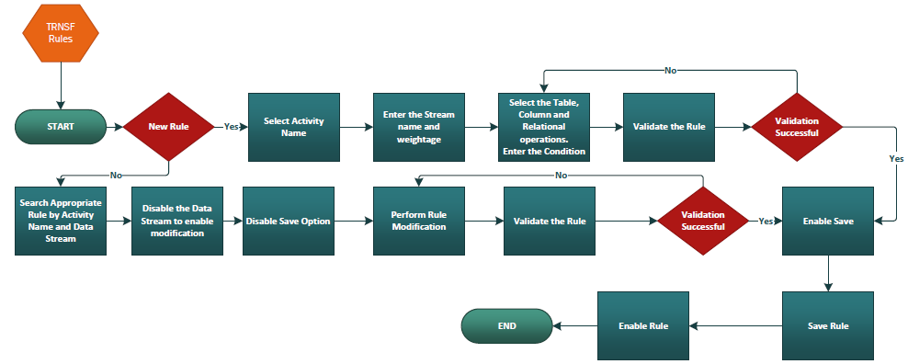

**Forward Flow Design**

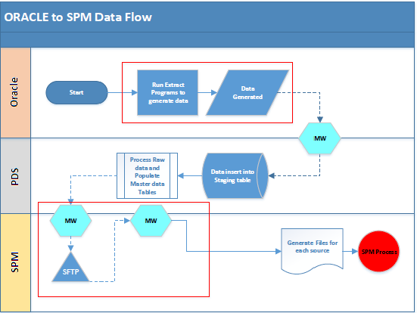

**Reverse Flow Design**

**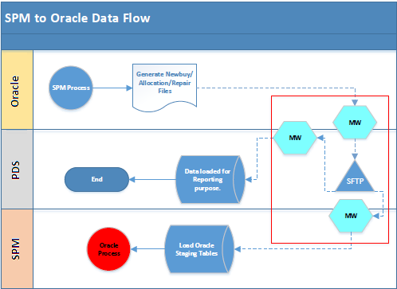**

**Health Check Design:**

**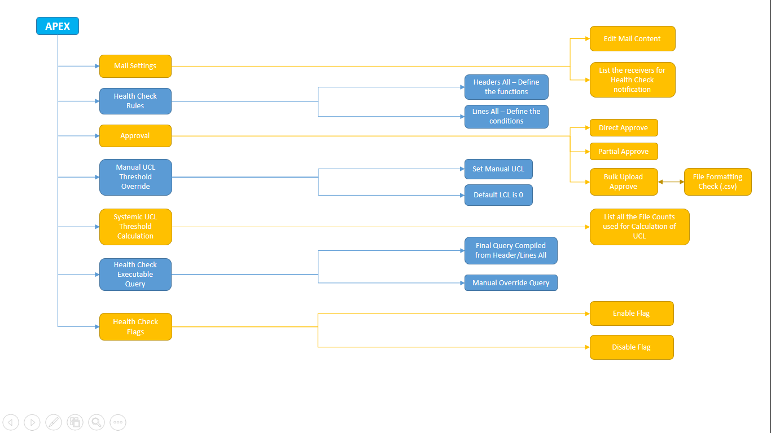**

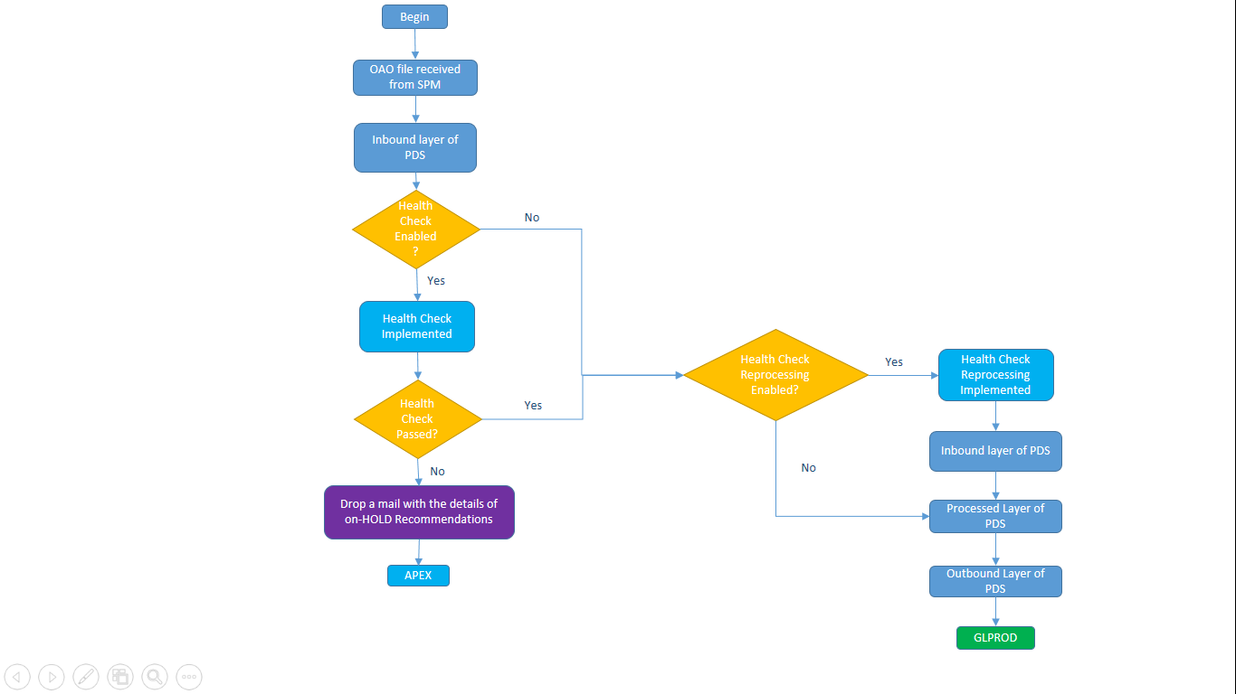

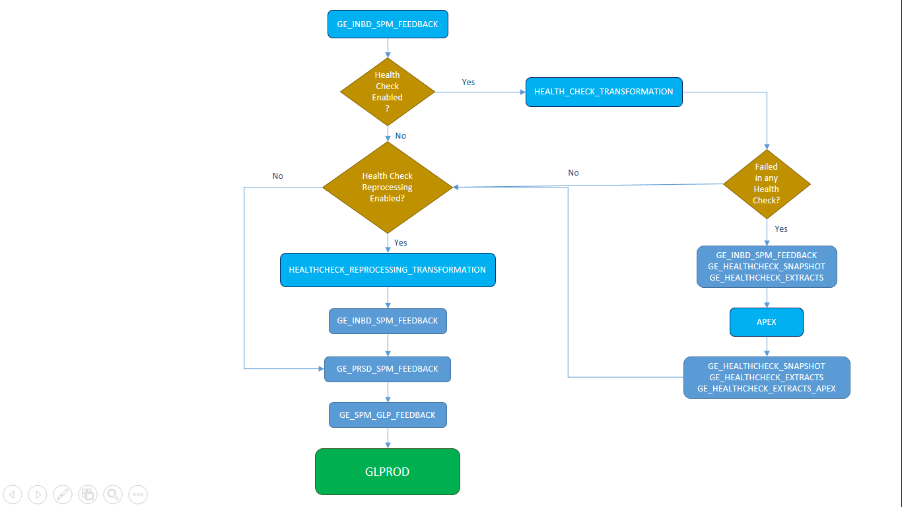

**Supply Conversion Design:**

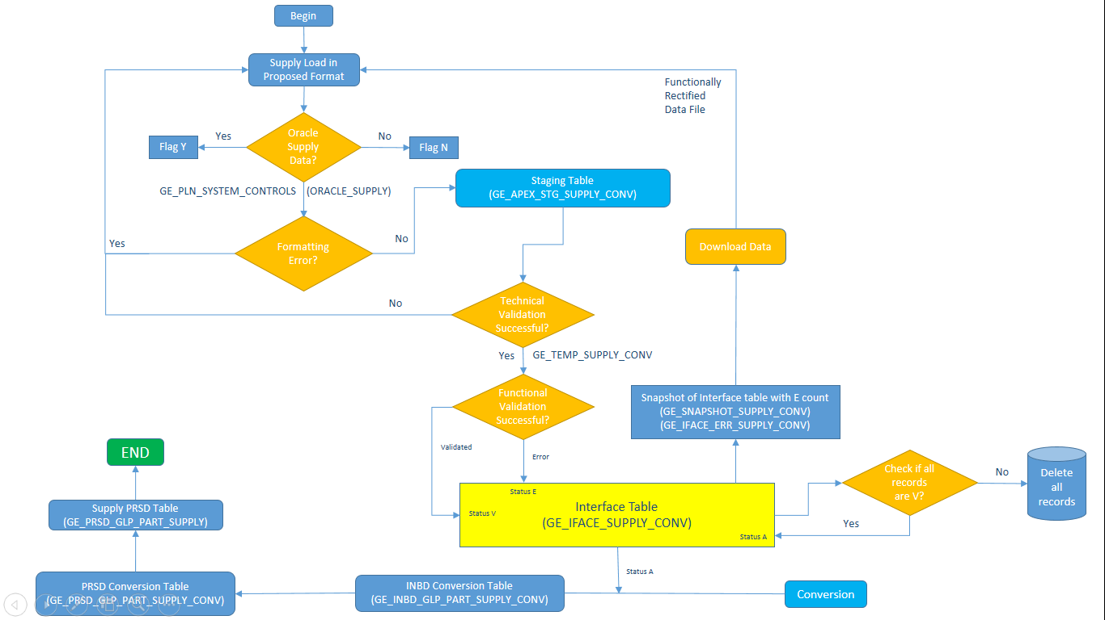

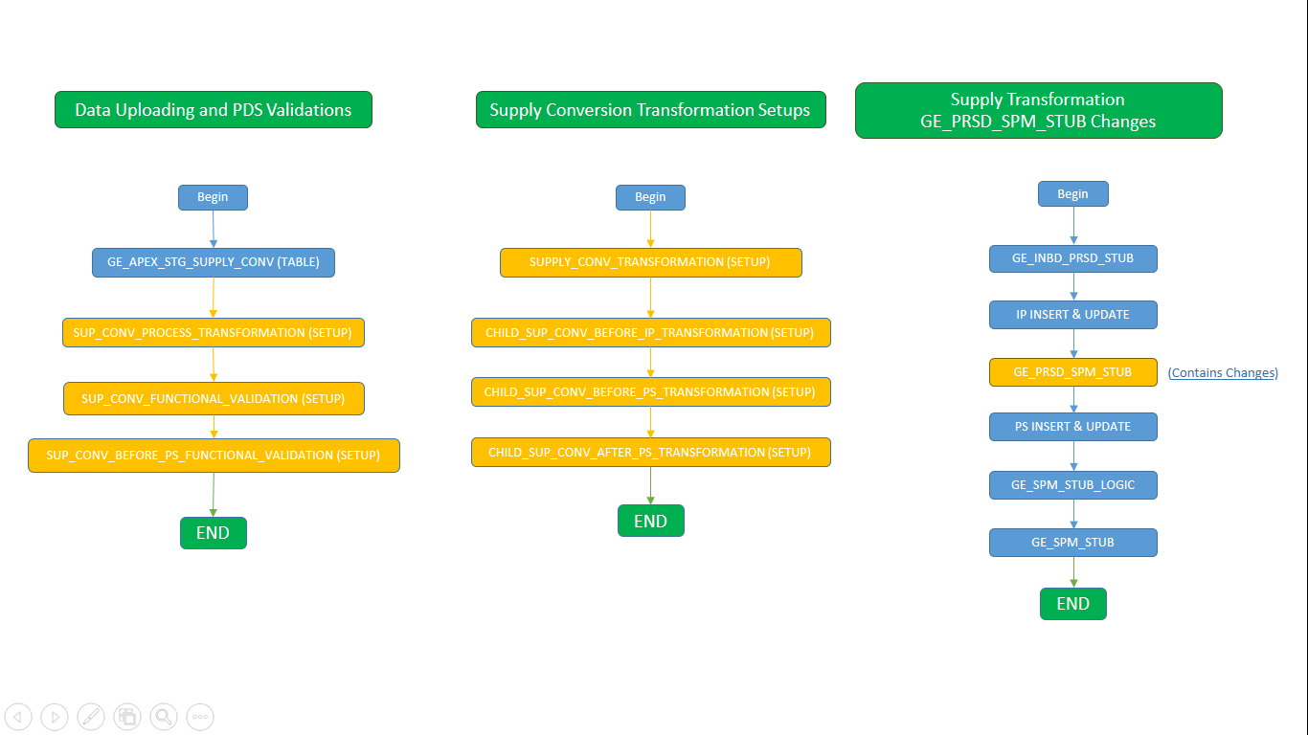

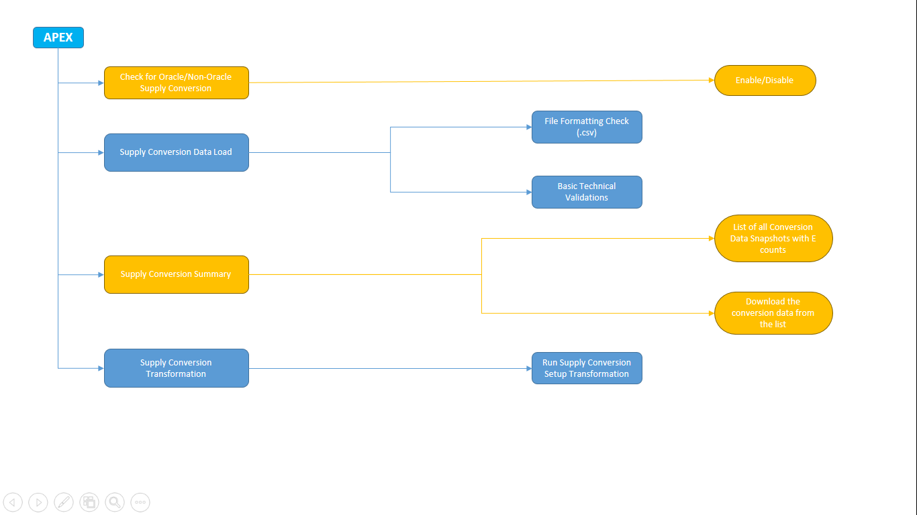**ODP TO SPM data sending design:**

|  |  |
| --- | --- |
| ODP to SPM Data Flow | |
|  | |
| ODP | DAAS Scheduled Job run to generate the file and sent to S3 bucket/ Update the elastic search for API execution.  ODP Scheduled Job to refresh source tables. |
| PDS | Process Raw data and Populate the Master data Tables  Data Insert Into PDS INBD Layer  MW |
| SPM | SFTP  MW |

**SBOM data flow**

**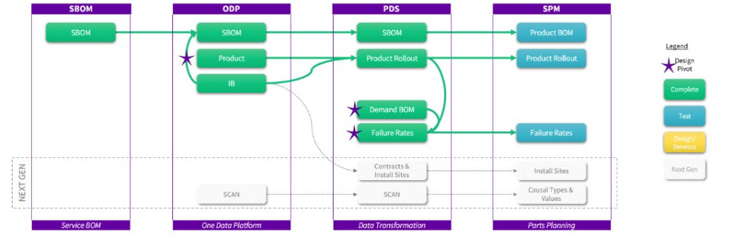**

**SPM Traceability Matrix:**

| **Reference** | **Document Type** | **Location** |
| --- | --- | --- |
| DOC1912195 | SPM Traceability Matrix | My Workshop: BOK98642 |

**PDS Tables :**

****

**Indexes :**

****

**Sequences :**

****

**Format for Demand Data Conversion:**

**** ****

**Standard Operating Procedure for Demand Data Conversion:**

****

**Format for Transaction Data Conversion:**

** **

**Standard Operating Procedure for Transaction Data Conversion:**

****

**SPM Master Report Mapping Document:**

****